UNITED STATES

SECURITIES AND EXCHANGE COMMISSION
Washington, D.C. 20549

FORM 8-K

CURRENT REPORT

Pursuant to Section 13 or 15(d)
of the Securities Exchange Act of 1934

Date of Report (Date of earliest event reported): October 23, 2026

SANGAMO THERAPEUTICS, INC.

(Exact name of registrant as specified in its charter)

Delaware

000-30171

68-0359556

(State or other jurisdiction
of incorporation)

(Commission
File Number)

(IRS Employer
ID Number)

501 Canal Blvd., Richmond, California 94804

(Address of principal executive offices) (Zip Code)

(510) 970-6000

(Registrant’s telephone number, including area code)

Not Applicable

(Former Name or Former Address, if Changed Since Last Report)

Check the appropriate box below if the Form 8-K filing is intended to simultaneously satisfy the filing obligation of the registrant under any of the following provisions:

- Written communications pursuant to Rule 425 under the Securities Act (17 CFR 230.425)

- Soliciting material pursuant to Rule 14a-12 under the Exchange Act (17 CFR 240.14a-12)

- Pre-commencement communications pursuant to Rule 14d-2(b) under the Exchange Act (17 CFR 240.14d-2(b))

- Pre-commencement communications pursuant to Rule 13e-4(c) under the Exchange Act (17 CFR 240.13e-4(c))

Securities registered pursuant to Section 12(b) of the Act:

Title of each class |  | Trading |  | Name of each exchange
 |  | Symbol(s) |  | on which registered
Common stock, par value $0.01 per share |  | SGMOQ |  | N/A (OTC Expert Market)*

Indicate by check mark whether the registrant is an emerging growth company as defined in Rule 405 of the Securities Act of 1933 (§ 230.405 of this chapter) or Rule 12b-2 of the Securities Exchange Act of 1934 (§ 240.12b-2 of this chapter).

Emerging growth company ☐

If an emerging growth company, indicate by check mark if the registrant has elected not to use the extended transition period for complying with any new or revised financial accounting standards provided pursuant to Section 13(a) of the Exchange Act. ☐

- Following a determination by the Nasdaq Stock Market LLC (“Nasdaq”) to delist the common stock of Sangamo Therapeutics, Inc. (the “Company”), the Company’s common stock was suspended from trading on Nasdaq on May 5, 2026 and currently trades on the OTC Expert Market on an unsolicited quotes only basis. On October 7, 2026, Nasdaq filed a Form 25 with the Securities and Exchange Commission to delist and deregister the Company’s common stock under Section 12(b) of the Exchange Act. The delisting became effective October 17, 2026.

Item 7.01 Regulation FD Disclosure.

As previously announced, on June 23, 2026, Sangamo Therapeutics, Inc. (the “Company”) filed a voluntary petition for relief under Chapter 11 of Title 11 of the United States Code (the “Bankruptcy Code”) in the United States Bankruptcy Court for the District of Delaware (the “Bankruptcy Court”), thereby commencing a Chapter 11 case for the Company (the “Chapter 11 Case”). The case number is 26-10989 and the case is styled as In re Sangamo Therapeutics, Inc.

On October 23, 2026, the Company filed with the Bankruptcy Court (i) an amended monthly operating report for each of the periods from

- July 1, 2026 to July 31, 2026 (the “Amended July MOR”), originally filed with the Securities and Exchange Commission (the “Commission”) on a Current Report on Form 8-K on September 8, 2026 and (b) August 1, 2026 to August 31, 2026 (the “Amended August MOR”), originally filed with the Commission on a Current Report on Form 8-K on October 15, 2026 and (ii) its monthly operating report for the period beginning September 1, 2026 and ended September 30, 2026 (the “September MOR,” together with each of the Amended July MOR and Amended August MOR, the “MORs”).

The information set forth in Item 7.01 of this Current Report on Form 8-K will not be deemed an admission as to the materiality of any information required to be disclosed solely by Regulation FD. The MORs are attached hereto as Exhibit 99.1, Exhibit 99.2 and Exhibit 99.3. The MORs and additional information regarding the Chapter 11 Case is available at https://www.veritaglobal.net/SangamoTherapeutics. The documents and other information on this website are not part of this Current Report on Form 8-K and shall not be incorporated by reference.

The information contained in this Item 7.01 and in Exhibit 99.1 is being “furnished” and shall not be deemed to be “filed” for purposes of Section 18 of the Securities Exchange Act of 1934, as amended (the “Exchange Act”), or otherwise subject to the liabilities of that section, and shall not be deemed to be incorporated by reference into any of the Company’s filings under the Securities Act of 1933, as amended (the “Securities Act”), or the Exchange Act, whether made before or after the date hereof and regardless of any general incorporation language in such filings, except to the extent expressly set forth by specific reference in such a filing.

Cautionary Statement Regarding the MORs

The Company cautions investors and potential investors not to place undue reliance upon the information contained in the MORs, which were not prepared for the purpose of providing the basis for an investment decision relating to any of the securities of the Company. The MORs are limited in scope, cover a limited time period and have been prepared solely for the purpose of complying with the reporting requirements of the Bankruptcy Court. The MORs are not audited or reviewed by independent accountants, were not prepared in accordance with generally accepted accounting principles in the United States, are in a format prescribed by applicable bankruptcy laws or rules, and are subject to future adjustment and reconciliation. The MORs also contain information for periods shorter than and otherwise different from those contained in the Company’s reports required to be filed pursuant to the Exchange Act. There can be no assurance that, from the perspective of an investor or potential investor in the Company’s securities, the MORs are complete. Results set forth in the MORs should not be viewed as indicative of future results.

Cautionary Language Regarding Trading in the Company’s Common Stock

The Company’s stockholders are cautioned that trading in the Company’s common stock during the pendency of the Chapter 11 Case is highly speculative and poses substantial risks. The Company’s common stock has been suspended from trading on the Nasdaq Capital Market (“Nasdaq”), and following the filing of a Form 25 by Nasdaq on October 7, 2026, was delisted effective October 17, 2026. The Company’s common stock is currently trading on the OTC Expert Market on an unsolicited quotes only basis, and trading prices for the Company’s common stock may bear little or no relationship to the actual recovery, if any, by holders thereof in the Company’s Chapter 11 Case. Accordingly, the Company urges extreme caution with respect to existing and future investments in its common stock.

Cautionary Language Regarding Forward-Looking Statements

This Current Report on Form 8-K contains certain forward-looking statements that reflect, when made, the Company’s current views with respect to current events and financial performance. These forward-looking statements are within the meaning of Private Securities Litigation Reform Act of 1995. These forward-looking statements include, but are not limited to, statements regarding process and potential outcomes of the Company’s Chapter 11 Case and/or statements preceded by, followed by or that include the words “intends,” “expects,” “estimates,” “plans,” or similar expressions. Although the Company believes that the expectations reflected in such forward-looking statements are based upon reasonable assumptions, beliefs and expectations, there can be no assurance that its expectations will be achieved. Except as otherwise may be required by law, the Company undertakes no obligation to update or publicly release any revisions to forward-looking statements to reflect events, circumstances, or changes in expectations after the date of this Current Report on Form 8-K.

Item 9.01 | Financial Statements and Exhibits.
(d) Exhibits
Exhibit
Number | Description of Document
99.1 | Sangamo Therapeutics, Inc. Amended Monthly Operating Report for the period ended July 31, 2026.
99.2 | Sangamo Therapeutics, Inc. Amended Monthly Operating Report for the period ended August 31, 2026.
99.3 | Sangamo Therapeutics, Inc. Monthly Operating Report for the period ended September 30, 2026.
104 | Cover Page Interactive Data File (embedded within the Inline XBRL document).

SIGNATURES

Pursuant to the requirements of the Securities Exchange Act of 1934, the registrant has duly caused this report to be signed on its behalf by the undersigned thereunto duly authorized.

SANGAMO THERAPEUTICS, INC.

Date: October 27, 2026 By: /s/ SCOTT B. WILLOUGHBY

Scott B. Willoughby

Chief Legal Officer and Corporate Secretary

 |  |  |  |  |  |  |  |  |  |  |  |  | Exhibit 99.1
 |  |  |  | UNITED STATES BANKRUPTCY COURT
 |  |  |  |  |  |  |  |  |  | DISTRICT OF DELAWARE
In Re. SANGAMO THERAPEUTICS, INC. |  |  |  | § |  |  |  |  |  | Case No. 26-10989
 |  |  |  | §
 |  |  |  | §
 | Debtor(s) |  |  | § |  |  |  |  |  | ☐ Jointly Administered
Amended Monthly Operating Report |  |  |  |  |  |  |  |  |  |  |  |  | Chapter 11
Reporting Period Ended: 07/31/2026 |  |  |  |  |  |  |  |  |  |  |  | Petition Date: | 06/23/2026
Months Pending: 1 |  |  |  |  |  |  |  |  |  |  |  | Industry Classification:
Reporting Method: |  | Accrual Basis |  |  |  |  |  |  |  | Cash Basis
Debtor’s Full-Time Employees (current): |  |  |  |  |  |  |  |  |  | 73
Debtor’s Full-Time Employees (as of date of order for relief): |  |  |  |  |  |  |  |  |  | 74

Supporting Documentation (check all that are attached):

(For jointly administered debtors, any required schedules must be provided on a non-consolidated basis for each debtor)

- Statement of cash receipts and disbursements

- Balance sheet containing the summary and detail of the assets, liabilities and equity (net worth) or deficit

- Statement of operations (profit or loss statement)

- Accounts receivable aging

- Postpetition liabilities aging

- Statement of capital assets

- Schedule of payments to professionals ☒ Schedule of payments to insiders
☒ All bank statements and bank reconciliations for the reporting period

- Description of the assets sold or transferred and the terms of the sale or transfer

/s/ Nikunj Jain |  | Nikunj Jain
Signature of Responsible Party |  | Printed Name of Responsible Party
10/23/2026
Date
 |  | 501 Canal Blvd., Suite A100 Richmond, CA 94804
 |  | Address

STATEMENT: This Periodic Report is associated with an open bankruptcy case; therefore, Paperwork Reduction Act exemption 5 C.F.R. §1320.4(a)(2) applies.

 |  | Docket No. 537
UST Form 11-MOR (12/01/2021) | 1 | Filed: 10/23/26

Debtor’s Name SANGAMO THERAPEUTICS, INC. |  |  |  |  |  |  |  |  |  |  | Case No. 26-10989
Part 1: Cash Receipts and Disbursements |  |  |  |  |  |  |  | Current Month |  |  |  |  | Cumulative
a. | Cash balance beginning of month |  |  |  |  |  |  | $ | 14,382,244
b. | Total receipts (net of transfers between accounts) |  |  |  |  |  |  | $ | 18,058,990 |  | $ |  | 28,562,062
c. | Total disbursements (net of transfers between accounts) |  |  |  |  |  |  | $ | 15,534,279 |  | $ |  | 16,512,210
d. | Cash balance end of month (a+b-c) |  |  |  |  |  |  | $ | 16,906,955
e. | Disbursements made by third party for the benefit of the estate |  |  |  |  |  |  | $ | 0 |  | $ |  | 0
f. | Total disbursements for quarterly fee calculation (c+e) |  |  |  |  |  |  | $ | 15,534,279 |  |  | $ | 16,512,210
Part 2: Asset and Liability Status
(Not generally applicable to Individual Debtors. See Instructions.) |  |  |  |  |  |  |  | Current Month
a. | Accounts receivable (total net of allowance) |  |  |  |  |  |  | $ | 500,160
b. | Accounts receivable over 90 days outstanding (net of allowance) |  |  |  |  |  |  | $ | 90,355
c. | Inventory (Book | Market |  |  | Other | (attach explanation)) |  | $ | 0
d | Total current assets |  |  |  |  |  |  | $ | 20,386,655
e. | Total assets |  |  |  |  |  |  | $155,117,944
f. | Postpetition payables (excluding taxes) |  |  |  |  |  |  | $ | 18,768,593
g. | Postpetition payables past due (excluding taxes) |  |  |  |  |  |  | $ | 366,473
h. | Postpetition taxes payable |  |  |  |  |  |  | $ | 269,455
i. | Postpetition taxes past due |  |  |  |  |  |  | $ | 0
j. | Total postpetition debt (f+h) |  |  |  |  |  |  | $ | 19,038,048
k. | Prepetition secured debt |  |  |  |  |  |  | $ | 0
l. | Prepetition priority debt |  |  |  |  |  |  | $ | 32,543
m. | Prepetition unsecured debt |  |  |  |  |  |  | $ | 78,061,802
n. | Total liabilities (debt) (j+k+l+m) |  |  |  |  |  |  | $ | 97,132,393
o. | Ending equity/net worth (e-n) |  |  |  |  |  |  | $ | 57,985,551
Part 3: Assets Sold or Transferred |  |  |  |  |  |  |  | Current Month |  |  |  |  | Cumulative
a. | Total cash sales price for assets sold/transferred outside the ordinary course of business |  |  |  |  |  |  | $ | 0 |  |  | $ | 0
b. | Total payments to third parties incident to assets being sold/transferred outside the ordinary course of business |  |  |  |  |  |  | $ | 0 |  |  | $ | 0
c. | Net cash proceeds from assets sold/transferred outside the ordinary course of business (a-b) |  |  |  |  |  |  | $ | 0 |  | $ |  | 0
Part 4: Income Statement (Statement of Operations)
(Not generally applicable to Individual Debtors. See Instructions.) |  |  |  |  |  |  |  | Current Month |  |  |  |  | Cumulative
a. | Gross income/sales (net of returns and allowances) |  |  |  |  |  |  | $ | 720,000
b. | Cost of goods sold (inclusive of depreciation, if applicable) |  |  |  |  |  |  | $ | 0
c. | Gross profit (a-b) |  |  |  |  |  |  | $ | 720,000
d. | Selling expenses |  |  |  |  |  |  | $ | 0
e. | General and administrative expenses |  |  |  |  |  |  | $ | 3,764,872
f. | Other expenses |  |  |  |  |  |  | $ | 3,231,570
g. | Depreciation and/or amortization (not included in 4b) |  |  |  |  |  |  | $ | 216,290
h. | Interest |  |  |  |  |  |  | $ | 105,000
i. | Taxes (local, state, and federal) |  |  |  |  |  |  | $ | 0
j. | Reorganization items |  |  |  |  |  |  | $ | 4,244,225
k. | Profit (loss) |  |  |  |  |  |  | $ -11,165,298 |  |  | $ |  | -14,920,356
UST Form 11-MOR (12/01/2021) |  |  |  |  |  | 2

Debtor’s Name SANGAMO THERAPEUTICS, INC. |  |  |  |  |  | Case No. 26-10989
Part 5: Professional Fees and Expenses
 |  |  |  | Approved | Approved | Paid Current | Paid
a. |  |  |  | Current Month | Cumulative | Month | Cumulative
a. | Debtor’s professional fees & expenses (bankruptcy) Aggregate Total
 | Itemized Breakdown by Firm
 |  | Firm Name | Role
 | i
 | ii
 | iii
 | iv
 | v
 | vi
 | vii
 | viii
 | ix
 | x
 | xi
 | xii
 | xiii
 | xiv
 | xv
 | xvi
 | xvii
 | xviii
 | xix
 | xx
 | xxi
 | xxii
 | xxiii
 | xxiv
 | xxv
 | xxvi
 | xxvii
 | xxviii
 | xxix
 | xxx
 | xxxi
 | xxxii
 | xxxiii
 | xxxiv
 | xxxv
 | xxxvi
UST Form 11-MOR (12/01/2021) |  |  | 3
Debtor’s Name SANGAMO THERAPEUTICS, INC. Case No. 26-10989

xxxvii


xxxviii

xxxix

xl

xli

xlii

xliii

xliv

xlv

xlvi

xlvii

xlviii

xlix

l

li

lii

liii

liv

lv

lvi

lvii

lviii

lix

lx

lxi

lxii

lxiii

lxiv

lxv

lxvi

lxvii

lxviii

lxix

lxx

lxxi

lxxii

lxxiii

lxxiv

lxxv

lxxvi

lxxvii

lxxviii

UST Form 11-MOR (12/01/2021) | 4

Debtor’s Name SANGAMO THERAPEUTICS, INC. Case No. 26-10989

lxxix


lxxx

lxxxi

lxxxii

lxxxiii

lxxxiv

lxxxv

lxxxvi

lxxxvii

lxxxviii

lxxxix

xc

xci

xcii

xciii

xciv

xcv

xcvi

xcvii

xcviii

xcix

c

ci

 |  |  |  | Approved | Approved | Paid Current | Paid
 |  |  |  | Current Month | Cumulative | Month | Cumulative
b. | Debtor’s professional fees & expenses (nonbankruptcy) Aggregate Total |  |  |  |  | $348 | $348
 | Itemized Breakdown by Firm
 |  | Firm Name | Role
 | i | Rothwell, Figg, Ernst & Manbec | Special Counsel |  |  | $295 | $295
 | ii | Daijogo & Pedersen, LLP | Special Counsel |  |  | $ 52 | $ 52
 | iii
 | iv
 | v
 | vi
 | vii
 | viii
 | ix
 | x
 | xi
 | xii
 | xiii
 | xiv
UST Form 11-MOR (12/01/2021) |  |  | 5

Debtor’s Name SANGAMO THERAPEUTICS, INC. Case No. 26-10989

xv


xvi

xvii

xviii

xix

xx

xxi

xxii

xxiii

xxiv

xxv

xxvi

xxvii

xxviii

xxix

xxx

xxxi

xxxii

xxxiii

xxxiv

xxxv

xxxvi

xxxvii

xxxviii

xxxix

xl

xli

xlii

xliii

xliv

xlv

xlvi

xlvii

xlviii

xlix

l

li

lii

liii

liv

lv

lvi

UST Form 11-MOR (12/01/2021) | 6

Debtor’s Name SANGAMO THERAPEUTICS, INC. |  |  |  |  |  |  |  |  |  | Case No. 26-10989
 | lvii
 | lviii
 | lix
 | lx
 | lxi
 | lxii
 | lxiii
 | lxiv
 | lxv
 | lxvi
 | lxvii
 | lxviii
 | lxix
 | lxx
 | lxxi
 | lxxii
 | lxxiii
 | lxxiv
 | lxxv
 | lxxvi
 | lxxvii
 | lxxviii
 | lxxix
 | lxxx
 | lxxxi
 | lxxxii
 | lxxxiii
 | lxxxiv
 | lxxxv
 | lxxxvi
 | lxxxvii
 | lxxxviii
 | lxxxix
 | xc
 | xci
 | xcii
 | xciii
 | xciv
 | xcv
 | xcvi
 | xcvii
 | xcviii
 | xcix
 | c
c. All professional fees and expenses (debtor & committees) |  |  |  |  | $ |  | 0 | $ |  | 0 | $348 | $348
UST Form 11-MOR (12/01/2021) |  |  | 7

Debtor’s Name SANGAMO THERAPEUTICS, INC. |  |  |  |  | Case No. 26-10989
Part 6: Postpetition Taxes |  |  |  | Current Month |  |  | Cumulative
a. | Postpetition income taxes accrued (local, state, and federal) |  |  | $ | 0 |  | $ | 0
b. | Postpetition income taxes paid (local, state, and federal) |  |  | $ | 0 |  | $ | 0
c. | Postpetition employer payroll taxes accrued |  | $ |  | 226,736 |  | $ | 282,175
d. | Postpetition employer payroll taxes paid |  |  | $ | 421,834 |  | $ | 421,834
e. | Postpetition property taxes paid |  | $ |  | 0 |  | $ | 0
f. | Postpetition other taxes accrued (local, state, and federal) |  |  | $ | 39,582 |  | $ | 57,404
g. | Postpetition other taxes paid (local, state, and federal) |  | $ |  | 0 |  | $ | 0
Part 7: Questionnaire - During this reporting period:

a. | Were any payments made on prepetition debt? (if yes, see Instructions) |  |  |  |  | Yes | No
b. | Were any payments made outside the ordinary course of business without court |  |  |  |  | Yes | No
 | approval? (if yes, see Instructions)
c. | Were any payments made to or on behalf of insiders? |  |  |  |  | Yes | No
d. | Are you current on postpetition tax return filings? |  |  |  |  | Yes | No
e. | Are you current on postpetition estimated tax payments? |  |  |  |  | Yes | No
f. | Were all trust fund taxes remitted on a current basis? |  |  |  |  | Yes | No
g. | Was there any postpetition borrowing, other than trade credit? (if yes, see |  |  |  |  | Yes | No
 | Instructions)
h. | Were all payments made to or on behalf of professionals approved by the court? |  |  |  |  | Yes | No
i. | Do you have: |  | Worker’s compensation insurance? |  |  | Yes | No
 |  |  |  | If yes, are your premiums current? |  | Yes | No
 |  |  | Casualty/property insurance? |  |  | Yes | No
 |  |  |  | If yes, are your premiums current? |  | Yes | No
 |  |  | General liability insurance? |  |  | Yes | No
 |  |  |  | If yes, are your premiums current? |  | Yes | No
j. | Has a plan of reorganization been filed with the court? |  |  |  |  | Yes | No
k. | Has a disclosure statement been filed with the court? |  |  |  |  | Yes | No
1. Are you current with quarterly U.S. Trustee fees as set forth under 28 U.S.C. |  |  |  |  |  | Yes | No
 | § 1930?
UST Form 11-MOR (12/01/2021) |  |  |  |  | 8

N/A

N/A (if no, see Instructions)

N/A (if no, see Instructions)

N/A (if no, see Instructions)

Debtor’s Name SANGAMO THERAPEUTICS, INC. |  |  |  |  | Case No. 26-10989
Part 8: Individual Chapter 11 Debtors (Only)
a. | Gross income (receipts) from salary and wages |  |  |  | $ |  |  |  | 0
b. | Gross income (receipts) from self-employment |  |  |  |  | $ |  |  | 0
c. | Gross income from all other sources |  |  |  | $ |  |  |  | 0
d. | Total income in the reporting period (a+b+c) |  |  |  |  | $ |  |  | 0
e. | Payroll deductions |  |  |  | $ |  |  |  | 0
f. | Self-employment related expenses |  |  |  |  | $ |  |  | 0
g. | Living expenses |  |  |  | $ |  |  |  | 0
h. | All other expenses |  |  |  |  | $ |  |  | 0
i. | Total expenses in the reporting period (e+f+g+h) |  |  |  | $ |  |  |  | 0
j. | Difference between total income and total expenses (d-i) |  |  |  |  | $ |  |  | 0
k. | List the total amount of all postpetition debts that are past due |  |  |  | $ |  |  |  | 0
l. | Are you required to pay any Domestic Support Obligations as defined by 11 U.S.C § 101(14A)? |  | Yes | No
m. If yes, have you made all Domestic Support Obligation payments? |  |  | Yes | No | N/A

Privacy Act Statement

28 U.S.C. § 589b authorizes the collection of this information, and provision of this information is mandatory under 11 U.S.C. §§ 704, 1106, and 1107. The United States Trustee will use this information to calculate statutory fee assessments under 28 U.S.C. § 1930(a)(6). The United States Trustee will also use this information to evaluate a chapter 11 debtor’s progress through the bankruptcy system, including the likelihood of a plan of reorganization being confirmed and whether the case is being prosecuted in good faith. This information may be disclosed to a bankruptcy trustee or examiner when the information is needed to perform the trustee’s or examiner’s duties or to the appropriate federal, state, local, regulatory, tribal, or foreign law enforcement agency when the information indicates a violation or potential violation of law. Other disclosures may be made for routine purposes. For a discussion of the types of routine disclosures that may be made, you may consult the Executive Office for United States Trustee’s systems of records notice, UST-001, “Bankruptcy Case Files and Associated Records.” See 71 Fed. Reg. 59,818 et seq. (Oct. 11, 2006). A copy of the notice may be obtained at the following link: http://www.justice.gov/ust/ eo/rules_regulations/index.htm. Failure to provide this information could result in the dismissal or conversion of your bankruptcy case or other action by the United States Trustee. 11 U.S.C. § 1112(b)(4)(F).

I declare under penalty of perjury that the foregoing Monthly Operating Report and its supporting documentation are true and correct and that I have been authorized to sign this report on behalf of the estate.

/s/ Nikunj Jain |  | Nikunj Jain
Signature of Responsible Party |  |  | Printed Name of Responsible Party
Interim Chief Financial Officer |  | 10/23/2026
Title |  |  | Date
UST Form 11-MOR (12/01/2021) | 9

Debtor’s Name SANGAMO THERAPEUTICS, INC. Case No. 26-10989
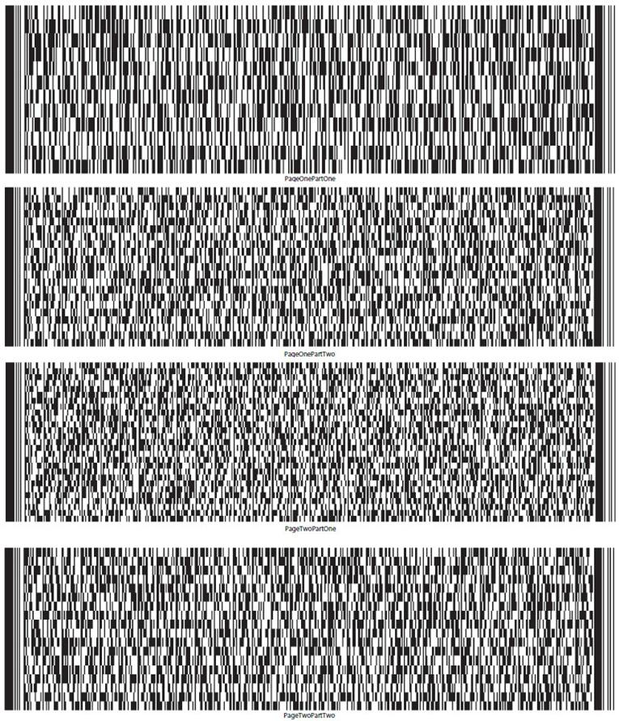

UST Form 11-MOR (12/01/2021) | 10

Debtor’s Name SANGAMO THERAPEUTICS, INC. Case No. 26-10989
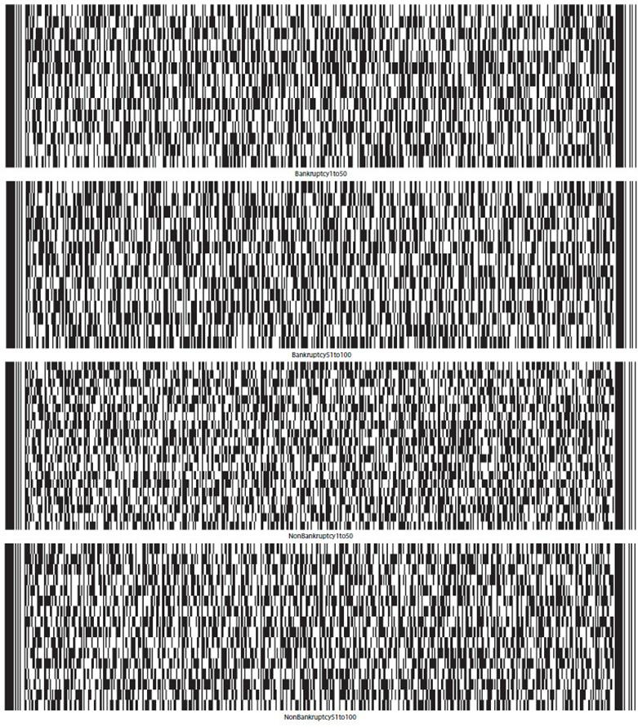

UST Form 11-MOR (12/01/2021) | 11

Debtor’s Name SANGAMO THERAPEUTICS, INC. Case No. 26-10989
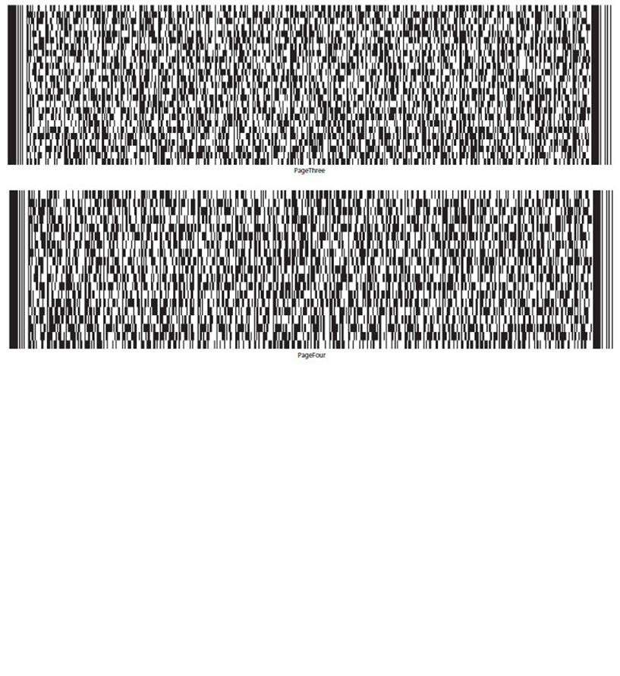

UST Form 11-MOR (12/01/2021) | 12

 | IN THE UNITED STATES BANKRUPTCY COURT
 | FOR THE DISTRICT DELAWARE
 | )
In re: | ) Chapter 11
 | )
SANGAMO THERAPEUTICS, INC. | ) Case No. 26-10989 (CTG)
 | )
Debtor.¹ | )
 | )

GLOBAL NOTES AND STATEMENT OF LIMITATIONS, METHODOLOGY, AND DISCLAIMERS REGARDING THE DEBTOR’S AMENDED² MONTHLY OPERATING REPORT

On June 23, 2026 (the “Petition Date”), Sangamo Therapeutics, Inc. (the “Debtor”) commenced the above-captioned chapter 11 case by filing a voluntary petition for relief under chapter 11 of title 11 of the United States Code (the “Bankruptcy Code”) with the United States Bankruptcy Court for the District of Delaware (the “Court”). The Debtor is authorized to operate its business as a debtor-in-possession pursuant to sections 1107(a) and 1108 of the Bankruptcy Code.

General Methodology

The Debtor is filing its monthly operating report (the “MOR”) for the period from July 1, 2026 through July 31, 2026 (the “Reporting Period”) for purposes of complying with the monthly reporting requirements applicable in the Debtor’s chapter 11 case. The MOR is unaudited and has not been prepared in accordance with accounting principles generally accepted in the United States of America (“U.S. GAAP”) and does not include all of the information and footnotes required by U.S. GAAP. The MOR is not intended to reconcile to any financial statements otherwise prepared or distributed by the Debtor. The MOR should not be relied upon by any persons for information relating to current or future financial condition, events, or performance of the Debtor or its affiliates, as the results of operations contained herein are not necessarily indicative of results which may be expected from any other period or for the full year and may not necessarily reflect the results of operations, financial position, and schedule of receipts and disbursements in the future.

- The Debtor and the last four digits of its taxpayer identification number are: Sangamo Therapeutics, Inc. (9556). The Debtor’s mailing address is

- This amended monthly operating report amends the July monthly operating report filed at Docket No. 427 to add information regarding payments inadvertently made to ordinary course professionals, as set forth in part 5(b) of the monthly operating report form and the attached attestation titled “Part 7(b) and 7(h) Payments Without Court Approval.”

Basis for Presentation

In preparing the MOR, the Debtor relied on financial information from its books and records at the time of such preparation. The financial information contained in the MOR is derived from the Debtor’s books and records without, among other things, all adjustments or reclassification that may be necessary or typical to accord with U.S. GAAP.

This information has not been subjected to procedures that would typically be applied to financial information presented in accordance with U.S. GAAP or any other recognized financial reporting framework. If such procedures were applied, the Debtor believes that the financial information presented in the MOR could be subject to change, including material change.

Although the Debtor made efforts to ensure the accuracy and completeness of the MOR, given the complexity of the Debtor’s business, inadvertent errors or omissions may occur. Accordingly, the Debtor hereby reserves all rights to dispute the nature, validity, status, enforceability, or executory nature of any claim amount, agreement, representation, or other statement set forth in the MOR. Further, the Debtor reserves the right to amend or supplement the MOR, if necessary, but shall be under no obligation to do so.

Moreover, given, among other things, the uncertainty surrounding the valuation and ownership of certain assets and the valuation and nature of certain liabilities, to the extent the Debtor shows more assets than liabilities, it is not an admission that the Debtor was solvent as of the Petition Date or at any time prior to the Petition Date. Likewise, to the extent the Debtor shows more liabilities than assets, it is not an admission that the Debtor was insolvent at the Petition Date or any time prior to the Petition Date.

For the reasons discussed above, there can be no assurance that the financial information presented in the MOR is complete, and readers are strongly cautioned not to place undue reliance on the MOR.

Each signatory to the MOR has necessarily relied upon the efforts, statements, advice, and representations of personnel of the Debtor and the Debtor’s advisors and professionals. Each signatory has not (and could not have) personally verified the accuracy of each such statement, representation, and answer contained in the MOR.

Reporting Period

Unless otherwise noted herein, the MOR generally reflects the Debtor’s books and records for the applicable Reporting Period. Unless otherwise noted herein, no adjustments have been made for activity occurring after the close of the Reporting Period.

Accuracy

The financial information disclosed in the MOR was not prepared in accordance with federal or state securities laws or other applicable non-bankruptcy law or in lieu of complying with any periodic reporting requirements thereunder. Persons and entities trading in or otherwise purchasing, selling, or transferring the claims against or equity interests in the Debtor should evaluate the financial information in light of the purposes for which it was prepared. The Debtor and its advisors are not liable for and undertake no responsibility to indicate variations from securities laws in the MOR or for any evaluations of the Debtor, including of their financial condition, based on this financial information or any other information.

Debtor in Possession Financing

On June 25, 2026, the Court entered the Interim Order (A) Authorizing the Debtor to Obtain Postpetition Financing, (B) Granting Liens and Providing Claims with Superpriority Administrative Expense Status, (C) Modifying Automatic Stay, (D) Scheduling Final Hearing, and (E) Granting Related Relief [Docket No. 63] (the “Initial Interim DIP Order”) authorizing the Debtor to enter into a senior secured superpriority debtor-in-possession term loan facility (the “Initial DIP Facility”). Prior to the Reporting Period, the Debtor drew $10,500,000 under the Initial DIP Facility. Please refer to the motion [Docket No. 10] seeking entry of the Initial Interim DIP Order for additional information regarding the Initial DIP Facility.

On July 23, 2026, the Court entered the Interim Order (A) Authorizing the Debtor to Obtain Replacement Postpetition Financing, (B) Granting Liens and Providing Claims with Superpriority Administrative Expense Status, (C) Modifying Automatic Stay, (D) Scheduling Final Hearing, and (E) Granting Related Relief [Docket No. 176] (the “Replacement Interim DIP Order”), which among other things, authorized the Debtor to enter into a senior secured superpriority debtor-in-possession term loan facility (the “Replacement DIP Facility”) to replace the Initial DIP Facility. During the Reporting Period, the Debtor incurred $18 million in DIP Obligations (as defined in the Replacement DIP Order) under the Replacement DIP Order, $11,432,958 of which was paid by the Debtor or on the Debtor’s behalf to satisfy all outstanding obligations arising under the Initial DIP Facility, including all fees. Please refer to the motion [Docket No. 161] seeking entry of the Replacement Interim DIP Order for additional information regarding the Replacement DIP Facility.

Payment of Prepetition Claims Pursuant to First Day Orders

Pursuant to certain interim orders of the Court entered on or about June 24, 2026 and final orders of the Court entered on or about July 21, 2026 (the “First Day Orders”), the Debtor is authorized (but not directed) to pay, among other things, certain prepetition claims of employees and taxing authorities. Accordingly, these liabilities may have been or may be satisfied in accordance with such First Day Orders. To the extent any payments were made on account of prepetition claims following the Petition Date pursuant to the authority granted to the Debtor under the First Day Orders, such payments have been included in the MOR (subject to the notes and statements and limitations provided herein).

Reservation of Rights

The Debtor reserves all rights to amend or supplement the MOR in all respects, as may be necessary or appropriate. Nothing contained in the MOR shall constitute a waiver of any of the Debtor’s rights or an admission with respect to any claim against the Debtor or otherwise in connection with this chapter 11 case

Specific MOR Disclosures

Part 1: Cash Receipts and Disbursements

Pursuant to the Initial Interim DIP Order and Replacement Interim DIP Order (together the “Interim DIP Orders”), fees and expenses of estate professionals were placed into the Professional Fees Account (as defined in the Interim DIP Orders) maintained by the Debtor. The transfer of such funds to the Professional Fee Account were treated as a transfer between Debtor accounts, and, therefore, were not treated as a distribution in Part 1(c). Professional fees will be treated as a disbursement in the reporting period in which they are paid to the applicable professionals.

Similarly, pursuant to the interim and final orders approving, among other things, the Debtor’s proposed form of adequate assurance of payment to utility companies [Docket No. 56 & 142] (the “Utilities Orders”), the Debtor deposited funds into the Utility Deposit Account (as defined in the Utilities Orders) maintained by the Debtor prior to the Reporting Period. The funds in such account will be treated as disbursements only if they are ultimately paid to a third party.

Notes to Part 2: Asset and Liability Status

Unless otherwise noted, all asset and liability information included in the MOR reflects net book value, which may differ from current market value. As set forth above, this information has not been subjected to procedures that would typically be applied to financial information presented in accordance with U.S. GAAP or any other recognized financial reporting framework. If such procedures were applied, the Debtor believes that the financial information presented in the MOR could be subject to change, including material change. Asset and liability information includes intercompany claims and other assets and liabilities which may not be settled in cash.

The Debtor continues to pay postpetition invoices on account of postpetition goods provided and services rendered in the ordinary course of business.

Given the Petition Date did not occur at month end, certain prepetition and postpetition liability balances are estimated. The Debtor has sought to assign liabilities to the prepetition and postpetition periods based on the information available as of and at the time the MOR was prepared. As additional information becomes available, the allocation of liabilities between prepetition and postpetition periods may change. The Debtor reserves the right to amend the balances as it deems appropriate and any such amendments will be reflected in future MORs

The amounts listed as “Prepetition Secured Debt,” “Prepetition Priority Debt” and “Prepetition Unsecured Debt” are preliminary and are subject to ongoing review and reconciliation by the Debtor. All amounts and classifications are subject to material adjustments.

Regarding Part 2c, the Debtor does not hold inventory; therefore, no inventory valuation method is applicable.

Notes to Part 6: Postpetition Taxes

Regarding Part 6c and 6d, postpetition employer payroll taxes accrued and paid include both the employer and employee portions of payroll taxes.

Notes to Part 7: Questionnaire

Regarding Part 7a, and as mentioned above, the Debtor is authorized to pay certain prepetition claims and obligations pursuant to the First Day Orders.

Regarding Part 7g, the Debtor incurred $18 million in DIP Obligations under the Replacement DIP Facility during the Reporting Period. The DIP Obligations were paid by the Debtor or on the Debtor’s behalf to pay all outstanding obligations under the Initial DIP Facility and to fund the Debtor’s business operations and its chapter 11 case.

UNITED STATES BANKRUPTCY COURT DISTRICT OF DELAWARE

Sangamo Therapeutics, Inc.

Schedule of Post-Petition Borrowing Activity

Case No: 26-10989

Reporting Period: July 1, 2026 – July 31, 2026

The Debtor hereby submits this attestation regarding postpetition borrowing during the period of July 1, 2026 through July 31, 2026.

In accordance with the Interim Order (A) Authorizing the Debtor to Obtain Replacement Postpetition Financing, (B) Granting Liens and Providing Claims with Superpriority Administrative Expense Status, (C) Modifying Automatic Stay, (D) Scheduling Final Hearing, and (E) Granting Related Relief [Docket No. 176] (the “Replacement Interim DIP Order”), the Debtor incurred $18 million in DIP Obligations under the Replacement DIP Facility (each as defined in the Replacement Interim DIP Order) during the Reporting Period.

/s/ Nikunj Jain |  | October 23, 2026
Signature of Authorized Individual |  |  | Date
Nikunj Jain |  | Interim Chief Financial Officer
Printed Name of Authorized Individual |  |  | Title of Authorized Individual

UNITED STATES BANKRUPTCY COURT DISTRICT OF DELAWARE

Sangamo Therapeutics, Inc.

Schedule of Payments on Prepetition Debt

Case No: 26-10989

Reporting Period: July 1, 2026 – July 31, 2026

All payments made by the Debtor during the Reporting Period (and included in the disbursements reported in this MOR) were authorized under various final orders granted by the Court, which authorized the Debtor’s various motions that were filed following the commencement of the chapter 11 case.

/s/ Nikunj Jain |  | October 23, 2026
Signature of Authorized Individual |  |  | Date
Nikunj Jain |  | Interim Chief Financial Officer
Printed Name of Authorized Individual |  |  | Title of Authorized Individual

UNITED STATES BANKRUPTCY COURT DISTRICT OF DELAWARE

Sangamo Therapeutics, Inc.

Part 7(b) and 7(h) Payments Without Court Approval

Case No: 26-10989

Reporting Period: July 1, 2026 – July 31, 2026

Payments made by the Debtor to Rothwell, Figg, Ernst & Manbeck, P.C. and Daijogo & Pedersen, LLP were inadvertently made prior to such firm’s retention as ordinary course professionals in accordance with the OCP Order [Docket No. 202].

/s/ Nikunj Jain |  | October 23, 2026
Signature of Authorized Individual |  |  | Date
Nikunj Jain |  | Interim Chief Financial Officer
Printed Name of Authorized Individual |  |  | Title of Authorized Individual

UNITED STATES BANKRUPTCY COURT DISTRICT OF DELAWARE

Sangamo Therapeutics, Inc.

Schedule of Payments to Insiders

Case No: 26-10989

Reporting Period: July 1, 2026 – July 31, 2026

The Debtor hereby submits this attestation regarding payments to insiders during the period of July 1, 2026 through July 31, 2026.

With respect to insiders, all cash payments made were on account of ordinary course salaries and authorized travel and expense reimbursements.

No non-cash transfers were made during this reporting period.
/s/ Nikunj Jain |  | October 23, 2026
Signature of Authorized Individual |  |  | Date
Nikunj Jain |  | Interim Chief Financial Officer
Printed Name of Authorized Individual |  |  | Title of Authorized Individual

UNITED STATES BANKRUPTCY COURT DISTRICT OF DELAWARE

Sangamo Therapeutics, Inc.

All bank statements and bank reconciliations for the reporting period

Case No: 26-10989

Reporting Period: July 1, 2026 – July 31, 2026

The Debtor hereby submits this attestation regarding bank account reconciliations in lieu of providing copies of bank statements, bank reconciliations, and journal entries.

The Debtor’s standard practice is to ensure that bank reconciliations are completed as part of the month end close each reporting period. I attest that each of the Debtor’s bank accounts has been reconciled in accordance with their standard practices.

/s/ Nikunj Jain |  | October 23, 2026
Signature of Authorized Individual |  |  | Date
Nikunj Jain |  | Interim Chief Financial Officer
Printed Name of Authorized Individual |  |  | Title of Authorized Individual

Sangamo Therapeutics Inc.

MOR #2 - Statement of cash receipts and disbursements

Units (i.e. $ in 000s)

 | 07/01/2026 -
 | 07/31/2026
Receipts
Receipts | $ |  | 59
DIP Draw | $ |  | 18,000
Total Receipts |  | $ | 18,059
Operational Disbursements
Payroll & Benefits | $ |  | 1,747
Rent & Facilities |  |  | 1,348
Program Costs |  |  | 319
International Operations |  |  | 416
Other Operating Disbursements |  |  | 271
Total Operational Disbursements | $ |  | 4,101
Restructuring Disbursements
Professional Fees |  |  | —
US Trustee Fees |  |  | —
DIP Interest & Fees |  |  | 933
DIP Repayments |  |  | 10,500
Total Restructuring Disbursements | $ |  | 11,433
Net Cash Flow | $ |  | 2,525
Cash, cash equivalents, and restricted cash, beginning of period | $ |  | 14,382
Cash, cash equivalents, and restricted cash, end of period |  | $ | 16,907
 | 1 of 4

Sangamo Therapeutics Inc.

MOR #2 - Balance sheet

Units (i.e. $ in 000s)

 |  |  |  | As of
 |  | 6/30/2026 |  |  |  | 7/31/2026
Assets
Cash, Cash Equivalents and Restricted Cash | $ | 14,382 |  |  | $ | 16,910
Accounts Receivables |  | 500 |  |  |  | 500
Other Current Assets |  | 3,303 |  |  |  | 2,977
Inventory |  | — |  |  |  | —
I/C Receivables - Current |  | — |  |  |  | —
Total Current Assets | $ | 18,186 |  |  | $ | 20,387
Property, Plant & Equipment (Net) | $ | 9,644 |  |  | $ | 9,430
Right of Use Assets |  | 2,747 |  |  |  | 2,694
Other Non-Current Assets |  | 779 |  |  |  | 779
Investments in Subsidiaries |  | 115,762 |  |  |  | 115,762
I/C Receivables - Non-Current |  | 5,970 |  |  |  | 6,067
Total Non-Current Assets | $ | 134,902 |  |  | $ | 134,731
Total Assets | $ | 153,087 |  |  | $ | 155,118
Liabilities and Stockholders’ Equity
A/P and Accrued Liabilities | $ | 30,620 |  |  | $ | 36,735
Compensation and Benefits Liabilities |  | 13,304 |  |  |  | 17,304
DIP Loan Payables |  | 10,500 |  |  |  | 18,000
Other Current Liabilities¹ |  | 9,001 |  |  |  | 8,713
I/C Payables - Current |  | 42,651 |  |  |  | 42,687
Other Non-Current Liabilities¹ |  | 23,678 |  |  |  | 23,240
I/C Payables - Non-Current |  | 692 |  |  |  | 703
Non-Current Portion of Long-Term Debt |  | — |  |  |  | —
Total Liabilities | $ | 130,446 |  |  | $ | 147,383
Stock | $ | 1,643,342 |  |  | $ | 1,643,342
Retained Earnings |  | (1,564,836) |  |  |  | (1,564,836)
Other Equity |  | (30) |  |  |  | (30)
Net Income |  | (55,834) |  |  |  | (70,741)
Total Stockholders’ Equity | $ | 22,642 |  |  | $ | 7,735
Total Liabilities and Stockholders’ Equity | $ | 153,087 |  |  | $ | 155,118

Notes:

- Includes Deferred Revenues and Lease Liabilities

2 of 4

Sangamo Therapeutics Inc.

MOR #2 - Statement of operations (profit or loss statement)

Units (i.e. $ in 000s)

 | 07/01/2026 -
 | 07/31/2026
Total Revenue |  | $ | 720
COGS |  |  | —
Gross Profit | $ |  | 720
Personnel & Staffing Costs¹ | $ |  | 1,931
R&D Expenses² |  |  | 3,184
Selling Expenses |  |  | —
General and Administrative Expenses |  |  | 863
Facilities & OH Expenses¹ |  |  | 972
I/C Expenses² |  |  | 28
Other Expenses² |  |  | 19
Interest Expense |  |  | 105
Restructuring Expenses³ |  |  | 4,244
Depreciation and/or amortization |  |  | 216
Total Operating Expenses |  | $ | 11,562
Unrealized FX (Gain)/Loss | $ |  | 336
Non-Operating (Income)/Expense |  |  | (12)
Total Non-Operating (Income)/Expense | $ |  | 323
Net Profit/(Loss) for the Period |  | ($ | 11,165 | )

Notes:

- Considered under “General and Administrative Expenses” for MOR

2Considered under “Other Expenses” for MOR

3Includes professional fees and DIP loan fees accruals

3 of 4

Sangamo Therapeutics Inc.

MOR #2 - Detailed explanations

Part 2 - Question C - Inventory

Sangamo does not hold inventory; therefore, no inventory valuation method is applicable

Part 7 - Question G - Was there any postpetition borrowing, other than trade credit?

Detail |  |  | Date |  | Payee/Lender Name |  |  | Amount
DIP Replacement - Future Solutions Invenstment |  |  | 7/24/2026 |  | Future Solution Investments LLC |  | $ | 18,000,000
 |  | 4 of 4

Miscellaneous:

26-10989-CTG Sangamo Therapeutics, Inc.

Type: bk

Chapter: 11 v

Office: 1 (Delaware)

Assets: y

Judge: CTG

Case Flag: CLMSAGNT, LeadSC, PlnDue, DsclsDue, STANDOrder, SealedDoc(s)

U.S. Bankruptcy Court

District of Delaware

Notice of Electronic Filing

The following transaction was received from James McCauley entered on 10/23/2026 at 12:33 PM EDT and filed on 10/23/2026

Case Name: | Sangamo Therapeutics, Inc.
Case Number: | 26- 10989-CTG
Document Number: | 537

Docket Text:

Amended Chapter 11 Monthly Operating Report for the Month Ending: 07/31/2026 (related document(s)[427]) Filed by Sangamo Therapeutics, Inc.. (McCauley, James)

The following document(s) are associated with this transaction:

Document description: Main Document

Original filename: SGMO - July 2026 MOR [AMENDED]. pdf

Electronic document Stamp:

[STAMP bkecfStamp_ID=983460418 [Date=10/23/2026] [FileNumber=20049499-0] [11 553d83764abea0bc846f63b121877f75bdf5cf7446f5ff90d993f070d73eec6a 4de2e06f9b7441c242c2714f7cd0e0554586255ef2836d209d30badcd0adee]]

26-10989-CTG Notice will be electronically mailed to:

Jacob A. Adlerstein on behalf of Interested Party Eli Lilly and Company

jadlerstein@paulweiss.com

Elihu Ezekiel Allinson, III on behalf of Interested Party Shire Human Genetic Therapies, Inc.

ZAllinson@SHA-LLC.com, ecf@williamdsullivanllc.com; hcoleman@sha-llc.com

Olya Antle on behalf of Debtor Sangamo Therapeutics, Inc. oantle@cooley.com, efilingnotice@cooley.com;efiling-notice@ecf.pacerpro.com

Joseph N. Argentina, Jr. on behalf of Creditor VWR International, LLC

joseph. argentina@faegredrinker.com, cathy.greer@faegredrinker.com

Darren Azman on behalf of Creditor Committee Official Committee of Unsecured Creditors of Sangamo Therapeutics, Inc. dazman@mcdermottlaw.com

Joshua Brooks on behalf of Interested Party PTC Therapeutics, Inc.

brooks@lrclaw.com, ramirez@lrclaw.com;huynh@lrclaw.com;hitchens@lrclaw.com;ford@lrclaw.com;kittinger@lrclaw.com

Kate R. Buck on behalf of Interested Party Astellas Gene Therapies, Inc.

kbuck@mccarter. com

Linda J. Casey on behalf of U.S. Trustee U.S. Trustee

Linda.Casey@usdoj.gov

Austin Chavez on behalf of Interested Party PTC Therapeutics, Inc.

austin.chavez@wilmerhale.com, Mike.McGuinness@wilmerhale.com

Shawn M. Christianson on behalf of Creditor Oracle America, Inc.

schristianson@buchalter.com, cmcintire@buchalter.com

James A. Copeland on behalf of Interested Party Northridge ATM, LLC

james.copeland@nortonrosefulbright.com

Kristin Cunningham on behalf of Debtor Sangamo Therapeutics, Inc. cunningham@rlf.com, rbgroup@rlf.com; rebecca--speaker-6328@ecf.pacerpro.com

Daniel J. DeFranceschi on behalf of Debtor Sangamo Therapeutics, Inc.

defranceschi@rlf.com, RBGroup@rlf.com;ann-jerominski-2390@ecf.pacerpro.com;rebecca--speaker-6328@ecf.pacerpro.com

Robert J. Dehney on behalf of Interested Party Eli Lilly and Company

rdehney@morrisnichols.com, robert-dehney-4464@ecf.pacerpro.com;jlawrence@morrisnichols.com;john-lawrence-0804@ecf.pacerpro.com;rchevli@morrisnichols.com;radha--chevli--2257@ecf.pacerpro.com

Brenna Anne Dolphin on behalf of Interested Party Eli Lilly and Company bdolphin@morrisnichols.com, brenna-dolphin-9491@ecf.pacerpro.com;john-lawrence-

0804@ecf.pacerpro.com;jlawrence@morrisnichols.com;rchevli@morrisnichols.com;radha--chevli--2257@ecf.pacerpro.com Andrew C. Ehrmann on behalf of Interested Party Northridge ATM, LLC

 |  |  |  |  |  |  |  |  |  |  |  | Exhibit 99.2
 |  |  |  | UNITED STATES BANKRUPTCY COURT
 |  |  |  |  |  |  |  |  |  | DISTRICT OF DELAWARE
In Re. SANGAMO THERAPEUTICS, INC. |  |  |  | § |  |  |  |  |  | Case No. 26-10989
 |  |  |  | §
 |  |  |  | §
 | Debtor(s) |  |  | § |  |  |  |  |  | ☐ Jointly Administered
Amended Monthly Operating Report |  |  |  |  |  |  |  |  |  |  |  | Chapter 11
Reporting Period Ended: 08/31/2026 |  |  |  |  |  |  |  |  |  |  |  | Petition Date: 06/23/2026
Months Pending: 2 |  |  |  |  |  |  |  |  |  |  |  | Industry Classification:
Reporting Method: |  | Accrual Basis |  |  |  |  |  |  |  | Cash Basis
Debtor’s Full-Time Employees (current): |  |  |  |  |  |  |  |  |  | 73
Debtor’s Full-Time Employees (as of date of order for relief): |  |  |  |  |  |  |  |  |  | 74

Supporting Documentation (check all that are attached):

(For jointly administered debtors, any required schedules must be provided on a non-consolidated basis for each debtor)

- Statement of cash receipts and disbursements

- Balance sheet containing the summary and detail of the assets, liabilities and equity (net worth) or deficit

- Statement of operations (profit or loss statement)

- Accounts receivable aging

- Postpetition liabilities aging

- Statement of capital assets

- Schedule of payments to professionals ☒ Schedule of payments to insiders
☒ All bank statements and bank reconciliations for the reporting period

☒ Description of the assets sold or transferred and the terms of the sale or transfer

/s/ Nikunj Jain |  | Nikunj Jain
Signature of Responsible Party |  | Printed Name of Responsible Party
10/23/2026
Date
 |  | 501 Canal Blvd., Suite A100 Richmond, CA 94804
 |  | Address

STATEMENT: This Periodic Report is associated with an open bankruptcy case; therefore, Paperwork Reduction Act exemption 5 C.F.R. §1320.4(a)(2) applies.

 |  | Docket No. 538
UST Form 11-MOR (12/01/2021) | 1 | Filed: 10/23/26

Debtor’s Name SANGAMO THERAPEUTICS, INC. |  |  |  |  |  |  |  |  |  |  |  | Case No. 26-10989
Part 1: Cash Receipts and Disbursements |  |  |  |  |  |  |  |  | Current Month |  |  |  |  | Cumulative
a. | Cash balance beginning of month |  |  |  |  |  |  |  | $ | 16,906,954
b. | Total receipts (net of transfers between accounts) |  |  |  |  |  |  |  | $ | 10,145,433 |  | $ |  | 38,707,494
c. | Total disbursements (net of transfers between accounts) |  |  |  |  |  |  |  | $ | 3,826,691 |  | $ |  | 20,338,902
d. | Cash balance end of month (a+b-c) |  |  |  |  |  |  |  | $ | 23,225,696
e. | Disbursements made by third party for the benefit of the estate |  |  |  |  |  |  |  | $ | 0 |  | $ |  | 0
f. | Total disbursements for quarterly fee calculation (c+e) |  |  |  |  |  |  |  | $ | 3,826,691 |  |  | $ | 20,338,902
Part 2: Asset and Liability Status
(Not generally applicable to Individual Debtors. See Instructions.) |  |  |  |  |  |  |  |  | Current Month
a. | Accounts receivable (total net of allowance) |  |  |  |  |  |  |  | $ | 90,355
b. | Accounts receivable over 90 days outstanding (net of allowance) |  |  |  |  |  |  |  | $ | 90,355
c. | Inventory (Book | Market |  |  | Other |  |  | (attach explanation)) | $ | 0
d | Total current assets |  |  |  |  |  |  |  | $ | 25,398,606
e. | Total assets |  |  |  |  |  |  |  | $147,881,705
f. | Postpetition payables (excluding taxes) |  |  |  |  |  |  |  | $ | 28,270,062
g. | Postpetition payables past due (excluding taxes) |  |  |  |  |  |  |  | $ | 768,173
h. | Postpetition taxes payable |  |  |  |  |  |  |  | $ | 308,160
i. | Postpetition taxes past due |  |  |  |  |  |  |  | $ | 0
j. | Total postpetition debt (f+h) |  |  |  |  |  |  |  | $ | 28,578,222
k. | Prepetition secured debt |  |  |  |  |  |  |  | $ | 0
l. | Prepetition priority debt |  |  |  |  |  |  |  | $ | 32,543
m. | Prepetition unsecured debt |  |  |  |  |  |  |  | $ | 78,651,484
n. | Total liabilities (debt) (j+k+l+m) |  |  |  |  |  |  |  | $107,262,249
o. | Ending equity/net worth (e-n) |  |  |  |  |  |  |  | $ | 40,619,456
Part 3: Assets Sold or Transferred |  |  |  |  |  |  |  |  | Current Month |  |  |  |  | Cumulative
a. | Total cash sales price for assets sold/transferred outside the ordinary course of business |  |  |  |  |  |  |  | $ | 2,300,000 |  |  | $ | 2,300,000
b. | Total payments to third parties incident to assets being sold/transferred outside the ordinary course of business |  |  |  |  |  |  |  | $ | 0 |  |  | $ | 0
c. | Net cash proceeds from assets sold/transferred outside the ordinary course of business (a-b) |  |  |  |  |  |  |  | $ | 2,300,000 |  | $ |  | 2,300,000
Part 4: Income Statement (Statement of Operations)
(Not generally applicable to Individual Debtors. See Instructions.) |  |  |  |  |  |  |  |  | Current Month |  |  |  |  | Cumulative
a. | Gross income/sales (net of returns and allowances) |  |  |  |  |  |  |  | $ | 430,190
b. | Cost of goods sold (inclusive of depreciation, if applicable) |  |  |  |  |  |  |  | $ | 0
c. | Gross profit (a-b) |  |  |  |  |  |  |  | $ | 430,190
d. | Selling expenses |  |  |  |  |  |  |  | $ | 0
e. | General and administrative expenses |  |  |  |  |  |  |  | $ | 3,679,482
f. | Other expenses |  |  |  |  |  |  |  | $ | 602,848
g. | Depreciation and/or amortization (not included in 4b) |  |  |  |  |  |  |  | $ | 137,645
h. | Interest |  |  |  |  |  |  |  | $ | 192,082
i. | Taxes (local, state, and federal) |  |  |  |  |  |  |  | $ | 0
j. | Reorganization items |  |  |  |  |  |  |  | $ | 9,979,799
k. | Profit (loss) |  |  |  |  |  |  |  | $ -14,449,029 |  |  | $ |  | -29,369,386
UST Form 11-MOR (12/01/2021) |  |  |  |  |  |  |  | 2

Debtor’s Name SANGAMO THERAPEUTICS, INC. |  |  |  |  |  |  | Case No. 26-10989
Part 5: Professional Fees and Expenses
 |  |  |  |  | Approved | Approved | Paid Current | Paid
a. |  |  |  |  | Current Month | Cumulative | Month | Cumulative
a. | Debtor’s professional fees & expenses (bankruptcy) Aggregate Total |  |  |  |  |  | $515,399 | $515,399
 | Itemized Breakdown by Firm
 |  | Firm Name |  | Role
 | i | Raymond James |  | Financial Professional |  |  | $175,000 | $175,000
 | ii | Verita |  | Other |  |  | $340,399 | $340,399
 | iii
 | iv
 | v
 | vi
 | vii
 | viii
 | ix
 | x
 | xi
 | xii
 | xiii
 | xiv
 | xv
 | xvi
 | xvii
 | xviii
 | xix
 | xx
 | xxi
 | xxii
 | xxiii
 | xxiv
 | xxv
 | xxvi
 | xxvii
 | xxviii
 | xxix
 | xxx
 | xxxi
 | xxxii
 | xxxiii
 | xxxiv
 | xxxv
 | xxxvi
UST Form 11-MOR (12/01/2021) |  |  | 3
Debtor’s Name SANGAMO THERAPEUTICS, INC. Case No. 26-10989


xxxvii

xxxviii

xxxix

xl

xli

xlii

xliii

xliv

xlv

xlvi

xlvii

xlviii

xlix

l

li

lii

liii

liv

lv

lvi

lvii

lviii

lix

lx

lxi

lxii

lxiii

lxiv

lxv

lxvi

lxvii

lxviii

lxix

lxx

lxxi

lxxii

lxxiii

lxxiv

lxxv

lxxvi

lxxvii

lxxviii

UST Form 11-MOR (12/01/2021) | 4

Debtor’s Name SANGAMO THERAPEUTICS, INC. |  |  |  |  |  |  |  |  | Case No. 26-10989
 | lxxix
 | lxxx
 | lxxxi
 | lxxxii
 | lxxxiii
 | lxxxiv
 | lxxxv
 | lxxxvi
 | lxxxvii
 | lxxxviii
 | lxxxix
 | xc
 | xci
 | xcii
 | xciii
 | xciv
 | xcv
 | xcvi
 | xcvii
 | xcviii
 | xcix
 | c
 | ci
 |  |  |  |  | Approved |  | Approved |  | Paid Current |  | Paid
 |  |  |  |  | Current Month |  | Cumulative |  | Month |  | Cumulative
b. | Debtor’s professional fees & expenses (nonbankruptcy) Aggregate Total |  |  |  |  |  |  |  | $11,851 |  | $12,199
 | Itemized Breakdown by Firm
 |  | Firm Name |  | Role
 | i | Rothwell, Figg, Ernst & Manbec |  | Special Counsel |  |  |  |  | $11,693 |  | $11,988
 | ii | Daijogo & Pedersen, LLP |  | Special Counsel |  |  |  |  | $ 0 |  | $ 53
 | iii | Kilpatrick Townsend & Stockto |  | Special Counsel |  |  |  |  | $ 158 |  | $ 158
 | iv
 | v
 | vi
 | vii
 | viii
 | ix
 | x
 | xi
 | xii
 | xiii
 | xiv
UST Form 11-MOR (12/01/2021) |  |  | 5

Debtor’s Name SANGAMO THERAPEUTICS, INC. Case No. 26-10989

xv


xvi

xvii

xviii

xix

xx

xxi

xxii

xxiii

xxiv

xxv

xxvi

xxvii

xxviii

xxix

xxx

xxxi

xxxii

xxxiii

xxxiv

xxxv

xxxvi

xxxvii

xxxviii

xxxix

xl

xli

xlii

xliii

xliv

xlv

xlvi

xlvii

xlviii

xlix

l

li

lii

liii

liv

lv

lvi

UST Form 11-MOR (12/01/2021) | 6

Debtor’s Name SANGAMO THERAPEUTICS, INC. |  |  |  |  | Case No. 26-10989
 | lvii
 | lviii
 | lix
 | lx
 | lxi
 | lxii
 | lxiii
 | lxiv
 | lxv
 | lxvi
 | lxvii
 | lxviii
 | lxix
 | lxx
 | lxxi
 | lxxii
 | lxxiii
 | lxxiv
 | lxxv
 | lxxvi
 | lxxvii
 | lxxviii
 | lxxix
 | lxxx
 | lxxxi
 | lxxxii
 | lxxxiii
 | lxxxiv
 | lxxxv
 | lxxxvi
 | lxxxvii
 | lxxxviii
 | lxxxix
 | xc
 | xci
 | xcii
 | xciii
 | xciv
 | xcv
 | xcvi
 | xcvii
 | xcviii
 | xcix
 | c
c. All professional fees and expenses (debtor & committees) |  |  |  |  | $ 0 $ 0 $527,250 | $527,597
UST Form 11-MOR (12/01/2021) |  |  | 7

Debtor’s Name SANGAMO THERAPEUTICS, INC.

Part 6: Postpetition Taxes

a. | Postpetition income taxes accrued (local, state, and federal)
b. | Postpetition income taxes paid (local, state, and federal)
c. | Postpetition employer payroll taxes accrued
d. | Postpetition employer payroll taxes paid
e. | Postpetition property taxes paid
f. | Postpetition other taxes accrued (local, state, and federal)
g. | Postpetition other taxes paid (local, state, and federal)

Part 7: Questionnaire - During this reporting period:

a. | Were any payments made on prepetition debt? (if yes, see Instructions) |  |  |  | Yes | No
b. | Were any payments made outside the ordinary course of business without court |  |  |  | Yes | No
 | approval? (if yes, see Instructions)
c. | Were any payments made to or on behalf of insiders? |  |  |  | Yes | No
d. | Are you current on postpetition tax return filings? |  |  |  | Yes | No
e. | Are you current on postpetition estimated tax payments? |  |  |  | Yes | No
f. | Were all trust fund taxes remitted on a current basis? |  |  |  | Yes | No
g. | Was there any postpetition borrowing, other than trade credit? (if yes, see |  |  |  | Yes | No
 | Instructions)
h. | Were all payments made to or on behalf of professionals approved by the court? |  |  |  | Yes | No
i. | Do you have: | Worker’s compensation insurance? |  |  | Yes | No
 |  |  | If yes, are your premiums current? |  | Yes | No
 |  | Casualty/property insurance? |  |  | Yes | No
 |  |  | If yes, are your premiums current? |  | Yes | No
 | General liability insurance? |  |  |  | Yes | No
 |  |  | If yes, are your premiums current? |  | Yes | No
j. | Has a plan of reorganization been filed with the court? |  |  |  | Yes | No
k. | Has a disclosure statement been filed with the court? |  |  |  | Yes | No
l. | Are you current with quarterly U.S. Trustee fees as set forth under 28 U.S.C. § |  |  |  | Yes | No
 | 1930?
UST Form 11-MOR (12/01/2021) |  |  |  | 8

Case No. 26-10989

 | Current Month |  |  |  |  | Cumulative
 | $ | 0 |  |  |  | $ | 0
$ |  | 0 |  |  |  | $ | 0
$ |  | 211,413 |  |  |  | $ | 493,588
$ |  | 455,499 |  |  |  | $ | 877,333
$ |  | 361,948 |  |  |  | $ | 361,948
$ |  | 96,747 |  |  |  | $ | 154,151
$ |  | 0 |  |  |  | $ | 0

N/A

N/A (if no, see Instructions)

N/A (if no, see Instructions)

N/A (if no, see Instructions)

Debtor’s Name SANGAMO THERAPEUTICS, INC.

Part 8: Individual Chapter 11 Debtors (Only)

a. | Gross income (receipts) from salary and wages
b. | Gross income (receipts) from self-employment
c. | Gross income from all other sources
d. | Total income in the reporting period (a+b+c)
e. | Payroll deductions
f. | Self-employment related expenses
g. | Living expenses
h. | All other expenses
i. | Total expenses in the reporting period (e+f+g+h)
j. | Difference between total income and total expenses (d-i)
k. | List the total amount of all postpetition debts that are past due
l. | Are you required to pay any Domestic Support Obligations as defined by 11 U.S.C § 101(14A)?

m. If yes, have you made all Domestic Support Obligation payments?

Privacy Act Statement

Case No. 26-10989

$ 0

$ 0

$ 0

$ 0

$ 0

$ 0

$ 0

$ 0

$ 0

$ 0

$ 0

Yes No

Yes No N/A

28 U.S.C. § 589b authorizes the collection of this information, and provision of this information is mandatory under 11 U.S.C. §§ 704, 1106, and 1107. The United States Trustee will use this information to calculate statutory fee assessments under 28 U.S.C. § 1930(a)(6). The United States Trustee will also use this information to evaluate a chapter 11 debtor’s progress through the bankruptcy system, including the likelihood of a plan of reorganization being confirmed and whether the case is being prosecuted in good faith. This information may be disclosed to a bankruptcy trustee or examiner when the information is needed to perform the trustee’s or examiner’s duties or to the appropriate federal, state, local, regulatory, tribal, or foreign law enforcement agency when the information indicates a violation or potential violation of law. Other disclosures may be made for routine purposes. For a discussion of the types of routine disclosures that may be made, you may consult the Executive Office for United States Trustee’s systems of records notice, UST-001, “Bankruptcy Case Files and Associated Records.” See 71 Fed. Reg. 59,818 et seq. (Oct. 11, 2006). A copy of the notice may be obtained at the following link: http://www.justice.gov/ust/ eo/rules_regulations/index.htm. Failure to provide this information could result in the dismissal or conversion of your bankruptcy case or other action by the United States Trustee. 11 U.S.C. § 1112(b)(4)(F).

I declare under penalty of perjury that the foregoing Monthly Operating Report and its supporting documentation are true and correct and that I have been authorized to sign this report on behalf of the estate.

/s/ Nikunj Jain |  | Nikunj Jain
Signature of Responsible Party |  |  | Printed Name of Responsible Party
Interim Chief Financial Officer |  | 10/23/2026
Title |  |  | Date
UST Form 11-MOR (12/01/2021) | 9

Debtor’s Name SANGAMO THERAPEUTICS, INC. Case No. 26-10989
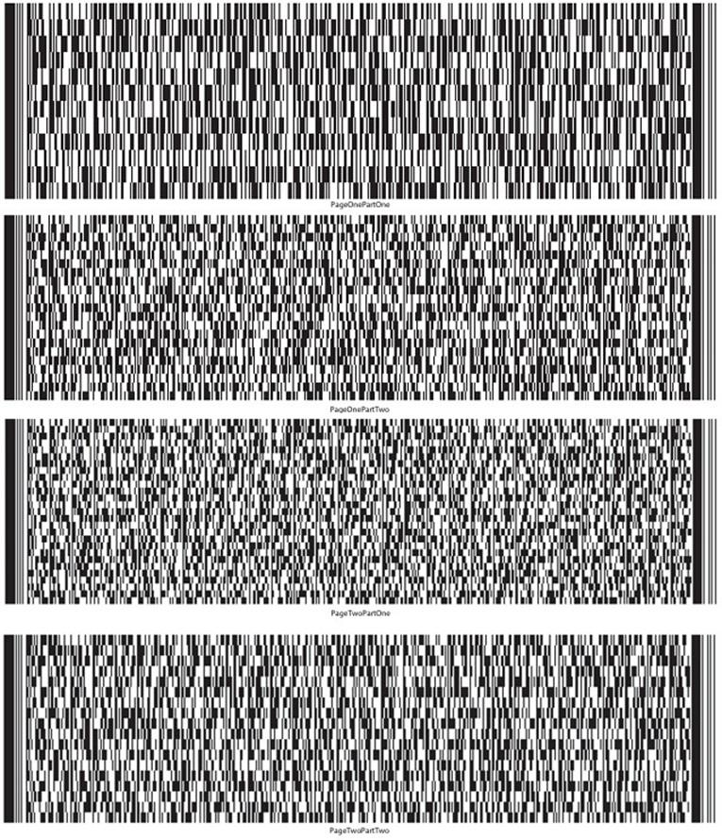

UST Form 11-MOR (12/01/2021) | 10

Debtor’s Name SANGAMO THERAPEUTICS, INC. Case No. 26-10989
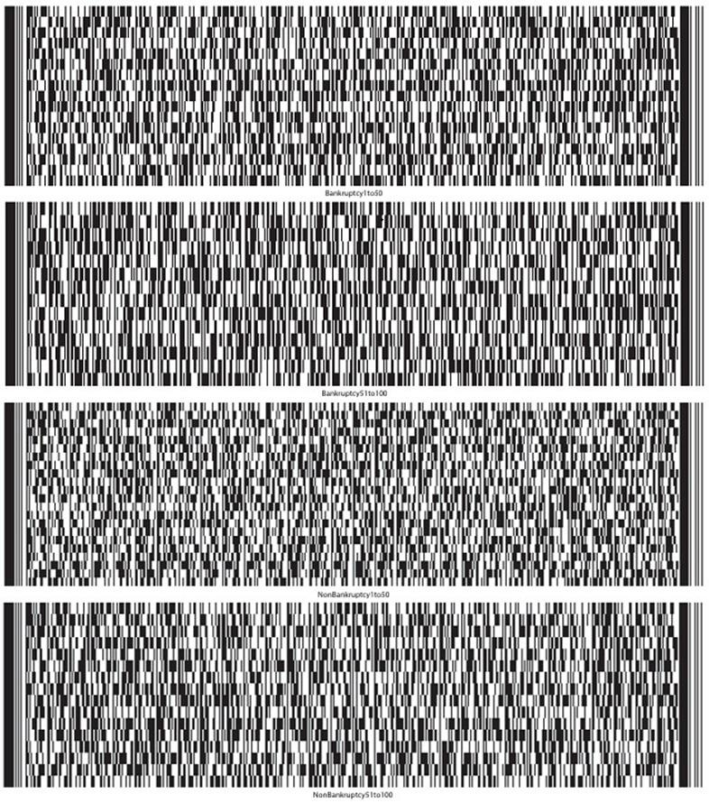

UST Form 11-MOR (12/01/2021) | 11

Debtor’s Name SANGAMO THERAPEUTICS, INC. Case No. 26-10989
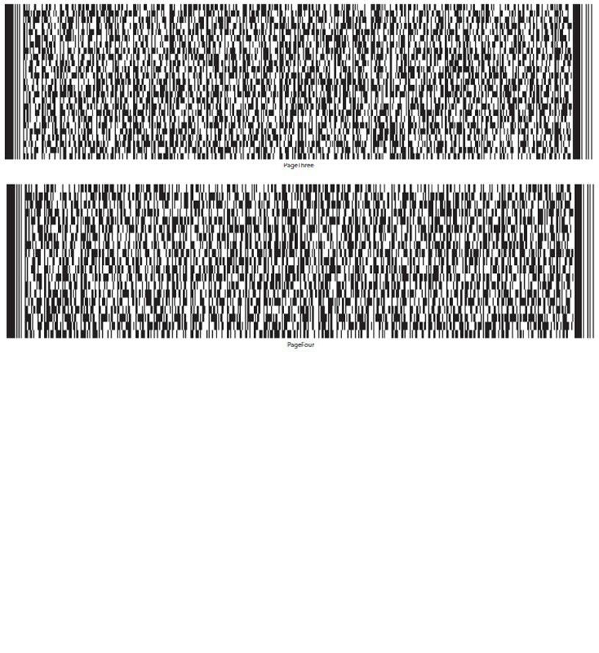

UST Form 11-MOR (12/01/2021) | 12

 | IN THE UNITED STATES BANKRUPTCY COURT
 | FOR THE DISTRICT DELAWARE
 | )
In re: | ) Chapter 11
 | )
SANGAMO THERAPEUTICS, INC. | ) Case No. 26-10989 (CTG)
 | )
Debtor.¹ | )
 | )

GLOBAL NOTES AND STATEMENT OF LIMITATIONS, METHODOLOGY, AND DISCLAIMERS REGARDING THE DEBTOR’S AMENDED² MONTHLY OPERATING REPORT

On June 23, 2026 (the “Petition Date”), Sangamo Therapeutics, Inc. (the “Debtor”) commenced the above-captioned chapter 11 case by filing a voluntary petition for relief under chapter 11 of title 11 of the United States Code (the “Bankruptcy Code”) with the United States Bankruptcy Court for the District of Delaware (the “Court”). The Debtor is authorized to operate its business as a debtor-in-possession pursuant to sections 1107(a) and 1108 of the Bankruptcy Code.

General Methodology

The Debtor is filing its monthly operating report (the “MOR”) for the period from August 1, 2026 through August 31, 2026 (the “Reporting Period”) for purposes of complying with the monthly reporting requirements applicable in the Debtor’s chapter 11 case. The MOR is unaudited and has not been prepared in accordance with accounting principles generally accepted in the United States of America (“U.S. GAAP”) and does not include all of the information and footnotes required by U.S. GAAP. The MOR is not intended to reconcile to any financial statements otherwise prepared or distributed by the Debtor. The MOR should not be relied upon by any persons for information relating to current or future financial condition, events, or performance of the Debtor or its affiliates, as the results of operations contained herein are not necessarily indicative of results which may be expected from any other period or for the full year and may not necessarily reflect the results of operations, financial position, and schedule of receipts and disbursements in the future.

- The Debtor and the last four digits of its taxpayer identification number are: Sangamo Therapeutics, Inc. (9556). The Debtor’s mailing address is

- This amended monthly operating report amends the August monthly operating report filed at Docket No. 513 to add information regarding payments inadvertently made to ordinary course professionals, as set forth in part 5(b) of the monthly operating report form and the attached attestation titled “Part 7(b) and 7(h) Payments Without Court Approval.”

Basis for Presentation

In preparing the MOR, the Debtor relied on financial information from its books and records at the time of such preparation. The financial information contained in the MOR is derived from the Debtor’s books and records without, among other things, all adjustments or reclassification that may be necessary or typical to accord with U.S. GAAP.

This information has not been subjected to procedures that would typically be applied to financial information presented in accordance with U.S. GAAP or any other recognized financial reporting framework. If such procedures were applied, the Debtor believes that the financial information presented in the MOR could be subject to change, including material change.

Although the Debtor made efforts to ensure the accuracy and completeness of the MOR, given the complexity of the Debtor’s business, inadvertent errors or omissions may occur. Accordingly, the Debtor hereby reserves all rights to dispute the nature, validity, status, enforceability, or executory nature of any claim amount, agreement, representation, or other statement set forth in the MOR. Further, the Debtor reserves the right to amend or supplement the MOR, if necessary, but shall be under no obligation to do so.

Moreover, given, among other things, the uncertainty surrounding the valuation and ownership of certain assets and the valuation and nature of certain liabilities, to the extent the Debtor shows more assets than liabilities, it is not an admission that the Debtor was solvent as of the Petition Date or at any time prior to the Petition Date. Likewise, to the extent the Debtor shows more liabilities than assets, it is not an admission that the Debtor was insolvent at the Petition Date or any time prior to the Petition Date.

For the reasons discussed above, there can be no assurance that the financial information presented in the MOR is complete, and readers are strongly cautioned not to place undue reliance on the MOR.

Each signatory to the MOR has necessarily relied upon the efforts, statements, advice, and representations of personnel of the Debtor and the Debtor’s advisors and professionals. Each signatory has not (and could not have) personally verified the accuracy of each such statement, representation, and answer contained in the MOR.

Reporting Period

Unless otherwise noted herein, the MOR generally reflects the Debtor’s books and records for the applicable Reporting Period. Unless otherwise noted herein, no adjustments have been made for activity occurring after the close of the Reporting Period.

Accuracy

The financial information disclosed in the MOR was not prepared in accordance with federal or state securities laws or other applicable non-bankruptcy law or in lieu of complying with any periodic reporting requirements thereunder. Persons and entities trading in or otherwise purchasing, selling, or transferring the claims against or equity interests in the Debtor should evaluate the financial information in light of the purposes for which it was prepared. The Debtor and its advisors are not liable for and undertake no responsibility to indicate variations from securities laws in the MOR or for any evaluations of the Debtor, including of their financial condition, based on this financial information or any other information.

Debtor in Possession Financing

On June 25, 2026, the Court entered the Interim Order (A) Authorizing the Debtor to Obtain Postpetition Financing, (B) Granting Liens and Providing Claims with Superpriority Administrative Expense Status, (C) Modifying Automatic Stay, (D) Scheduling Final Hearing, and (E) Granting Related Relief [Docket No. 63] (the “Initial Interim DIP Order”) authorizing the Debtor to enter into a senior secured superpriority debtor-in-possession term loan facility (the “Initial DIP Facility”). Prior to the Reporting Period, the Debtor drew $10,500,000 under the Initial DIP Facility. Please refer to the motion [Docket No. 10] seeking entry of the Initial Interim DIP Order for additional information regarding the Initial DIP Facility.

On July 23, 2026, the Court entered the Interim Order (A) Authorizing the Debtor to Obtain Replacement Postpetition Financing, (B) Granting Liens and Providing Claims with Superpriority Administrative Expense Status, (C) Modifying Automatic Stay, (D) Scheduling Final Hearing, and (E) Granting Related Relief [Docket No. 176] (the “Replacement Interim DIP Order”), which, among other things, authorized the Debtor to enter into a senior secured superpriority debtor-in possession term loan facility (the “Replacement DIP Facility”) with Future Solution Investments LLC (“FSI”), as lender, to replace the Initial DIP Facility. Prior to the Reporting Period, the Debtor incurred $18 million in DIP Obligations (as defined in the Replacement DIP Order) under the Replacement DIP Facility, $11,432,958 of which was paid by the Debtor or on the Debtor’s behalf to satisfy all outstanding obligations arising under the Initial DIP Facility, including all fees. Please refer to the motion [Docket No. 161] (the “Replacement DIP Motion”) seeking entry of the Replacement Interim DIP Order for additional information regarding the Replacement DIP Facility.

On August 20, 2026, the Court entered an order [Docket No. 360] (the “Replacement Final DIP Order,” and together with the Initial Interim DIP Order and the Replacement Interim DIP Order, the “DIP Orders”) granting the relief requested in the Replacement DIP Motion on a final basis. The Final Replacement DIP Order authorized the Debtor to borrow up to $35 million under the Replacement DIP Facility ($17 million more than was authorized by the Replacement Interim DIP Order). During the Reporting Period, (i) the Debtor drew $7 million in additional DIP Obligations under the Replacement Final DIP Order, and (ii) FSI credit bid $250,000 of DIP Obligations in connection with the FSI Equipment Sale (as defined below).

Payment of Prepetition Claims Pursuant to First Day Orders

Pursuant to certain interim orders of the Court entered on or about June 24, 2026 and final orders of the Court entered on or about July 21, 2026 (the “First Day Orders”), the Debtor is authorized (but not directed) to pay, among other things, certain prepetition claims of employees and taxing authorities. Accordingly, these liabilities may have been or may be satisfied in accordance with such First Day Orders. To the extent any payments were made on account of prepetition claims following the Petition Date pursuant to the authority granted to the Debtor under the First Day Orders, such payments have been included in the MOR (subject to the notes and statements and limitations provided herein).

Reservation of Rights

The Debtor reserves all rights to amend or supplement the MOR in all respects, as may be necessary or appropriate. Nothing contained in the MOR shall constitute a waiver of any of the Debtor’s rights or an admission with respect to any claim against the Debtor or otherwise in connection with this chapter 11 case.

Specific MOR Disclosures

Part 1: Cash Receipts and Disbursements

Pursuant to the DIP Orders, fees and expenses of estate professionals were placed into the Professional Fees Account (as defined in the DIP Orders) maintained by the Debtor. The transfer of such funds to the Professional Fee Account were treated as a transfer between Debtor accounts, and, therefore, were not treated as a distribution in Part 1(c). Professional fees will be treated as a disbursement in the reporting period in which they are paid to the applicable professionals.

Similarly, pursuant to the interim and final orders approving, among other things, the Debtor’s proposed form of adequate assurance of payment to utility companies [Docket Nos. 56 & 142] (the “Utilities Orders”), the Debtor deposited funds into the Utility Deposit Account (as defined in the Utilities Orders) prior to the Reporting Period. The Utility Deposit Account is a segregated account maintained by the Debtor. Accordingly, the funds in such account will be treated as disbursements only if they are ultimately paid to a third party.

Notes to Part 2: Asset and Liability Status

Unless otherwise noted, all asset and liability information included in the MOR reflects net book value, which may differ from current market value. As set forth above, this information has not been subjected to procedures that would typically be applied to financial information presented in accordance with U.S. GAAP or any other recognized financial reporting framework. If such procedures were applied, the Debtor believes that the financial information presented in the MOR could be subject to change, including material change. Asset and liability information includes intercompany claims and other assets and liabilities which may not be settled in cash.

The Debtor continues to pay postpetition invoices on account of postpetition goods provided and services rendered in the ordinary course of business.

Given the Petition Date did not occur at month end, certain prepetition and postpetition liability balances are estimated. The Debtor has sought to assign liabilities to the prepetition and postpetition periods based on the information available as of and at the time the MOR was prepared. As additional information becomes available, the allocation of liabilities between prepetition and postpetition periods may change. The Debtor reserves the right to amend the balances as it deems appropriate and any such amendments will be reflected in future MORs.

The amounts listed as “Prepetition Secured Debt,” “Prepetition Priority Debt” and “Prepetition Unsecured Debt” are preliminary and are subject to ongoing review and reconciliation by the Debtor. All amounts and classifications are subject to material adjustments.

Regarding Part 2c, the Debtor does not hold inventory; therefore, no inventory valuation method is applicable.

Note to Part 3: Assets Sold or Transferred

On August 20, 2026, the Court entered: (i) an order [Docket No. 356] approving the sale (the “Surplus Equipment Sale”) of certain equipment and

office furniture to Surplus Solutions, LLC for $2,300,000 plus certain other consideration, and (ii) an order [Docket No. 358] approving the sale (the

“FSI Equipment Sale,” and together with the Surplus Equipment Sale, the “Equipment Sales”) of certain lab equipment to FSI for an offset of

$250,000 against the DIP Obligations (as defined in the Replacement Final DIP Order) plus certain other consideration. Both equipment sales closed on

or about August 20, 2026.

Notes to Part 5: Professional Fees and Expenses

All payments to professionals were authorized by the Court’s orders approving the retention of various professionals in this Chapter 11 Case. For the Reporting Period, such amounts represent: (i) fees paid to Kurtzman Carson Consultants, LLC dba Verita Global for services performed and expenses incurred in connection with its retention as claims and noticing agent (see Docket No. 55), and (ii) a monthly fee payable to Raymond James & Associates, Inc., which is payable each month without a prior fee application (see Docket No. 276).

Notes to Part 6: Postpetition Taxes

Regarding Part 6c and 6d, postpetition employer payroll taxes accrued and paid include both the employer and employee portions of payroll taxes.

Notes to Part 7: Questionnaire

Please see attached attestations regarding post-petition borrowing, payments on prepetition debt, and payments to insiders.

UNITED STATES BANKRUPTCY COURT DISTRICT OF DELAWARE

Sangamo Therapeutics, Inc.

Schedule of Post-Petition Borrowing Activity

Case No: 26-10989

Reporting Period: August 1, 2026 – August 31, 2026

The Debtor hereby submits this attestation regarding postpetition borrowing during the period of August 1, 2026 through August 31, 2026.

Pursuant to the Final Order (A) Authorizing the Debtor to Obtain Replacement Postpetition Financing, (B) Granting Liens and Providing Claims with

Superpriority Administrative Expense Status, (C) Modifying Automatic Stay, (D) Scheduling Final Hearing, and (E) Granting Related Relief

[Docket No. 360] (the “Replacement Final DIP Order”) during the reporting period: (i) the Debtor incurred $7 million in DIP Obligations under the

Replacement DIP Facility (each as defined in the Replacement Final DIP Order), and (ii) FSI credit bid $250,000 of DIP Obligations in connection with

the FSI Equipment Sale.

/s/ Nikunj Jain |  | October 23, 2026
Signature of Authorized Individual |  |  | Date
Nikunj Jain |  | Interim Chief Financial Officer
Printed Name of Authorized Individual |  |  | Title of Authorized Individual

UNITED STATES BANKRUPTCY COURT DISTRICT OF DELAWARE

Sangamo Therapeutics, Inc.

Schedule of Payments on Prepetition Debt

Case No: 26-10989

Reporting Period: August 1, 2026 – August 31, 2026

All payments made by the Debtor during the Reporting Period (and included in the disbursements reported in this MOR) were authorized under various final orders granted by the Court, which authorized the Debtor’s various motions that were filed following the commencement of the chapter 11 case.

/s/ Nikunj Jain |  | October 23, 2026
Signature of Authorized Individual |  |  | Date
Nikunj Jain |  | Interim Chief Financial Officer
Printed Name of Authorized Individual |  |  | Title of Authorized Individual

UNITED STATES BANKRUPTCY COURT DISTRICT OF DELAWARE

Sangamo Therapeutics, Inc.

Part 7(b) and 7(h) Payments Without Court Approval

Case No: 26-10989

Reporting Period: July 1, 2026 – July 31, 2026

Payments made by the Debtor to Rothwell, Figg, Ernst & Manbeck, P.C. and Kilpatrick Townsend & Stockton LLP were inadvertently made prior to such firm’s retention as ordinary course professionals in accordance with the OCP Order [Docket No. 202].

/s/ Nikunj Jain |  | October 23, 2026
Signature of Authorized Individual |  |  | Date
Nikunj Jain |  | Interim Chief Financial Officer
Printed Name of Authorized Individual |  |  | Title of Authorized Individual

UNITED STATES BANKRUPTCY COURT DISTRICT OF DELAWARE

Sangamo Therapeutics, Inc.

Schedule of Payments to Insiders

Case No: 26-10989

Reporting Period: August 1, 2026 – August 31, 2026

The Debtor hereby submits this attestation regarding payments to insiders during the period of August 1, 2026 through August 31, 2026.

With respect to insiders, all cash payments made were on account of ordinary course salaries and authorized travel and expense reimbursements.

On July 31, 2026, the Court entered an order [Docket No. 216], among other things, authorizing the Debtor to implement a key employee retention program and a key employee incentive program (the “KEIP/KERP Programs”). No payments were made under the KEIP/KERP Programs to insiders or otherwise during the Reporting Period.

As set forth in the Debtor’s motion seeking authority to pay prepetition employee obligations [Docket No. 9], the Debtor maintained certain equity-based compensation programs prior to the Petition Date. Pursuant to such programs, certain employees, including certain executives that may be insiders, were awarded restricted stock units (the “RSUs”) prior to the Petition Date. During the Reporting Period, 213,628 RSUs awarded to 74 individuals prior to the Petition Date vested. For the avoidance of doubt, the Debtor stopped awarding RSUs prior to the Petition Date and no RSUs or any other form of equity-based compensation have been awarded since the Petition Date.

No other non-cash transfers were made during this reporting period.
/s/ Nikunj Jain |  | October 23, 2026
Signature of Authorized Individual |  |  | Date
Nikunj Jain |  | Interim Chief Financial Officer
Printed Name of Authorized Individual |  |  | Title of Authorized Individual

UNITED STATES BANKRUPTCY COURT DISTRICT OF DELAWARE

Sangamo Therapeutics, Inc.

All bank statements and bank reconciliations for the reporting period

Case No: 26-10989

Reporting Period: August 1, 2026 – August 31, 2026

The Debtor hereby submits this attestation regarding bank account reconciliations in lieu of providing copies of bank statements, bank reconciliations, and journal entries.

The Debtor’s standard practice is to ensure that bank reconciliations are completed as part of the month end close each reporting period. I attest that each of the Debtor’s bank accounts has been reconciled in accordance with its standard practices.

/s/ Nikunj Jain |  | October 23, 2026
Signature of Authorized Individual |  |  | Date
Nikunj Jain |  | Interim Chief Financial Officer
Printed Name of Authorized Individual |  |  | Title of Authorized Individual

UNITED STATES BANKRUPTCY COURT DISTRICT OF DELAWARE

Sangamo Therapeutics, Inc.

Assets Sold or Transferred

Case No: 26-10989

Reporting Period: August 1, 2026 – August 31, 2026

The Debtor hereby submits this attestation regarding assets sold or transferred during the period of August 1, 2026 through August 31, 2026.

On August 20, 2026, the Court entered: (i) an order [Docket No. 356] approving the sale (the “Surplus Equipment Sale”) of certain equipment and

office furniture to Surplus Solutions, LLC for $2,300,000 plus certain other consideration, and (ii) an order [Docket No. 358] approving the sale (the

“FSI Equipment Sale,” and together with the Surplus Equipment Sales, the “Equipment Sales”) of certain lab equipment to FSI for an offset of

$250,000 against the DIP Obligations (as defined in the Replacement Final DIP Order) plus certain other consideration. Both equipment sales closed on

or about August 20, 2026.

/s/ Nikunj Jain |  | October 23, 2026
Signature of Authorized Individual |  |  | Date
Nikunj Jain |  | Interim Chief Financial Officer
Printed Name of Authorized Individual |  |  | Title of Authorized Individual

Sangamo Therapeutics Inc.

MOR #3 - Statement of cash receipts and disbursements

$ in 000s

 | 07/01/2026 - |  |  |  | 08/01/2026 -
 | 07/31/2026 |  |  |  | 08/31/2026
Receipts
Receipts | $ |  | 59 |  | $ |  | 3,145
DIP Draw | $ |  | 18,000 |  | $ |  | 7,000
Total Receipts |  | $ | 18,059 |  |  | $ | 10,145
Operational Disbursements
Payroll & Benefits | $ |  | 1,747 |  | $ |  | 1,693
Rent & Facilities |  |  | 1,348 |  |  |  | 319
Program Costs |  |  | 319 |  |  |  | 226
International Operations |  |  | 416 |  |  |  | 240
Other Operating Disbursements |  |  | 271 |  |  |  | 579
Total Operational Disbursements | $ |  | 4,101 |  | $ |  | 3,057
Restructuring Disbursements
Professional Fees |  |  | — |  | $ |  | 515
US Trustee Fees |  |  | — |  |  |  | 4
DIP Interest & Fees |  |  | 933 |  |  |  | 250
DIP Repayments |  |  | 10,500 |  |  |  | —
Total Restructuring Disbursements | $ |  | 11,433 |  | $ |  | 769
Net Cash Flow | $ |  | 2,525 |  | $ |  | 6,319
Cash, cash equivalents, and restricted cash, beginning of period | $ |  | 14,382 |  | $ |  | 16,907
Cash, cash equivalents, and restricted cash, end of period |  | $ | 16,907 |  |  | $ | 23,226
 | 1 of 4

Sangamo Therapeutics Inc.

MOR #3 - Balance sheet

$ in 000s

 |  |  |  | As of
 |  |  | 07/31/2026 |  | 08/31/2026
Assets
Cash, Cash Equivalents and Restricted Cash | $ |  | 16,910 |  | $ | 23,197
Accounts Receivables |  |  | 500 |  |  | 90
Other Current Assets |  |  | 2,977 |  |  | 2,111
Total Current Assets | $ |  | 20,387 |  | $ | 25,399
Property, Plant & Equipment (Net) | $ |  | 9,430 |  | $ | 2
Right of Use Assets³ |  |  | 2,694 |  |  | —
Other Non-Current Assets |  |  | 779 |  |  | 613
Investments in Subsidiaries |  |  | 115,762 |  |  | 115,762
I/C Receivables - Non-Current |  |  | 6,067 |  |  | 6,106
Total Non-Current Assets | $ |  | 134,731 |  | $ | 122,483
Total Assets |  | $ | 155,118 |  | $ | 147,882
Liabilities and Stockholders’ Equity
A/P and Accrued Liabilities | $ |  | 36,735 |  | $ | 44,182
Compensation and Benefits Liabilities |  |  | 17,304 |  |  | 17,397
DIP Loan Payables² |  |  | 18,000 |  |  | 24,942
Other Current Liabilities¹ |  |  | 8,713 |  |  | 9,723
I/C Payables - Current |  |  | 42,687 |  |  | 42,903
Other Non-Current Liabilities¹ |  |  | 23,240 |  |  | 14,754
I/C Payables - Non-Current |  |  | 703 |  |  | 708
Total Liabilities | $ |  | 147,383 |  | $ | 154,609
Stock | $ |  | 1,643,342 |  | $ | 1,643,328
Retained Earnings |  |  | (1,564,836) |  |  | (1,564,836)
Other Equity |  |  | (30) |  |  | (30)
Net Income |  |  | (70,741) |  |  | (85,190)
Total Stockholders’ Equity | $ |  | 7,735 |  | ($ | 6,727)
Total Liabilities and Stockholders’ Equity | $ |  | 155,118 |  | $ | 147,882

Notes:

- Includes:

  - Deferred Revenues

  - Lease Liabilities; the Richmond lease is presented as a one-year liability, estimated for lease rejection purposes

- Includes accrued August DIP interest of $192K (paid 9/2); net of FSI’s $250K lab equipment credit bid

- Fully written off in August in connection with the wind-down of Richmond facility

2 of 4

Sangamo Therapeutics Inc.

MOR #3 - Statement of operations (profit or loss statement)

$ in 000s

 | 07/01/2026 - |  |  |  |  | 08/01/2026 -
 | 07/31/2026 |  |  |  |  | 08/31/2026
Total Revenue |  | $ | 720 |  |  |  | $ | 430
COGS |  |  | — |  |  |  |  | —
Gross Profit | $ |  | 720 |  |  | $ |  | 430
Personnel & Staffing Costs¹ | $ |  | 1,931 |  |  | $ |  | 1,693
R&D Expenses² |  |  | 3,184 |  |  |  |  | 473
Selling Expenses |  |  | — |  |  |  |  | —
General and Administrative Expenses⁴ |  |  | 863 |  |  |  |  | 1,037
Facilities & OH Expenses¹ |  |  | 972 |  |  |  |  | 950
I/C Expenses² |  |  | 28 |  |  |  |  | 127
Other Expenses² |  |  | 19 |  |  |  |  | 3
Interest Expense |  |  | 105 |  |  |  |  | 192
Restructuring Expenses³ |  |  | 4,244 |  |  |  |  | 9,980
Depreciation and/or amortization |  |  | 216 |  |  |  |  | 138
Total Operating Expenses |  | $ | 11,562 |  |  |  | $ | 14,592
Unrealized FX (Gain)/Loss | $ |  | 336 |  |  | $ |  | 292
Non-Operating (Income)/Expense |  |  | (12) |  |  |  |  | (5)
Total Non-Operating (Income)/Expense | $ |  | 323 |  |  | $ |  | 287
Net Profit/(Loss) for the Period |  | ($ | 11,165 | ) |  |  | ($ | 14,449 | )

Notes:

- Considered under “General and Administrative Expenses” for MOR

- Considered under “Other Expenses” for MOR

- Includes professional fees and asset write-offs/disposals, net of lease rejection gains

- Includes D&O insurance expense for prior months not previously recognized, recorded in August

3 of 4

Sangamo Therapeutics Inc.

MOR #3 - Detailed explanations

Part 2 - Question C - Inventory

Sangamo does not hold inventory; therefore, no inventory valuation method is applicable

Part 7 - Question G - Was there any postpetition borrowing, other than trade credit?

Detail |  | Date |  | Payee/Lender Name |  | Amount
DIP draw |  | 8/21/2026 |  | Future Solution Investments LLC |  | $ 7,000,000
 |  |  |  | 4 of 4

Miscellaneous:

26-10989-CTG Sangamo Therapeutics, Inc.

Type: bk

Assets: y

Chapter: 11 v

Judge: CTG

Office: 1 (Delaware)

Case Flag: CLMSAGNT, LeadSC, PlnDue, DsclsDue, STANDOrder, SealedDoc(s)

U.S. Bankruptcy Court

District of Delaware

Notice of Electronic Filing

The following transaction was received from James McCauley entered on 10/23/2026 at 1:03 PM EDT and filed on 10/23/2026

Case Name: | Sangamo Therapeutics, Inc.
Case Number: | 26-10989-CTG
Document Number: | 538

Docket Text:

Amended Chapter 11 Monthly Operating Report for the Month Ending: 08/31/2026 (related document(s)[513]) Filed by Sangamo Therapeutics, Inc.. (McCauley, James)

The following document(s) are associated with this transaction:

Document description:Main Document

Original filename:SGMO - August 2026 MOR [AMENDED].pdf

Electronic document Stamp:

[STAMP bkecfStamp_ID=983460418 [Date=10/23/2026] [FileNumber=20049567- 0] [69bdb41297fe57581063fc1b02a27c05cfe148b80b016323f14884f454e676452d c3558b420144fafd3a3b88f7bf8f2480d23e562f046a964696f82bb68edf46]]

26-10989-CTG Notice will be electronically mailed to:

Jacob A. Adlerstein on behalf of Interested Party Eli Lilly and Company

jadlerstein@paulweiss.com

Elihu Ezekiel Allinson, III on behalf of Interested Party Shire Human Genetic Therapies, Inc.

ZAllinson@SHA-LLC.com, ecf@williamdsullivanllc.com;hcoleman@sha-llc.com

Olya Antle on behalf of Debtor Sangamo Therapeutics, Inc. oantle@cooley.com, efilingnotice@cooley.com;efiling-notice@ecf.pacerpro.com

Joseph N. Argentina, Jr. on behalf of Creditor VWR International, LLC

joseph.argentina@faegredrinker.com, cathy.greer@faegredrinker.com

Darren Azman on behalf of Creditor Committee Official Committee of Unsecured Creditors of Sangamo Therapeutics, Inc. dazman@mcdermottlaw.com

Joshua Brooks on behalf of Interested Party PTC Therapeutics, Inc.

brooks@lrclaw.com, ramirez@lrclaw.com;huynh@lrclaw.com;hitchens@lrclaw.com;ford@lrclaw.com;kittinger@lrclaw.com

Kate R. Buck on behalf of Interested Party Astellas Gene Therapies, Inc.

kbuck@mccarter.com

Linda J. Casey on behalf of U.S. Trustee U.S. Trustee

Linda.Casey@usdoj.gov

Austin Chavez on behalf of Interested Party PTC Therapeutics, Inc.

austin.chavez@wilmerhale.com, Mike.McGuinness@wilmerhale.com

Shawn M. Christianson on behalf of Creditor Oracle America, Inc.

schristianson@buchalter.com, cmcintire@buchalter.com

James A. Copeland on behalf of Interested Party Northridge ATM, LLC

james.copeland@nortonrosefulbright.com

Kristin Cunningham on behalf of Debtor Sangamo Therapeutics, Inc. cunningham@rlf.com, rbgroup@rlf.com;rebecca--speaker-6328@ecf.pacerpro.com

Daniel J. DeFranceschi on behalf of Debtor Sangamo Therapeutics, Inc.

defranceschi@rlf.com, RBGroup@rlf.com;ann-jerominski-2390@ecf.pacerpro.com;rebecca--speaker-6328@ecf.pacerpro.com

Robert J. Dehney on behalf of Interested Party Eli Lilly and Company

rdehney@morrisnichols.com, robert-dehney-4464@ecf.pacerpro.com;jlawrence@morrisnichols.com;john-lawrence-0804@ecf.pacerpro.com;rchevli@morrisnichols.com;radha--chevli--2257@ecf.pacerpro.com

Brenna Anne Dolphin on behalf of Interested Party Eli Lilly and Company bdolphin@morrisnichols.com, brenna-dolphin-9491@ecf.pacerpro.com;john-lawrence-

0804@ecf.pacerpro.com;jlawrence@morrisnichols.com;rchevli@morrisnichols.com;radha--chevli--2257@ecf.pacerpro.com Andrew C. Ehrmann on behalf of Interested Party Northridge ATM, LLC

 |  |  |  |  |  |  |  |  |  |  |  |  | Exhibit 99.3
 |  |  |  | UNITED STATES BANKRUPTCY COURT
 |  |  |  |  |  |  |  |  |  | DISTRICT OF DELAWARE
In Re. SANGAMO THERAPEUTICS, INC. |  |  |  | § |  |  |  |  |  | Case No. 26-10989
 |  |  |  | §
 |  |  |  | §
 | Debtor(s) |  |  | § |  |  |  |  |  | ☐ Jointly Administered
Monthly Operating Report |  |  |  |  |  |  |  |  |  |  |  |  | Chapter 11
Reporting Period Ended: 09/30/2026 |  |  |  |  |  |  |  |  |  |  |  | Petition Date: | 06/23/2026
Months Pending: 3 |  |  |  |  |  |  |  |  |  |  |  | Industry Classification:
Reporting Method: |  | Accrual Basis |  |  |  |  |  |  |  | Cash Basis
Debtor’s Full-Time Employees (current): |  |  |  |  |  |  |  |  |  | 13
Debtor’s Full-Time Employees (as of date of order for relief): |  |  |  |  |  |  |  |  |  | 74

Supporting Documentation (check all that are attached):

(For jointly administered debtors, any required schedules must be provided on a non-consolidated basis for each debtor)

- Statement of cash receipts and disbursements

- Balance sheet containing the summary and detail of the assets, liabilities and equity (net worth) or deficit

- Statement of operations (profit or loss statement)

- Accounts receivable aging

- Postpetition liabilities aging

- Statement of capital assets

- Schedule of payments to professionals

- Schedule of payments to insiders

- All bank statements and bank reconciliations for the reporting period

- Description of the assets sold or transferred and the terms of the sale or transfer

/s/ Nikunj Jain |  | Nikunj Jain
Signature of Responsible Party |  | Printed Name of Responsible Party
10/23/2026
Date
 |  | 501 Canal Blvd., Suite A100 Richmond, CA 94804
 |  | Address

STATEMENT: This Periodic Report is associated with an open bankruptcy case; therefore, Paperwork Reduction Act exemption 5 C.F.R. §1320.4(a)(2) applies.

 |  | Docket No. 536
UST Form 11-MOR (12/01/2021) | 1 | Filed: 10/23/26

Debtor’s Name SANGAMO THERAPEUTICS, INC. |  |  |  |  |  |  |  |  |  | Case No. 26-10989
Part 1: Cash Receipts and Disbursements |  |  |  |  |  |  | Current Month |  |  |  |  | Cumulative
a. | Cash balance beginning of month |  |  |  |  |  | $ | 23,225,696
b. | Total receipts (net of transfers between accounts) |  |  |  |  |  | $161,393,899 |  |  | $ |  | 200,101,393
c. | Total disbursements (net of transfers between accounts) |  |  |  |  |  | $ | 46,165,309 |  | $ |  | 66,504,211
d. | Cash balance end of month (a+b-c) |  |  |  |  |  | $138,454,286
e. | Disbursements made by third party for the benefit of the estate |  |  |  |  |  | $ | 0 |  | $ |  | 0
f. | Total disbursements for quarterly fee calculation (c+e) |  |  |  |  |  | $ | 46,165,309 |  |  | $ | 66,504,211
Part 2: Asset and Liability Status
(Not generally applicable to Individual Debtors. See Instructions.) |  |  |  |  |  |  | Current Month
a. | Accounts receivable (total net of allowance) |  |  |  |  |  | $ | 90,355
b. | Accounts receivable over 90 days outstanding (net of allowance) |  |  |  |  |  | $ | 90,355
c. | Inventory( Book | Market |  | Other | (attach explanation)) |  | $ | 0
d | Total current assets |  |  |  |  |  | $141,885,264
e. | Total assets |  |  |  |  |  | $264,234,115
f. | Postpetition payables (excluding taxes) |  |  |  |  |  | $ | 21,177,667
g. | Postpetition payables past due (excluding taxes) |  |  |  |  |  | $ | 202,840
h. | Postpetition taxes payable |  |  |  |  |  | $ | 72,229
i. | Postpetition taxes past due |  |  |  |  |  | $ | 0
j. | Total postpetition debt (f+h) |  |  |  |  |  | $ | 21,249,896
k. | Prepetition secured debt |  |  |  |  |  | $ | 0
l. | Prepetition priority debt |  |  |  |  |  | $ | 32,543
m. | Prepetition unsecured debt |  |  |  |  |  | $ | 61,623,747
n. | Total liabilities (debt) (j+k+l+m) |  |  |  |  |  | $ | 82,906,186
o. | Ending equity/net worth (e-n) |  |  |  |  |  | $181,327,929
Part 3: Assets Sold or Transferred |  |  |  |  |  |  | Current Month |  |  |  |  | Cumulative
a. | Total cash sales price for assets sold/transferred outside the ordinary course of business |  |  |  |  |  | $161,000,000 |  |  |  | $ | 163,300,000
b. | Total payments to third parties incident to assets being sold/transferred outside the ordinary course of business |  |  |  |  |  | $ | 32,171,714 |  |  | $ | 32,171,714
c. | Net cash proceeds from assets sold/transferred outside the ordinary course of business (a-b) |  |  |  |  |  | $128,828,286 |  |  | $ |  | 131,128,286
Part 4: Income Statement (Statement of Operations)
(Not generally applicable to Individual Debtors. See Instructions.) |  |  |  |  |  |  | Current Month |  |  |  |  | Cumulative
a. | Gross income/sales (net of returns and allowances) |  |  |  |  |  | $161,062,325
b. | Cost of goods sold (inclusive of depreciation, if applicable) |  |  |  |  |  | $ | 0
c. | Gross profit (a-b) |  |  |  |  |  | $161,062,325
d. | Selling expenses |  |  |  |  |  | $ | 0
e. | General and administrative expenses |  |  |  |  |  | $ | 2,655,227
f. | Other expenses |  |  |  |  |  | $ | 630,915
g. | Depreciation and/or amortization (not included in 4b) |  |  |  |  |  | $ | 0
h. | Interest |  |  |  |  |  | $ | 169,896
i. | Taxes (local, state, and federal) |  |  |  |  |  | $ | 0
j. | Reorganization items |  |  |  |  |  | $ | 14,622,578
k. | Profit (loss) |  |  |  |  |  | $143,792,625 |  |  | $ |  | 114,423,239
UST Form 11-MOR (12/01/2021) |  |  |  |  | 2

Debtor’s Name SANGAMO THERAPEUTICS, INC. |  |  |  |  |  |  | Case No. 26-10989
Part 5: Professional Fees and Expenses
 |  |  |  |  | Approved | Approved | Paid Current | Paid
a. |  |  |  |  | Current Month | Cumulative | Month | Cumulative
a. | Debtor’s professional fees & expenses (bankruptcy) Aggregate Total |  |  |  | $419,718 | $935,117 | $419,718 | $935,117
 | Itemized Breakdown by Firm
 |  | Firm Name |  | Role
 | i | Raymond James |  | Financial Professional | $75,000 | $250,000 | $75,000 | $250,000
 | ii | Verita |  | Other | $344,718 | $685,117 | $344,718 | $685,117
 | iii
 | iv
 | v
 | vi
 | vii
 | viii
 | ix
 | x
 | xi
 | xii
 | xiii
 | xiv
 | xv
 | xvi
 | xvii
 | xviii
 | xix
 | xx
 | xxi
 | xxii
 | xxiii
 | xxiv
 | xxv
 | xxvi
 | xxvii
 | xxviii
 | xxix
 | xxx
 | xxxi
 | xxxii
 | xxxiii
 | xxxiv
 | xxxv
 | xxxvi
UST Form 11-MOR (12/01/2021) |  |  | 3
Debtor’s Name SANGAMO THERAPEUTICS, INC. |  |  |  |  |  |  | Case No. 26-10989
 | xxxvii
 | xxxviii
 | xxxix
 | xl
 | xli
 | xlii
 | xliii
 | xliv
 | xlv
 | xlvi
 | xlvii
 | xlviii
 | xlix
 | l
 | li
 | lii
 | liii
 | liv
 | lv
 | lvi
 | lvii
 | lviii
 | lix
 | lx
 | lxi
 | lxii
 | lxiii
 | lxiv
 | lxv
 | lxvi
 | lxvii
 | lxviii
 | lxix
 | lxx
 | lxxi
 | lxxii
 | lxxiii
 | lxxiv
 | lxxv
 | lxxvi
 | lxxvii
 | lxxviii
UST Form 11-MOR (12/01/2021) |  |  | 4
Debtor’s Name SANGAMO THERAPEUTICS, INC. Case No. 26-10989

lxxix


lxxx

lxxxi

lxxxii

lxxxiii

lxxxiv

lxxxv

lxxxvi

lxxxvii

lxxxviii

lxxxix

xc

xci

xcii

xciii

xciv

xcv

xcvi

xcvii

xcviii

xcix

c

ci

 |  |  |  |  | Approved | Approved | Paid Current | Paid
 |  |  |  |  | Current Month | Cumulative | Month | Cumulative
b. | Debtor’s professional fees & expenses (nonbankruptcy) Aggregate Total |  |  |  | $75,228 | $75,228 | $63,029 | $75,228
 | Itemized Breakdown by Firm
 |  | Firm Name |  | Role
 | i | Rothwell, Figg, Ernst & Manbec |  | Special Counsel | $11,988 | $11,988 | $ 0 | $11,988
 | ii | Daijogo & Pedersen, LLP |  | Special Counsel | $ 818 | $ 818 | $ 765 | $ 818
 | iii | Kilpatrick Townsend & Stockto |  | Special Counsel | $ 2,600 | $ 2,600 | $ 2,442 | $ 2,600
 | iv | Snell & Wilmer L.L.P. |  | Special Counsel | $33,144 | $33,144 | $33,144 | $33,144
 | v | Foley & Lardner LLP |  | Special Counsel | $24,486 | $24,486 | $24,486 | $24,486
 | vi | Leason Ellis LLP |  | Special Counsel | $ 2,192 | $ 2,192 | $ 2,192 | $ 2,192
 | vii
 | viii
 | ix
 | x
 | xi
 | xii
 | xiii
 | xiv
UST Form 11-MOR (12/01/2021) |  |  | 5

Debtor’s Name SANGAMO THERAPEUTICS, INC. Case No. 26-10989

- xv xvi xvii xviii xix xx xxi xxii xxiii xxiv xxv xxvi xxvii xxviii xxix xxx xxxi xxxii xxxiii xxxiv xxxv xxxvi xxxvii xxxviii xxxix xl

xli xlii xliii xliv xlv xlvi xlvii xlviii xlix l
li lii liii liv lv lvi


UST Form 11-MOR (12/01/2021) | 6

Debtor’s Name SANGAMO THERAPEUTICS, INC. |  |  |  |  |  |  | Case No. 26-10989
 | lvii
 | lviii
 | lix
 | lx
 | lxi
 | lxii
 | lxiii
 | lxiv
 | lxv
 | lxvi
 | lxvii
 | lxviii
 | lxix
 | lxx
 | lxxi
 | lxxii
 | lxxiii
 | lxxiv
 | lxxv
 | lxxvi
 | lxxvii
 | lxxviii
 | lxxix
 | lxxx
 | lxxxi
 | lxxxii
 | lxxxiii
 | lxxxiv
 | lxxxv
 | lxxxvi
 | lxxxvii
 | lxxxviii
 | lxxxix
 | xc
 | xci
 | xcii
 | xciii
 | xciv
 | xcv
 | xcvi
 | xcvii
 | xcviii
 | xcix
 | c
c. All professional fees and expenses (debtor & committees) |  |  |  |  | $1,291,252 | $1,806,651 | $1,120,363 | $1,647,960
UST Form 11-MOR (12/01/2021) |  |  | 7

Debtor’s Name SANGAMO THERAPEUTICS, INC. |  |  |  | Case No. 26-10989
Part 6: Postpetition Taxes |  |  | Current Month |  |  |  | Cumulative
a. | Postpetition income taxes accrued (local, state, and federal) |  | $ | 0 |  |  | $ | 0
b. | Postpetition income taxes paid (local, state, and federal) |  | $ | 0 |  |  | $ | 0
c. | Postpetition employer payroll taxes accrued |  | $ | 72,229 |  | $ |  | 565,817
d. | Postpetition employer payroll taxes paid |  | $ | 2,378,080 |  |  | $ | 3,255,413
e. | Postpetition property taxes paid |  | $ | 0 |  | $ |  | 361,948
f. | Postpetition other taxes accrued (local, state, and federal) |  | $ | 65,905 |  |  | $ | 220,056
g. | Postpetition other taxes paid (local, state, and federal) |  | $ | 0 |  | $ |  | 0

Part 7: Questionnaire - During this reporting period:

a. | Were any payments made on prepetition debt? (if yes, see Instructions) |  |  |  | Yes | No
b. | Were any payments made outside the ordinary course of business without court |  |  |  | Yes | No
 | approval? (if yes, see Instructions)
c. | Were any payments made to or on behalf of insiders? |  |  |  | Yes | No
d. | Are you current on postpetition tax return filings? |  |  |  | Yes | No
e. | Are you current on postpetition estimated tax payments? |  |  |  | Yes | No
f. | Were all trust fund taxes remitted on a current basis? |  |  |  | Yes | No
g. | Was there any postpetition borrowing, other than trade credit? (if yes, see |  |  |  | Yes | No
 | Instructions)
h. | Were all payments made to or on behalf of professionals approved by the court? |  |  |  | Yes | No
i. | Do you have: | Worker’s compensation insurance? |  |  | Yes | No
 |  |  | If yes, are your premiums current? |  | Yes | No
 |  | Casualty/property insurance? |  |  | Yes | No
 |  |  | If yes, are your premiums current? |  | Yes | No
 | General liability insurance? |  |  |  | Yes | No
 |  |  | If yes, are your premiums current? |  | Yes | No
j. | Has a plan of reorganization been filed with the court? |  |  |  | Yes | No
k. | Has a disclosure statement been filed with the court? |  |  |  | Yes | No
l. | Are you current with quarterly U.S. Trustee fees as set forth under 28 U.S.C. § |  |  |  | Yes | No
 | 1930?
UST Form 11-MOR (12/01/2021) |  |  |  | 8

N/A

N/A (if no, see Instructions)

N/A (if no, see Instructions)

N/A (if no, see Instructions)

Debtor’s Name SANGAMO THERAPEUTICS, INC. |  |  |  |  | Case No. 26-10989
Part 8: Individual Chapter 11 Debtors (Only)
a. | Gross income (receipts) from salary and wages |  |  |  | $ |  |  |  | 0
b. | Gross income (receipts) from self-employment |  |  |  |  | $ |  |  | 0
c. | Gross income from all other sources |  |  |  | $ |  |  |  | 0
d. | Total income in the reporting period (a+b+c) |  |  |  |  | $ |  |  | 0
e. | Payroll deductions |  |  |  | $ |  |  |  | 0
f. | Self-employment related expenses |  |  |  |  | $ |  |  | 0
g. | Living expenses |  |  |  | $ |  |  |  | 0
h. | All other expenses |  |  |  |  | $ |  |  | 0
i. | Total expenses in the reporting period (e+f+g+h) |  |  |  | $ |  |  |  | 0
j. | Difference between total income and total expenses (d-i) |  |  |  |  | $ |  |  | 0
k. | List the total amount of all postpetition debts that are past due |  |  |  | $ |  |  |  | 0
l. | Are you required to pay any Domestic Support Obligations as defined by 11 U.S.C § 101(14A)? |  | Yes | No
m. If yes, have you made all Domestic Support Obligation payments? |  |  | Yes | No | N/A

Privacy Act Statement

28 U.S.C. § 589b authorizes the collection of this information, and provision of this information is mandatory under 11 U.S.C. §§ 704, 1106, and 1107. The United States Trustee will use this information to calculate statutory fee assessments under 28 U.S.C. § 1930(a)(6). The United States Trustee will also use this information to evaluate a chapter 11 debtor’s progress through the bankruptcy system, including the likelihood of a plan of reorganization being confirmed and whether the case is being prosecuted in good faith. This information may be disclosed to a bankruptcy trustee or examiner when the information is needed to perform the trustee’s or examiner’s duties or to the appropriate federal, state, local, regulatory, tribal, or foreign law enforcement agency when the information indicates a violation or potential violation of law. Other disclosures may be made for routine purposes. For a discussion of the types of routine disclosures that may be made, you may consult the Executive Office for United States Trustee’s systems of records notice, UST-001, “Bankruptcy Case Files and Associated Records.” See 71 Fed. Reg. 59,818 et seq. (Oct. 11, 2006). A copy of the notice may be obtained at the following link: http://www.justice.gov/ust/ eo/rules_regulations/index.htm. Failure to provide this information could result in the dismissal or conversion of your bankruptcy case or other action by the United States Trustee. 11 U.S.C. § 1112(b)(4)(F).

I declare under penalty of perjury that the foregoing Monthly Operating Report and its supporting documentation are true and correct and that I have been authorized to sign this report on behalf of the estate.

/s/ Nikunj Jain |  | Nikunj Jain
Signature of Responsible Party |  |  | Printed Name of Responsible Party
Interim Chief Financial Officer |  | 10/23/2026
Title |  |  | Date
UST Form 11-MOR (12/01/2021) | 9

Debtor’s Name SANGAMO THERAPEUTICS, INC. Case No. 26-10989
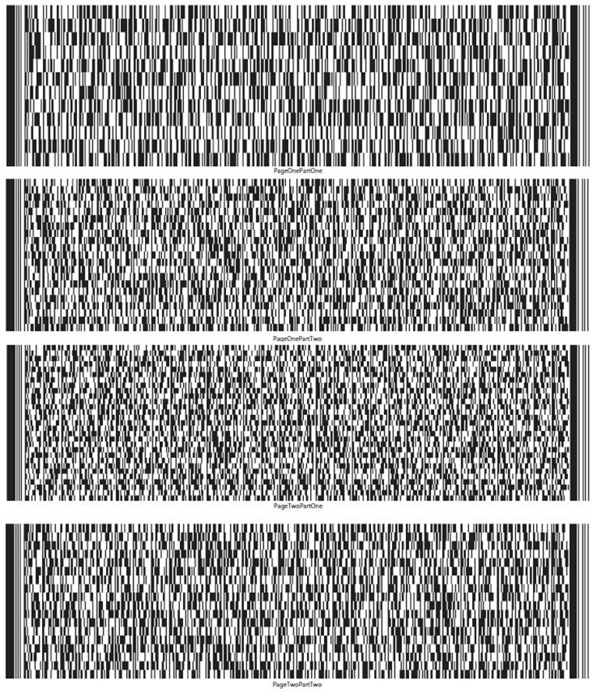

UST Form 11-MOR (12/01/2021) | 10

Debtor’s Name SANGAMO THERAPEUTICS, INC. Case No. 26-10989
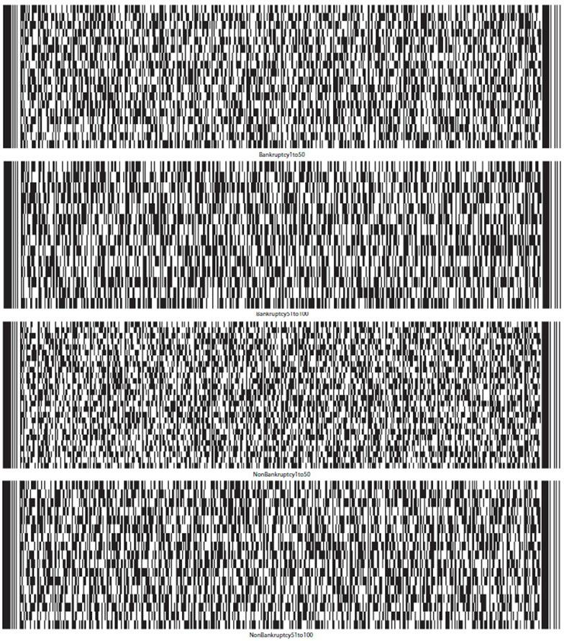

UST Form 11-MOR (12/01/2021) | 11

Debtor’s Name SANGAMO THERAPEUTICS, INC. Case No. 26-10989
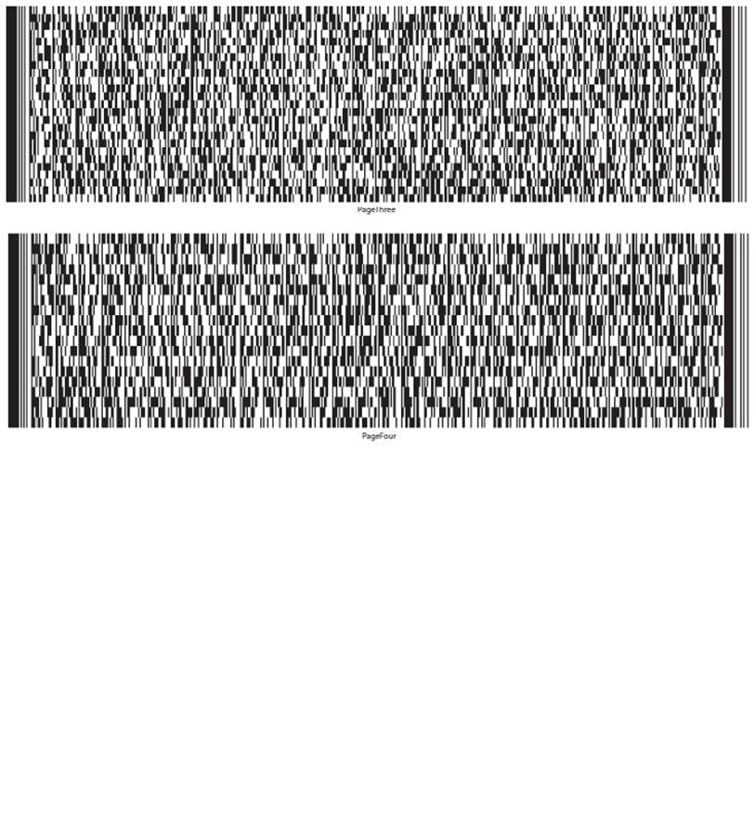

UST Form 11-MOR (12/01/2021) | 12

 | IN THE UNITED STATES BANKRUPTCY COURT
 | FOR THE DISTRICT DELAWARE
 | )
In re: | ) Chapter 11
 | )
SANGAMO THERAPEUTICS, INC. | ) Case No. 26-10989 (CTG)
 | )
Debtor.¹ | )
 | )

GLOBAL NOTES AND STATEMENT OF LIMITATIONS, METHODOLOGY, AND

DISCLAIMERS REGARDING THE DEBTOR’S MONTHLY OPERATING REPORT

On June 23, 2026 (the “Petition Date”), Sangamo Therapeutics, Inc. (the “Debtor”) commenced the above-captioned chapter 11 case by filing a voluntary petition for relief under chapter 11 of title 11 of the United States Code (the “Bankruptcy Code”) with the United States Bankruptcy Court for the District of Delaware (the “Court”). The Debtor is authorized to operate its business as a debtor-in-possession pursuant to sections 1107(a) and 1108 of the Bankruptcy Code.

General Methodology

The Debtor is filing its monthly operating report (the “MOR”) for the period from September 1, 2026 through September 30, 2026 (the

“Reporting Period”) for purposes of complying with the monthly reporting requirements applicable in the Debtor’s chapter 11 case. The MOR is

unaudited and has not been prepared in accordance with accounting principles generally accepted in the United States of America (“U.S. GAAP”) and

does not include all of the information and footnotes required by U.S. GAAP. The MOR is not intended to reconcile to any financial statements

otherwise prepared or distributed by the Debtor. The MOR should not be relied upon by any persons for information relating to current or future

financial condition, events, or performance of the Debtor or its affiliates, as the results of operations contained herein are not necessarily indicative of

results which may be expected from any other period or for the full year and may not necessarily reflect the results of operations, financial position, and

schedule of receipts and disbursements in the future.

Basis for Presentation

In preparing the MOR, the Debtor relied on financial information from its books and records at the time of such preparation. The financial information contained in the MOR is derived from the Debtor’s books and records without, among other things, all adjustments or reclassification that may be necessary or typical to accord with U.S. GAAP.

- The Debtor and the last four digits of its taxpayer identification number are: Sangamo Therapeutics, Inc. (9556). The Debtor’s mailing address is 7000 Marina Blvd, Brisbane, CA 94005.

This information has not been subjected to procedures that would typically be applied to financial information presented in accordance with U.S. GAAP or any other recognized financial reporting framework. If such procedures were applied, the Debtor believes that the financial information presented in the MOR could be subject to change, including material change.

Although the Debtor made efforts to ensure the accuracy and completeness of the MOR, given the complexity of the Debtor’s business, inadvertent errors or omissions may occur. Accordingly, the Debtor hereby reserves all rights to dispute the nature, validity, status, enforceability, or executory nature of any claim amount, agreement, representation, or other statement set forth in the MOR. Further, the Debtor reserves the right to amend or supplement the MOR, if necessary, but shall be under no obligation to do so.

Moreover, given, among other things, the uncertainty surrounding the valuation and ownership of certain assets and the valuation and nature of certain liabilities, to the extent the Debtor shows more assets than liabilities, it is not an admission that the Debtor was solvent as of the Petition Date or at any time prior to the Petition Date. Likewise, to the extent the Debtor shows more liabilities than assets, it is not an admission that the Debtor was insolvent at the Petition Date or any time prior to the Petition Date.

For the reasons discussed above, there can be no assurance that the financial information presented in the MOR is complete, and readers are strongly cautioned not to place undue reliance on the MOR.

Each signatory to the MOR has necessarily relied upon the efforts, statements, advice, and representations of personnel of the Debtor and the Debtor’s advisors and professionals. Each signatory has not (and could not have) personally verified the accuracy of each such statement, representation, and answer contained in the MOR.

Reporting Period

Unless otherwise noted herein, the MOR generally reflects the Debtor’s books and records for the applicable Reporting Period. Unless otherwise noted herein, no adjustments have been made for activity occurring after the close of the Reporting Period.

Accuracy

The financial information disclosed in the MOR was not prepared in accordance with federal or state securities laws or other applicable non-bankruptcy law or in lieu of complying with any periodic reporting requirements thereunder. Persons and entities trading in or otherwise purchasing, selling, or transferring the claims against or equity interests in the Debtor should evaluate the financial information in light of the purposes for which it was prepared. The Debtor and its advisors are not liable for and undertake no responsibility to indicate variations from securities laws in the MOR or for any evaluations of the Debtor, including of their financial condition, based on this financial information or any other information.

Debtor in Possession Financing

On June 25, 2026, the Court entered the Interim Order (A) Authorizing the Debtor to Obtain Postpetition Financing, (B) Granting Liens and Providing Claims with Superpriority Administrative Expense Status, (C) Modifying Automatic Stay, (D) Scheduling Final Hearing, and (E) Granting Related Relief [Docket No. 63] (the “Initial Interim DIP Order”) authorizing the Debtor to enter into a senior secured superpriority debtor-in-possession term loan facility (the “Initial DIP Facility”). Following the entry of the Initial Interim DIP Order, the Debtor drew $10,500,000 under the Initial DIP Facility. Please refer to the motion [Docket No. 10] seeking entry of the Initial Interim DIP Order for additional information regarding the Initial DIP Facility.

On July 22, 2026, the Debtor filed the Debtor’s Motion for Entry of Interim and Final Orders (A) Authorizing the Debtor to Obtain Replacement Postpetition Financing, (B) Granting Liens and Providing Claims with Superpriority Administrative Expense Status, (C) Modifying Automatic Stay,

- Scheduling Final Hearing, and (E) Granting Related Relief [Docket No. 161] (the “Replacement DIP Motion”), which sought entry of interim and final orders, among other things, authorizing the Debtor to enter into a senior secured superpriority debtor-in possession term loan facility (the “Replacement DIP Facility”) with Future Solution Investments LLC (“FSI”), as lender, to replace the Initial DIP Facility. On July 23, 2026, the Court entered an interim order [Docket No. 176] (the “Replacement Interim DIP Order”) granting the relief requested in the Replacement DIP Motion on an interim basis, and on August 20, 2026, the Court entered a final order [Docket No. 360] (the “Replacement Final DIP Order,” and together with the Initial Interim DIP Order and the Replacement Interim DIP Order, the “DIP Orders”) granting the relief requested in the Replacement DIP Motion on a final basis. Prior to the Reporting Period, the Debtor incurred $25 million in DIP Obligations (as defined in the Final Replacement DIP Order) under the Replacement DIP Facility, $11,432,958 of which was paid by the Debtor or on the Debtor’s behalf to satisfy all outstanding obligations arising under the Initial DIP Facility, including all fees. Also, prior to the Reporting Period, FSI credit bid $250,000 of DIP Obligations in connection with the FSI Equipment Sale (as defined below). Please refer to the Replacement DIP Motion for additional information regarding the Replacement DIP Facility.

During the Reporting Period, the Debtor repaid approximately $7.2 million of DIP Obligations. All remaining DIP Obligations were paid in full on October 5, 2026, and such payment will be reflected in the October monthly operating report.

Payment of Prepetition Claims Pursuant to First Day Orders

Pursuant to certain interim orders of the Court entered on or about June 24, 2026 and final orders of the Court entered on or about July 21, 2026 (the “First Day Orders”), the Debtor is authorized (but not directed) to pay, among other things, certain prepetition claims of employees and taxing authorities. Accordingly, these liabilities may have been or may be satisfied in accordance with such First Day Orders.

In addition, in connection with the Sale Transactions, as defined below, the Debtor assumed and assigned certain executory contracts to the buyers of its assets. In connection therewith, the Debtor and/or the buyers paid certain cure costs to cure prepetition defaults under the relevant contracts.

To the extent any payments were made on account of prepetition claims following the Petition Date to satisfy cure costs or pursuant to the authority granted to the Debtor under the First Day Orders, such payments have been included in the MOR (subject to the notes and statements and limitations provided herein).

Reservation of Rights

The Debtor reserves all rights to amend or supplement the MOR in all respects, as may be necessary or appropriate. Nothing contained in the MOR shall constitute a waiver of any of the Debtor’s rights or an admission with respect to any claim against the Debtor or otherwise in connection with this chapter 11 case.

Specific MOR Disclosures

Part 1: Cash Receipts and Disbursements

Pursuant to the DIP Orders, fees and expenses of estate professionals were placed into the Professional Fees Account (as defined in the DIP Orders) maintained by the Debtor. The transfer of such funds to the Professional Fee Account were treated as a transfer between Debtor accounts, and, therefore, were not treated as a distribution in Part 1(c). Professional fees will be treated as a disbursement in the reporting period in which they are paid to the applicable professionals.

Similarly, pursuant to the interim and final orders approving, among other things, the Debtor’s proposed form of adequate assurance of payment to utility companies [Docket Nos. 56 & 142] (the “Utilities Orders”), the Debtor deposited funds into the Utility Deposit Account (as defined in the Utilities Orders) prior to the Reporting Period. The Utility Deposit Account is a segregated account maintained by the Debtor. Accordingly, the funds in such account will be treated as disbursements only if they are ultimately paid to a third party.

Notes to Part 2: Asset and Liability Status

Unless otherwise noted, all asset and liability information included in the MOR reflects net book value, which may differ from current market value. As set forth above, this information has not been subjected to procedures that would typically be applied to financial information presented in accordance with U.S. GAAP or any other recognized financial reporting framework. If such procedures were applied, the Debtor believes that the financial information presented in the MOR could be subject to change, including material change. Asset and liability information includes intercompany claims and other assets and liabilities which may not be settled in cash.

The Debtor continues to pay postpetition invoices on account of postpetition goods provided and services rendered in the ordinary course of business.

Given the Petition Date did not occur at month end, certain prepetition and postpetition liability balances are estimated. The Debtor has sought to assign liabilities to the prepetition and postpetition periods based on the information available as of and at the time the MOR was prepared. As additional information becomes available, the allocation of liabilities between prepetition and postpetition periods may change. The Debtor reserves the right to amend the balances as it deems appropriate and any such amendments will be reflected in future MORs.

The amounts listed as “Prepetition Secured Debt,” “Prepetition Priority Debt” and “Prepetition Unsecured Debt” are preliminary and are subject to ongoing review and reconciliation by the Debtor. All amounts and classifications are subject to material adjustments.

Regarding Part 2c, the Debtor does not hold inventory; therefore, no inventory valuation method is applicable.

Note to Part 3: Assets Sold or Transferred

Prior to the Reporting Period, the Court entered: (i) an order [Docket No. 356] approving the sale (the “Surplus Equipment Sale”) of certain equipment and office furniture to Surplus Solutions, LLC for $2,300,000 plus certain other consideration, and (ii) an order [Docket No. 358] approving the sale (the “FSI Equipment Sale”) of certain lab equipment to FSI for an offset of $250,000 against the DIP Obligations (as defined in the Replacement Final DIP Order) plus certain other consideration. Both equipment sales closed on or about August 20, 2026.

During the Reporting Period, the Debtor closed two additional sales for certain of its assets. First, on August 20, 2026, the Court entered an order [Docket No. 362] approving, among other things, the sale (the “Merope Sale Transaction”) of certain assets to Merope Acquisition Sub, LLC. The Merope Sale Transaction closed on September 4, 2026 [Docket No. 436]. Second, on September 2, 2026, the Court entered an order [Docket No. 426], approving, among other things, the sale (the “Fabry Sale Transaction” and together with the Equipment Sales and the Merope Sale Transaction, the “Sale Transactions”) of certain assets to PTC Therapeutics, Inc. The Fabry Sale Transaction closed on September 17, 2026 [Docket No. 468].

Collectively, the Sale Transactions generated $161 million in cash proceeds, plus $100 million in milestone payments that may be payable to the Debtor if certain programs sold pursuant to the Sale Transactions achieve specified development and sales targets. Also, in connection with the Sale Transactions: (i) the Debtor’s employee headcount decreased significantly (leading to increased payroll costs and cashed out paid-tine-off expenses), (ii) the Debtor agreed to provide certain transition services to the buyers in exchange for cash payments, (iii) certain employees earned awards under the KEIP/KERP programs (as defined in the attestations attached hereto), (iv) the Debtor and/or the buyers made payments to cure defaults under certain executory contracts that were assumed and assigned to the buyers, and (iv) the Debtor’s paid Astellas Gene Therapies, Inc.’s bid protections from the proceeds of the Fabry Sale Transaction in accordance with the order establishing bidding procedures for the sale of the Debtor’s assets [Docket No. 122].

Notes to Part 5: Professional Fees and Expenses

All payments to professionals were authorized by (i) the Order Establishing Procedures for Interim Compensation and Reimbursement of Professionals [Docket No. 205] (the “Interim Compensation Order”) (ii) the Order (I) Authorizing the Employment and Compensation of Professionals Utilized in the Ordinary Course of Business and (II) Granting Related Relief [Docket No. 202] (the “OCP Order”), or (iii) the Court’s orders approving the retention of various professionals in this chapter 11 case.

Each ordinary course professional that received payments during the Reporting Period was retained prior to or during the Reporting Period in accordance with the OCP Order. While certain ordinary course professionals were inadvertently paid prematurely, all professionals that received premature payments were subsequently retained in accordance with the OCP Order.

During the Reporting Period, the Debtor’s transferred certain transaction fees earned by Raymond James & Associates, LLP, the Debtor’s investment banker, into an escrow account. All amounts placed in such account will be held in escrow until such fees are authorized for payment pursuant to the procedures set forth in the Interim Compensation Order or another order of the Court.

Notes to Part 6: Postpetition Taxes

Regarding Part 6c and 6d, postpetition employer payroll taxes accrued and paid include both the employer and employee portions of payroll taxes. Such amounts include payroll taxes associated with cashed-out paid time off.

Notes to Part 7: Questionnaire

Please see attached attestations regarding post-petition borrowing, payments on prepetition debt, and payments to insiders.

UNITED STATES BANKRUPTCY COURT DISTRICT OF DELAWARE

Sangamo Therapeutics, Inc.

Schedule of Post-Petition Borrowing Activity

Case No: 26-10989

Reporting Period: September 1, 2026 – September 30, 2026

The Debtor hereby submits this attestation regarding postpetition borrowing during the period of September 1, 2026 through September 30, 2026.

Prior to the Reporting Period, the Debtor incurred $25 million under the Final Order (A) Authorizing the Debtor to Obtain Replacement Postpetition Financing, (B) Granting Liens and Providing Claims with Superpriority Administrative Expense Status, (C) Modifying Automatic Stay, (D) Scheduling Final Hearing, and (E) Granting Related Relief [Docket No. 360] (the “Replacement Final DIP Order”). The Debtor did not make any draws under the Replacement Final DIP Order and did not otherwise incur any postpetition debt during the reporting period. During the Reporting Period, the Debtor repaid approximate $7.2 million of DIP Obligations

/s/ Nikunj Jain |  | October 23, 2026
Signature of Authorized Individual |  | Date
Nikunj Jain |  | Interim Chief Financial Officer
Printed Name of Authorized Individual |  | Title of Authorized Individual

UNITED STATES BANKRUPTCY COURT DISTRICT OF DELAWARE

Sangamo Therapeutics, Inc.

Schedule of Payments on Prepetition Debt

Case No: 26-10989

Reporting Period: September 1, 2026 – September 30, 2026

All payments on prepetition debt made by the Debtor during the Reporting Period (and included in the disbursements reported in this MOR) were authorized under various orders granted by the Court, which (i) granted the Debtor’s various “first day” motions that were filed following the commencement of the chapter 11 case, and (ii) authorized the Debtor and/or the buyers to pay amounts necessary to cure prepetition defaults under executory contracts that were assumed during the Reporting Period.

/s/ Nikunj Jain |  | October 23, 2026
Signature of Authorized Individual |  |  | Date
Nikunj Jain |  | Interim Chief Financial Officer
Printed Name of Authorized Individual |  |  | Title of Authorized Individual

UNITED STATES BANKRUPTCY COURT DISTRICT OF DELAWARE

Sangamo Therapeutics, Inc.

Schedule of Payments to Insiders

Case No: 26-10989

Reporting Period: September 1, 2026 – September 30, 2026

The Debtor hereby submits this attestation regarding payments to insiders during the period of September 1, 2026 through September 30, 2026.

Except as set forth below, all payments to insiders were on account of ordinary course salaries and authorized travel and expense reimbursements.

On July 31, 2026, the Court entered an order [Docket No. 216], among other things, authorizing the Debtor to implement a key employee retention program and a key employee incentive program (the “KEIP/KERP Programs”). During the Reporting Period, certain payments were made to insiders under the KEIP/KERP Programs for awards earned upon the closing of the Sale Transactions.

As set forth in the Debtor’s motion seeking authority to pay prepetition employee obligations [Docket No. 9], the Debtor maintained certain equity-based compensation programs prior to the Petition Date. Pursuant to such programs, certain employees, including certain executives that may be insiders, were awarded restricted stock units (the “RSUs”) prior to the Petition Date. During the Reporting Period, 35,931 RSUs awarded to two individuals prior to the Petition Date vested. For the avoidance of doubt, the Debtor stopped awarding RSUs prior to the Petition Date and no RSUs or any other form of equity-based compensation have been awarded since the Petition Date.

No other transfers were made to insiders during this reporting period.
 | /s/ Nikunj Jain |  | October 23, 2026
 | Signature of Authorized Individual |  | Date
 | Nikunj Jain |  | Interim Chief Financial Officer
 | Printed Name of Authorized Individual |  | Title of Authorized Individual

UNITED STATES BANKRUPTCY COURT DISTRICT OF DELAWARE

Sangamo Therapeutics, Inc.

All bank statements and bank reconciliations for the reporting period

Case No: 26-10989

Reporting Period: September 1, 2026 – September 30, 2026

The Debtor hereby submits this attestation regarding bank account reconciliations in lieu of providing copies of bank statements, bank reconciliations, and journal entries.

The Debtor’s standard practice is to ensure that bank reconciliations are completed as part of the month end close each reporting period. I attest that each of the Debtor’s bank accounts has been reconciled in accordance with its standard practices.

/s/ Nikunj Jain |  | October 23, 2026
Signature of Authorized Individual |  | Date
Nikunj Jain |  | Interim Chief Financial Officer
Printed Name of Authorized Individual |  | Title of Authorized Individual

UNITED STATES BANKRUPTCY COURT DISTRICT OF DELAWARE

Sangamo Therapeutics, Inc.

Assets Sold or Transferred

Case No: 26-10989

Reporting Period: September 1, 2026 – September 30, 2026

The Debtor hereby submits this attestation regarding assets sold or transferred during the period of September 1, 2026 through September 30, 2026.

During the Reporting Period, the Debtor closed two sales for certain of its assets. First, on August 20, 2026, the Court entered an order [Docket No. 362] approving, among other things, the sale (the “Merope Sale Transaction”) of certain assets to Merope Acquisition Sub, LLC. The Merope Sale Transaction closed on September 4, 2026 [Docket No. 436]. Second, on September 2, 2026, the Court entered an order [Docket No. 426], approving, among other things, the sale (the “Fabry Sale Transaction” and together with the Equipment Sales and the Merope Sale Transaction, the “Sale Transactions”) of certain assets to PTC Therapeutics, Inc. The Fabry Sale Transaction closed on September 17, 2026 [Docket No. 468].

/s/ Nikunj Jain |  | October 23, 2026
Signature of Authorized Individual |  | Date
Nikunj Jain |  | Interim Chief Financial Officer
Printed Name of Authorized Individual |  | Title of Authorized Individual

Sangamo Therapeutics Inc.

MOR #4 - Statement of cash receipts and disbursements

$ in 000s)

 | 08/01/2026 - |  |  | 09/01/2026 -
 | 08/31/2026 |  |  | 09/30/2026
Receipts
Receipts | $ | 3,145 |  | $ |  | 161,394
DIP Draw | $ | 7,000 |  |  |  | —
Total Receipts | $ | 10,145 |  |  | $ | 161,394
Operational Disbursements
Payroll & Benefits | $ | 1,693 |  | $ |  | 3,000
Rent & Facilities |  | 319 |  |  |  | 75
Program Costs |  | 226 |  |  |  | 541
International Operations |  | 240 |  |  |  | 828
Other Operating Disbursements |  | 579 |  |  |  | 997
Total Operational Disbursements | $ | 3,057 |  | $ |  | 5,441
Restructuring Disbursements
Professional Fees¹ | $ | 515 |  | $ |  | 11,102
US Trustee Fees |  | 4 |  |  |  | —
DIP Interest & Fees |  | 250 |  |  |  | 295
DIP Repayments |  | — |  |  |  | 7,200
Sale-related Cure Costs / Break-up Fee |  | — |  |  |  | 18,381
KEIP / KERP |  | — |  |  |  | 3,746
Total Restructuring Disbursements | $ | 769 |  | $ |  | 40,724
Net Cash Flow | $ | 6,319 |  | $ |  | 115,229
Cash, cash equivalents, and restricted cash, beginning of period | $ | 16,907 |  | $ |  | 23,226
Cash, cash equivalents, and restricted cash, end of period | $ | 23,226 |  |  | $ | 138,454

Notes:

- Includes a $10,045K disbursement to escrow account per Docket No. 107 1 of 3

Sangamo Therapeutics Inc.

MOR #4 - Balance sheet

$ in 000s)

 |  |  |  | As of
 |  | 08/31/2026 |  |  | 09/30/2026
Assets
Cash, Cash Equivalents and Restricted Cash | $ |  | 23,197 |  | $ | 138,447
Accounts Receivables |  |  | 90 |  |  | 90
Other Current Assets¹ |  |  | 2,111 |  |  | 3,348
Total Current Assets | $ |  | 25,399 |  | $ | 141,885
Property, Plant & Equipment (Net) | $ |  | 2 |  | ($ | 4)
Right of Use Assets |  |  | — |  |  | —
Other Non-Current Assets |  |  | 613 |  |  | 613
Investments in Subsidiaries |  |  | 115,762 |  |  | 115,762
I/C Receivables - Non-Current |  |  | 6,106 |  |  | 5,978
Total Non-Current Assets | $ |  | 122,483 |  | $ | 122,349
Total Assets |  | $ | 147,882 |  | $ | 264,234
Liabilities and Stockholders’ Equity
A/P and Accrued Liabilities | $ |  | 44,182 |  | $ | 26,392
Compensation and Benefits Liabilities |  |  | 17,397 |  |  | 12,474
DIP Loan Payables² |  |  | 24,942 |  |  | 17,617
Other Current Liabilities³ |  |  | 9,723 |  |  | 10,180
I/C Payables - Current |  |  | 42,903 |  |  | 41,284
Other Non-Current Liabilities³ |  |  | 14,754 |  |  | 14,364
I/C Payables - Non-Current |  |  | 708 |  |  | 693
Total Liabilities | $ |  | 154,609 |  | $ | 123,004
Stock | $ |  | 1,643,328 |  | $ | 1,643,326
Retained Earnings⁴ |  |  | (1,564,836) |  |  | (1,560,669)
Other Equity |  |  | (30) |  |  | (30)
Net Income |  |  | (85,190) |  |  | 58,602
Total Stockholders’ Equity | ($ |  | 6,727) |  | $ | 141,230
Total Liabilities and Stockholders’ Equity | $ |  | 147,882 |  | $ | 264,234

Notes:

- Prepaid D&O insurance amortized over six years; reflects reversal of the prior MOR adjustment

- Principal of $17.55M plus accrued interest of $67K

- Includes Deferred Revenues and Lease Liabilities

- Includes prior period KEIP/KERP accrual and D&O insurance adjustment, reclassified to current period results

2 of 3

Sangamo Therapeutics Inc.

MOR #4 - Statement of operations (profit or loss statement)

$ in 000s)

 | 08/01/2026 - |  |  |  | 09/01/2026 -
 | 08/31/2026 |  |  |  | 09/30/2026
Total Revenue | $ | 430 |  |  | $ 161,062
COGS |  | — |  |  |  | —
Gross Profit | $ | 430 |  |  | $ 161,062
Personnel & Staffing Costs¹ | $ | 1,693 |  |  | $ | 1,606
R&D Expenses² |  | 473 |  |  |  | 485
Selling Expenses |  | — |  |  |  | —
General and Administrative Expenses³ |  | 1,037 |  |  |  | 212
Facilities & OH Expenses¹ |  | 950 |  |  |  | 838
I/C Expenses² |  | 127 |  |  |  | 137
Other Expenses² |  | 3 |  |  |  | 9
Interest Expense |  | 192 |  |  |  | 170
Restructuring Expenses⁴ |  | 9,980 |  |  |  | 14,623
Depreciation and/or amortization |  | 138 |  |  |  | —
Total Operating Expenses | $ | 14,592 |  |  | $ | 18,079
Unrealized FX (Gain)/Loss | $ | 292 |  |  | ($ | 806)
Non-Operating (Income)/Expense |  | (5) |  |  |  | (3)
Total Non-Operating (Income)/Expense | $ | 287 |  |  | ($ | 809)
Net Profit/(Loss) for the Period | ($ | 14,449 | ) |  | $ 143,793

Notes:

- Considered under “General and Administrative Expenses” for MOR

- Considered under “Other Expenses” for MOR

- Includes a $567K credit to D&O insurance expense to reflect amortization over the six-year policy term

- Includes professional and transactions-related fees, and KEIP/KERP

3 of 3

Miscellaneous:

26-10989-CTG Sangamo Therapeutics, Inc.

Type: bk

Assets: y

Chapter: 11 v

Judge: CTG

Office: 1 (Delaware)

Case Flag: CLMSAGNT, LeadSC, PlnDue, DsclsDue, STANDOrder, SealedDoc(s)

U.S. Bankruptcy Court

District of Delaware

Notice of Electronic Filing

The following transaction was received from James McCauley entered on 10/23/2026 at 12:21 PM EDT and filed on 10/23/2026

Case Name: | Sangamo Therapeutics, Inc.
Case Number: | 26-10989-CTG
Document Number: | 536

Docket Text:

Chapter 11 Monthly Operating Report for the Month Ending: 09/30/2026 Filed by Sangamo Therapeutics, Inc .. (McCauley, James)

The following document(s) are associated with this transaction:

Document description: Main Document

Original filename: SGMO - September MOR 2026.pdf

Electronic document Stamp:

[STAMP bkecfStamp_ID=983460418 [Date=10/23/2026] [FileNumber=20049465-0] [5b5c0f53f7b9e235e00278362d92bbf346ede23d80879b7b544d6e6b51f320d3bf eed250bdd1031fbb3dacd74fa7ffa7ebc8d0d1a9560be5e7f9725c1137aa07]]

26-10989-CTG Notice will be electronically mailed to:

Jacob A. Adlerstein on behalf of Interested Party Eli Lilly and Company jadlerstein@paulweiss.com

Elihu Ezekiel Allinson, III on behalf of Interested Party Shire Human Genetic Therapies, Inc.

ZAllinson@SHA-LLC.com, ecf@williamdsullivanllc.com;hcoleman@sha-llc.com

Olya Antle on behalf of Debtor Sangamo Therapeutics, Inc. oantle@cooley.com, efilingnotice@cooley.com;efiling-notice@ecf.pacerpro.com

Joseph N. Argentina, Jr. on behalf of Creditor VWR International, LLC joseph.argentina@faegredrinker.com, cathy.greer@faegredrinker.com

Darren Azman on behalf of Creditor Committee Official Committee of Unsecured Creditors of Sangamo Therapeutics, Inc. dazman@mcdermottlaw.com

Joshua Brooks on behalf of Interested Party PTC Therapeutics, Inc.

brooks@lrclaw.com, ramirez@lrclaw.com;huynh@lrclaw.com;hitchens@lrclaw.com;ford@lrclaw.com;kittinger@lrclaw.com

Kate R. Buck on behalf of Interested Party Astellas Gene Therapies, Inc.

kbuck@mccarter.com

Linda J. Casey on behalf of U.S. Trustee U.S. Trustee

Linda.Casey@usdoj.gov

Austin Chavez on behalf of Interested Party PTC Therapeutics, Inc. austin.chavez@wilmerhale.com, Mike.McGuinness@wilmerhale.com

Shawn M. Christianson on behalf of Creditor Oracle America, Inc.

schristianson@buchalter.com, cmcintire@buchalter.com

James A. Copeland on behalf of Interested Party Northridge ATM, LLC james.copeland@nortonrosefulbright.com

Kristin Cunningham on behalf of Debtor Sangamo Therapeutics, Inc. cunningham@rlf.com, rbgroup@rlf.com;rebecca – speaker-6328@ecf.pacerpro.com

Daniel J. DeFranceschi on behalf of Debtor Sangamo Therapeutics, Inc.

defranceschi@rlf.com, RBGroup@rlf.com;ann-jerominski-2390@ecf.pacerpro.com;rebecca--speaker-6328@ecf.pacerpro.com

Robert J. Dehney on behalf of Interested Party Eli Lilly and Company

rdehney@morrisnichols.com, robert-dehney-4464@ecf.pacerpro.com;jlawrence@morrisnichols.com;john-lawrence-0804@ecf.pacerpro.com;rchevli@morrisnichols.com;radha--chevli--2257@ecf.pacerpro.com

Brenna Anne Dolphin on behalf of Interested Party Eli Lilly and Company bdolphin@morrisnichols.com, brenna-dolphin-9491@ecf.pacerpro.com;john-lawrence-0804@ecf.pacerpro.com:ilawrence@morrisnichols.com:rchevli@morrisnichols.com;radha--chevli--2257@ecf.pacerpro.com

Andrew C. Ehrmann on behalf of Interested Party Northridge ATM, LLC

