UNITED STATES
SECURITIES AND EXCHANGE COMMISSION
Washington, D.C. 20549

FORM 8-K

CURRENT REPORT
Pursuant to Section 13 or 15(d)
of the Securities Exchange Act of 1934
Date of Report (Date of earliest event reported): September 2, 2026

SANGAMO THERAPEUTICS, INC.
(Exact name of registrant as specified in its charter)

Delaware |  | 000-30171 |  | 68-0359556
(State or other jurisdiction of  incorporation) |  | (Commission  File Number) |  | (IRS Employer  ID Number)

501 Canal Blvd., Richmond, California 94804
(Address of principal executive offices) (Zip Code)

(510) 970-6000
(Registrant’s telephone number, including area code)

Not Applicable
(Former Name or Former Address, if Changed Since Last Report)

Check the appropriate box below if the Form 8-K filing is intended to simultaneously satisfy the filing obligation of the registrant under any of the following provisions:

☐ | Written communications pursuant to Rule 425 under the Securities Act (17 CFR 230.425)
☐ | Soliciting material pursuant to Rule 14a-12 under the Exchange Act (17 CFR 240.14a-12)
☐ | Pre-commencement communications pursuant to Rule 14d-2(b) under the Exchange Act (17 CFR 240.14d-2(b))
☐ | Pre-commencement communications pursuant to Rule 13e-4(c) under the Exchange Act (17 CFR 240.13e-4(c))

Securities registered pursuant to Section 12(b) of the Act:

Title of each class |  | Trading Symbol(s) |  | Name of each exchange on which registered
Common Stock, $0.01 par value per share |  | SGMO |  | Nasdaq Capital Market*

Indicate by check mark whether the registrant is an emerging growth company as defined in Rule 405 of the Securities Act of 1933 (§ 230.405 of this chapter) or Rule 12b-2 of the Securities Exchange Act of 1934 (§ 240.12b-2 of this chapter).

Emerging growth company ☐

If an emerging growth company, indicate by check mark if the registrant has elected not to use the extended transition period for complying with any new or revised financial accounting standards provided pursuant to Section 13(a) of the Exchange Act. ☐

*Following a determination by the Nasdaq Stock Market LLC (“Nasdaq”) to delist the common stock of Sangamo Therapeutics, Inc. (the “Company”), the Company’s common stock was suspended from trading on Nasdaq on May 5, 2026 and currently trades on the OTCID Basic Market under the symbol “SGMOQ”. On July 14, 2026, the Nasdaq Hearings Panel issued a written determination letter denying the Company’s request to continue its listing on Nasdaq.

Item 1.03 | Bankruptcy or Receivership.

The information set forth under Item 2.01 below is incorporated into this Item 1.03 by reference.

Item 2.01 | Completion of Acquisition or Disposition of Assets.

As previously disclosed, on June 23, 2026, Sangamo Therapeutics, Inc. (the “Company”) filed a voluntary petition for relief (Case No. 26-10989) under Chapter 11 of the Bankruptcy Code in the United States Bankruptcy Court for the District of Delaware (the “Court” and such case, the “Chapter 11 Case”). The Company has continued to operate its business as a “debtor-in-possession” under the jurisdiction of the Court and in accordance with the applicable provisions of the Bankruptcy Code.

On July 14, 2026, the Court entered an order approving bidding procedures (the “Bid Procedures Order”) (Docket No. 122), which, among other things, authorized the Company to identify one or more purchasers, subject to the Court’s approval, in connection with the sale of substantially all of the Company’s assets and enter into one or more related purchase agreements. Pursuant to the Bid Procedures Order, the bid deadline was 5:00 p.m. (Eastern Time) on August 4, 2026, and the Company conducted a court-supervised auction process on August 10, 2026, at which Eli Lilly and Company (“Lilly”) was selected as the successful bidder for the Lilly Assets (as defined below).

On August 20, 2026, the Court entered a Sale Order authorizing the sale of the Lilly Assets pursuant to the terms of the Asset Purchase Agreement (as defined below) (Docket No. 362). Accordingly, on September 4, 2026, the Company completed the previously announced sale of its technology platforms, including its AAV capsid engineering platform, including the Company’s proprietary novel capsid known as STAC-BBB and related next-generation variants and related technology; its zinc finger protein technology platform; its Modular Integrase genome editing platform; the Company’s prion disease program (ST-506); certain intellectual property rights relating to the foregoing; and the Company’s rights to receive certain payments on account of certain of its outlicensing agreements, including the right to receive future milestone and royalty payments thereunder (collectively, the “Lilly Assets”), as contemplated by the Asset Purchase Agreement, dated June 22, 2026, by and among the Company, the Company’s wholly-owned subsidiaries, Merope Acquisition Sub, LLC, a Delaware limited liability company and wholly owned subsidiary of Lilly, and Lilly (solely as guarantor for purposes of section 10.21 of the Asset Purchase Agreement) (the “Asset Purchase Agreement”), for $50 million in cash and the assumption of certain specified liabilities related to the Lilly Assets.

The foregoing summary of the Asset Purchase Agreement and the transactions contemplated thereby is not complete and is qualified in its entirety by reference to the full text of the Asset Purchase Agreement, a copy of which is filed as Exhibit 2.1 to this Current Report on Form 8-K.

Item 7.01 | Regulation FD Disclosure.

On September 2, 2026, the Company filed with the Court its monthly operating report for the period beginning July 1, 2026 and ended July 31, 2026 (the “MOR”).

The information set forth in Item 7.01 of this Current Report on Form 8-K will not be deemed an admission as to the materiality of any information required to be disclosed solely by Regulation FD. The MOR is attached hereto as Exhibit 99.1. The MOR and additional information regarding the Chapter 11 Case is available at https://www.veritaglobal.net/SangamoTherapeutics. The documents and other information on this website are not part of this Current Report on Form 8-K and shall not be incorporated by reference.

The information contained in this Item 7.01 and in Exhibit 99.1 is being “furnished” and shall not be deemed to be “filed” for purposes of Section 18 of the Securities Exchange Act of 1934, as amended (the “Exchange Act”), or otherwise subject to the liabilities of that section, and shall not be deemed to be incorporated by reference into any of the Company’s filings under the Securities Act of 1933, as amended (the “Securities Act”), or the Exchange Act, whether made before or after the date hereof and regardless of any general incorporation language in such filings, except to the extent expressly set forth by specific reference in such a filing.

Cautionary Statement Regarding the MOR

The Company cautions investors and potential investors not to place undue reliance upon the information contained in the MOR, which was not prepared for the purpose of providing the basis for an investment decision relating to any of the securities of the Company. The MOR is limited in scope, covers a limited time period and has been prepared solely for the purpose of complying with the reporting requirements of the Court. The MOR is not audited or reviewed by independent accountants, was not prepared in accordance with generally accepted accounting principles in the United States, is in a format prescribed by applicable bankruptcy laws or rules, and is subject to future adjustment and reconciliation. The MOR also contains information for periods shorter and otherwise different from those contained in the Company’s reports required to be filed pursuant to the Exchange Act. There can be no assurance that, from the perspective of an investor or potential investor in the Company’s securities, the MOR is complete. Results set forth in the MOR should not be viewed as indicative of future results.

Cautionary Language Regarding Trading in the Company’s Common Stock

The Company’s stockholders are cautioned that trading in the Company’s common stock during the pendency of the Chapter 11 Case is highly speculative and poses substantial risks. The Company’s common stock has been suspended from trading on, and the Company received a notice of delisting from, the Nasdaq Capital Market and is currently trading on the OTCID Basic Market under the symbol “SGMOQ,” and trading prices for the Company’s common stock may bear little or no relationship to the actual recovery, if any, by holders thereof in the Company’s Chapter 11 Case. Accordingly, the Company urges extreme caution with respect to existing and future investments in its common stock.

Item 9.01. | Financial Statements and Exhibits.

(b) Pro Forma Financial Information

The Company is currently unable to prepare pro forma financial information reflecting the transaction described in Item 2.01 of this Current Report without unreasonable effort or expense and thus such information is not reasonably available to the Company within the meaning of Rule 12b-21 under the Securities Exchange Act of 1934, as amended. As a debtor-in-possession under the Bankruptcy Code, the Company files monthly operating reports with the Court, which reports include financial statements that are limited in scope and prepared solely for the purpose of complying with requirements of the Court. The Company cautions investors and potential investors not to place undue reliance upon the information contained in the monthly operating reports, which are not prepared for the purpose of providing the basis for an investment decision relating to any of the securities of the Company.

(d) Exhibits

Exhibit  No. |  | Description
2.1# |  | Asset Purchase Agreement, dated June 22, 2026, by and among Sangamo Therapeutics, Inc., Merope Acquisition Sub, LLC, Eli Lilly and Company, and Sangamo Therapeutics UK Ltd., Sangamo Therapeutics France SAS, and Ceregene, Inc. (incorporated by reference to Exhibit 2.1 to the Company’s Current Report on Form 8-K/A filed on June 23, 2026)
99.1 |  | Sangamo Therapeutics, Inc. Monthly Operating Report for the period ended July 31, 2026.
104 |  | Cover Page Interactive Data File (embedded within Inline XBRL document).

# | Certain of the exhibits and schedules to this exhibit have been omitted in accordance with Regulation S-K Item 601(a)(5). The Company agrees to furnish a copy of all omitted exhibits and schedules to the SEC upon its request.

SIGNATURES

Pursuant to the requirements of the Securities Exchange Act of 1934, the registrant has duly caused this report to be signed on its behalf by the undersigned hereunto duly authorized.

 | SANGAMO THERAPEUTICS, INC.
Dated: September 8, 2026 | By: | /s/ SCOTT B. WILLOUGHBY
 | Name: | Scott B. Willoughby
 | Title: | Chief Legal Officer and Corporate Secretary

Exhibit 99.1

 | 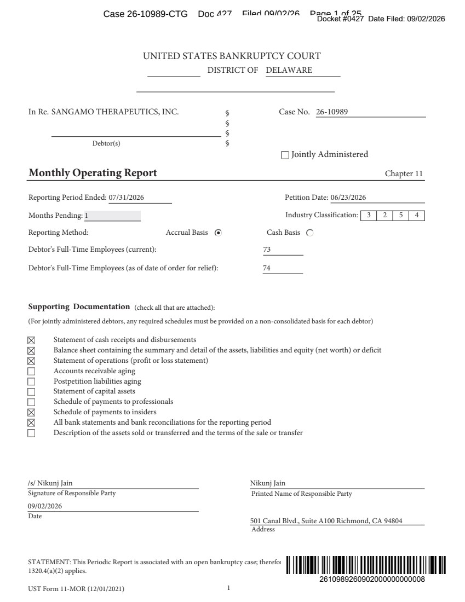 | UST Form 11-MOR (12/01/2021) 1 UNITED STATES BANKRUPTCY COURT DISTRICT OF DELAWARE In Re. SANGAMO THERAPEUTICS, INC. Debtor(s) § § § § Case No. 26-10989 Jointly Administered Monthly Operating Report Chapter 11 Reporting Period Ended: 07/31/2026 Petition Date: 06/23/2026 Months Pending: 1 Industry Classification: 3254 Reporting Method: Accrual Basis Cash Basis Debtor's Full-Time Employees (current): 73 Debtor's Full-Time Employees (as of date of order for relief): 74 Supporting Documentation (check all that are attached): (For jointly administered debtors, any required schedules must be provided on a non-consolidated basis for each debtor) Statement of cash receipts and disbursements Balance sheet containing the summary and detail of the assets, liabilities and equity (net worth) or deficit Statement of operations (profit or loss statement) Accounts receivable aging Postpetition liabilities aging Statement of capital assets Schedule of payments to professionals Schedule of payments to insiders All bank statements and bank reconciliations for the reporting period Description of the assets sold or transferred and the terms of the sale or transfer Signature of Responsible Party Printed Name of Responsible Party Date Address /s/ Nikunj Jain 09/02/2026 Nikunj Jain 501 Canal Blvd., Suite A100 Richmond, CA 94804 STATEMENT: This Periodic Report is associated with an open bankruptcy case; therefore, Paperwork Reduction Act exemption 5 C.F.R. § 1320.4(a)(2) applies. Case 26-10989-CTG Doc 427 Filed 09/02/26 Page 1 of 25
 | 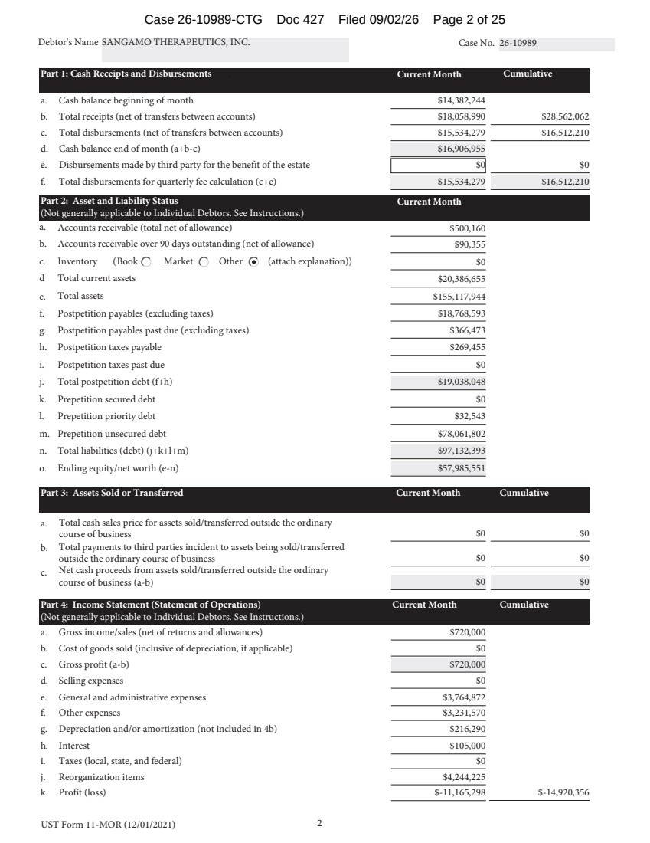 | UST Form 11-MOR (12/01/2021) 2 Debtor's Name SANGAMO THERAPEUTICS, INC. Case No. 26-10989 Part 1: Cash Receipts and Disbursements Current Month Cumulative a. Cash balance beginning of month $14,382,244 b. Total receipts (net of transfers between accounts) $18,058,990 $28,562,062 c. Total disbursements (net of transfers between accounts) $15,534,279 $16,512,210 d. Cash balance end of month (a+b-c) $16,906,955 e. Disbursements made by third party for the benefit of the estate $0 $0 f. Total disbursements for quarterly fee calculation (c+e) $15,534,279 $16,512,210 Part 2: Asset and Liability Status Current Month (Not generally applicable to Individual Debtors. See Instructions.) a. Accounts receivable (total net of allowance) $500,160 b. Accounts receivable over 90 days outstanding (net of allowance) $90,355 c. Inventory ( (attach explanation)) Book Market Other $0 d Total current assets $20,386,655 e. Total assets $155,117,944 f. Postpetition payables (excluding taxes) $18,768,593 g. Postpetition payables past due (excluding taxes) $366,473 h. Postpetition taxes payable $269,455 i. Postpetition taxes past due $0 j. Total postpetition debt (f+h) $19,038,048 k. Prepetition secured debt $0 l. Prepetition priority debt $32,543 m. Prepetition unsecured debt $78,061,802 n. Total liabilities (debt) (j+k+l+m) $97,132,393 o. Ending equity/net worth (e-n) $57,985,551 Part 3: Assets Sold or Transferred Current Month Cumulative a. Total cash sales price for assets sold/transferred outside the ordinary course of business $0 $0 b. Total payments to third parties incident to assets being sold/transferred outside the ordinary course of business $0 $0 c. Net cash proceeds from assets sold/transferred outside the ordinary course of business (a-b) $0 $0 Part 4: Income Statement (Statement of Operations) Current Month Cumulative (Not generally applicable to Individual Debtors. See Instructions.) a. Gross income/sales (net of returns and allowances) $720,000 b. Cost of goods sold (inclusive of depreciation, if applicable) $0 c. Gross profit (a-b) $720,000 d. Selling expenses $0 e. General and administrative expenses $3,764,872 f. Other expenses $3,231,570 g. Depreciation and/or amortization (not included in 4b) $216,290 h. Interest $105,000 i. Taxes (local, state, and federal) $0 j. Reorganization items $4,244,225 k. Profit (loss) $-11,165,298 $-14,920,356 Case 26-10989-CTG Doc 427 Filed 09/02/26 Page 2 of 25
 | 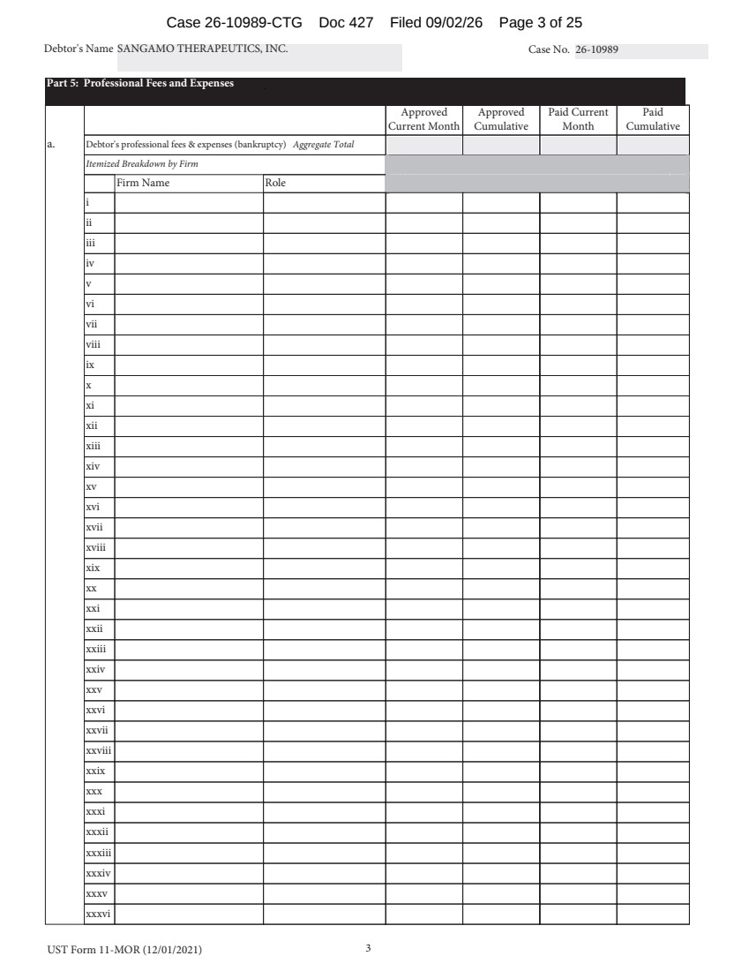 | UST Form 11-MOR (12/01/2021) 3 Debtor's Name SANGAMO THERAPEUTICS, INC. Case No. 26-10989 Part 5: Professional Fees and Expenses Approved Current Month Approved Cumulative Paid Current Month Paid Cumulative a. Debtor's professional fees & expenses (bankruptcy) Aggregate Total Itemized Breakdown by Firm Firm Name Role i ii iii iv v vi vii viii ix x xi xii xiii xiv xv xvi xvii xviii xix xx xxi xxii xxiii xxiv xxv xxvi xxvii xxviii xxix xxx xxxi xxxii xxxiii xxxiv xxxv xxxvi Case 26-10989-CTG Doc 427 Filed 09/02/26 Page 3 of 25
 | 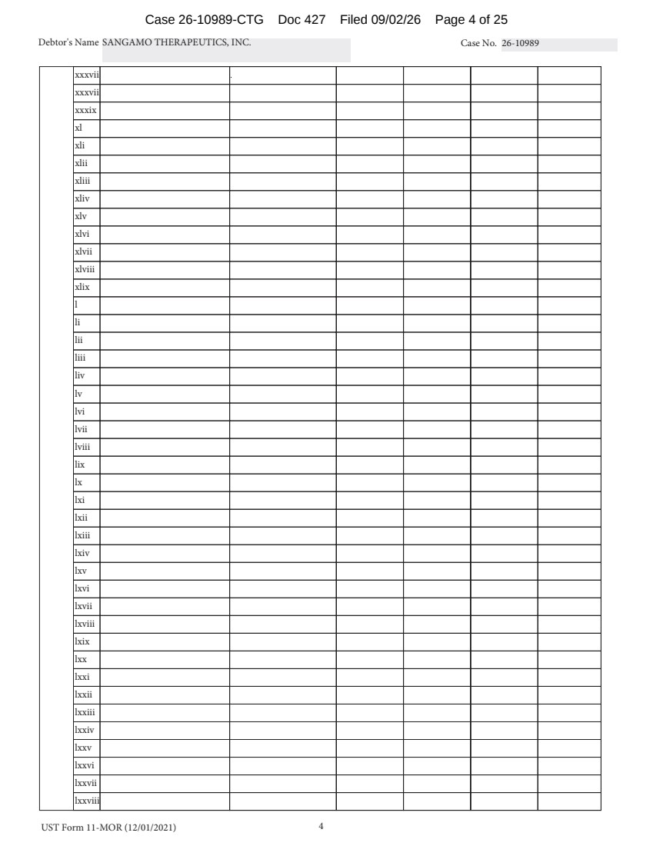 | UST Form 11-MOR (12/01/2021) 4 Debtor's Name SANGAMO THERAPEUTICS, INC. Case No. 26-10989 xxxvii xxxvii xxxix xl xli xlii xliii xliv xlv xlvi xlvii xlviii xlix l li lii liii liv lv lvi lvii lviii lix lx lxi lxii lxiii lxiv lxv lxvi lxvii lxviii lxix lxx lxxi lxxii lxxiii lxxiv lxxv lxxvi lxxvii lxxviii Case 26-10989-CTG Doc 427 Filed 09/02/26 Page 4 of 25
 | 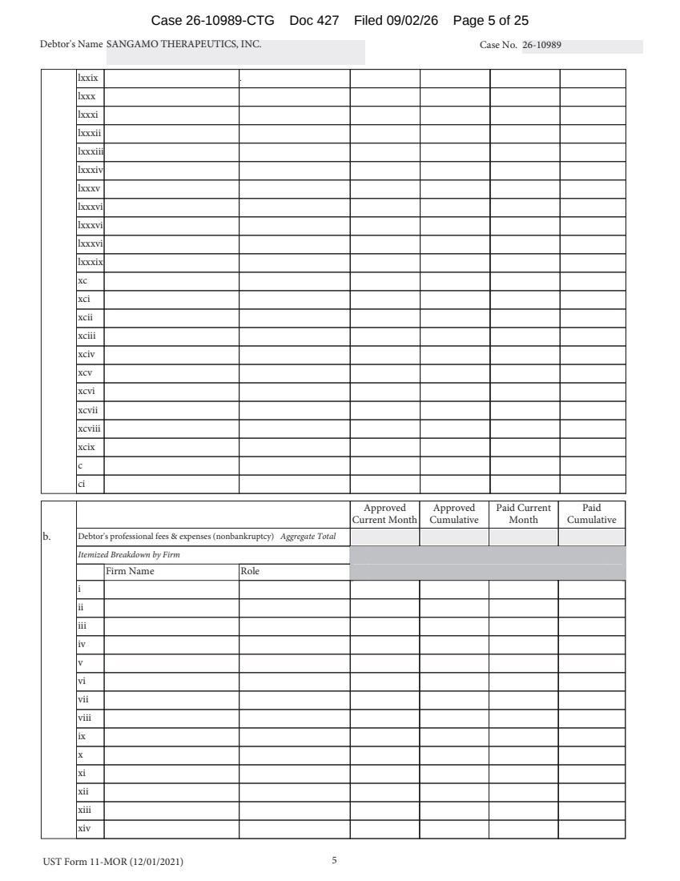 | UST Form 11-MOR (12/01/2021) 5 Debtor's Name SANGAMO THERAPEUTICS, INC. Case No. 26-10989 lxxix lxxx lxxxi lxxxii lxxxiii lxxxiv lxxxv lxxxvi lxxxvi lxxxvi lxxxix xc xci xcii xciii xciv xcv xcvi xcvii xcviii xcix c ci Approved Current Month Approved Cumulative Paid Current Month Paid Cumulative b. Debtor's professional fees & expenses (nonbankruptcy) Aggregate Total Itemized Breakdown by Firm Firm Name Role i ii iii iv v vi vii viii ix x xi xii xiii xiv Case 26-10989-CTG Doc 427 Filed 09/02/26 Page 5 of 25
 | 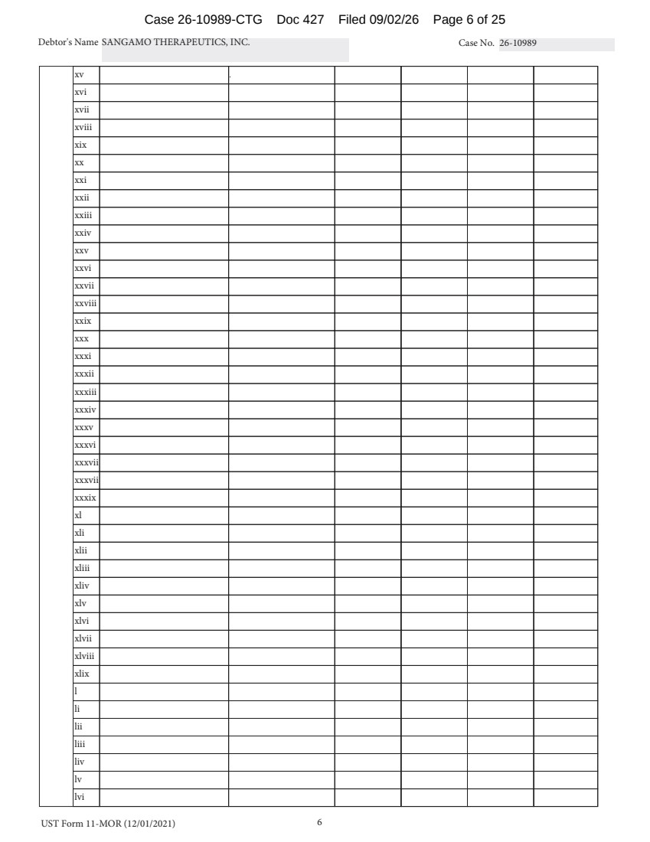 | UST Form 11-MOR (12/01/2021) 6 Debtor's Name SANGAMO THERAPEUTICS, INC. Case No. 26-10989 xv xvi xvii xviii xix xx xxi xxii xxiii xxiv xxv xxvi xxvii xxviii xxix xxx xxxi xxxii xxxiii xxxiv xxxv xxxvi xxxvii xxxvii xxxix xl xli xlii xliii xliv xlv xlvi xlvii xlviii xlix l li lii liii liv lv lvi Case 26-10989-CTG Doc 427 Filed 09/02/26 Page 6 of 25
 | 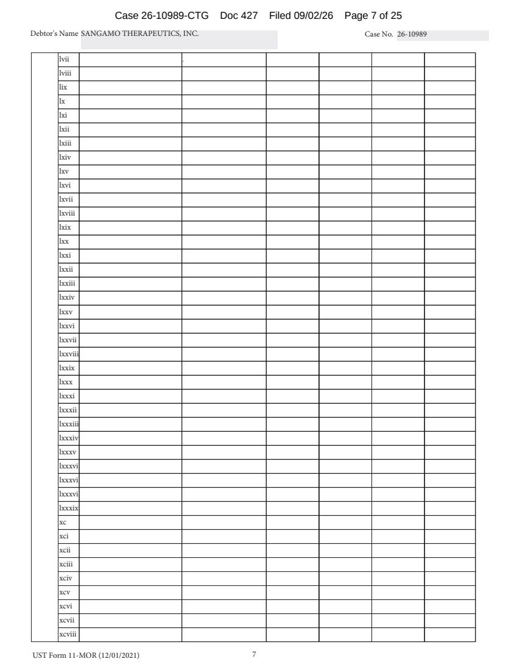 | UST Form 11-MOR (12/01/2021) 7 Debtor's Name SANGAMO THERAPEUTICS, INC. Case No. 26-10989 lvii lviii lix lx lxi lxii lxiii lxiv lxv lxvi lxvii lxviii lxix lxx lxxi lxxii lxxiii lxxiv lxxv lxxvi lxxvii lxxviii lxxix lxxx lxxxi lxxxii lxxxiii lxxxiv lxxxv lxxxvi lxxxvi lxxxvi lxxxix xc xci xcii xciii xciv xcv xcvi xcvii xcviii Case 26-10989-CTG Doc 427 Filed 09/02/26 Page 7 of 25
 | 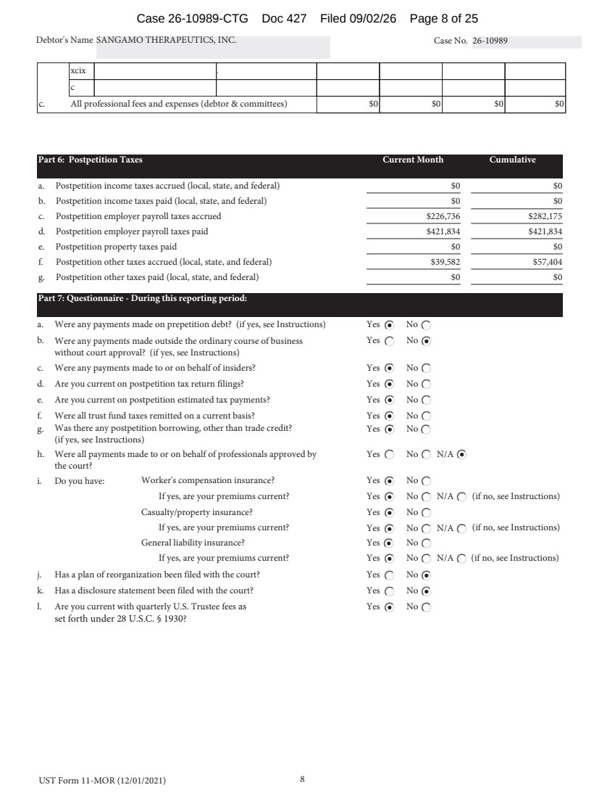 | UST Form 11-MOR (12/01/2021) 8 Debtor's Name SANGAMO THERAPEUTICS, INC. Case No. 26-10989 xcix c c. All professional fees and expenses (debtor & committees) $0 $0 $0 $0 Part 6: Postpetition Taxes Current Month Cumulative a. Postpetition income taxes accrued (local, state, and federal) $0 $0 b. Postpetition income taxes paid (local, state, and federal) $0 $0 c. Postpetition employer payroll taxes accrued $226,736 $282,175 d. Postpetition employer payroll taxes paid $421,834 $421,834 e. Postpetition property taxes paid $0 $0 f. Postpetition other taxes accrued (local, state, and federal) $39,582 $57,404 g. Postpetition other taxes paid (local, state, and federal) $0 $0 Part 7: Questionnaire - During this reporting period: a. Were any payments made on prepetition debt? (if yes, see Instructions) Yes No b. Were any payments made outside the ordinary course of business Yes No without court approval? (if yes, see Instructions) c. Were any payments made to or on behalf of insiders? Yes No d. Are you current on postpetition tax return filings? Yes No e. Are you current on postpetition estimated tax payments? Yes No f. Were all trust fund taxes remitted on a current basis? Yes No g. Was there any postpetition borrowing, other than trade credit? Yes No (if yes, see Instructions) h. Were all payments made to or on behalf of professionals approved by the court? Yes No N/A i. Do you have: Worker's compensation insurance? Yes No If yes, are your premiums current? Yes No N/A (if no, see Instructions) Casualty/property insurance? Yes No If yes, are your premiums current? Yes No N/A (if no, see Instructions) General liability insurance? Yes No If yes, are your premiums current? Yes No N/A (if no, see Instructions) j. Has a plan of reorganization been filed with the court? Yes No k. Has a disclosure statement been filed with the court? Yes No l. Are you current with quarterly U.S. Trustee fees as set forth under 28 U.S.C. § 1930? Yes No Case 26-10989-CTG Doc 427 Filed 09/02/26 Page 8 of 25
 | 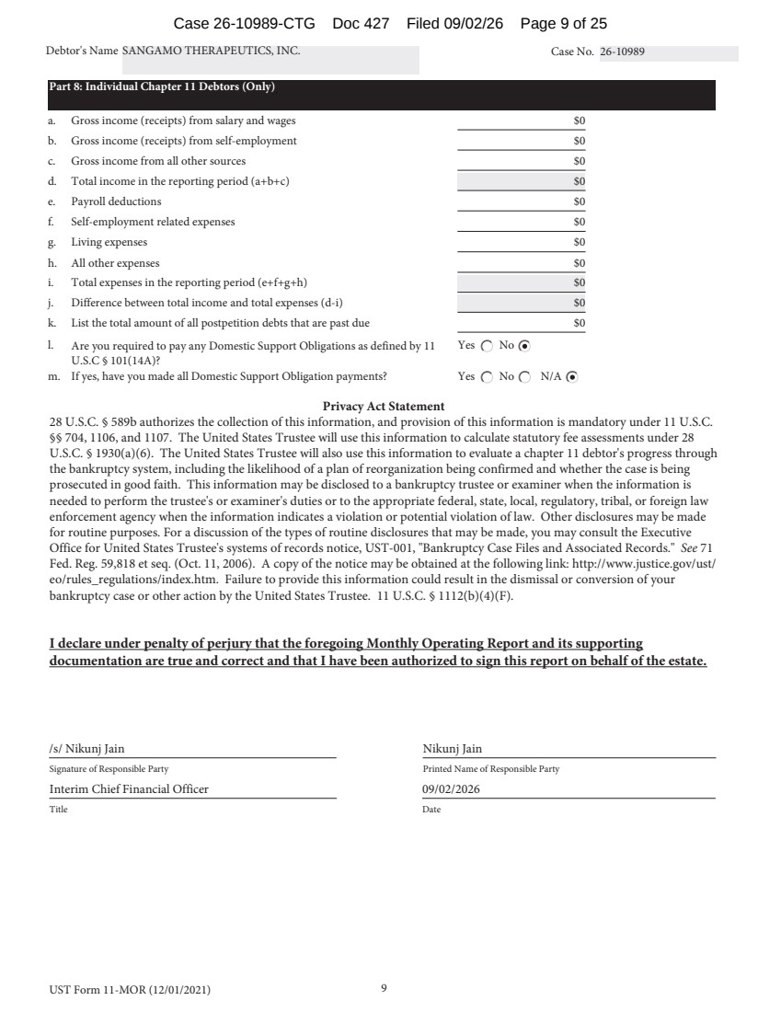 | UST Form 11-MOR (12/01/2021) 9 Debtor's Name SANGAMO THERAPEUTICS, INC. Case No. 26-10989 Part 8: Individual Chapter 11 Debtors (Only) a. Gross income (receipts) from salary and wages $0 b. Gross income (receipts) from self-employment $0 c. Gross income from all other sources $0 d. Total income in the reporting period (a+b+c) $0 e. Payroll deductions $0 f. Self-employment related expenses $0 g. Living expenses $0 h. All other expenses $0 i. Total expenses in the reporting period (e+f+g+h) $0 j. Difference between total income and total expenses (d-i) $0 k. List the total amount of all postpetition debts that are past due $0 l. Are you required to pay any Domestic Support Obligations as defined by 11 U.S.C § 101(14A)? Yes No m. If yes, have you made all Domestic Support Obligation payments? Yes No N/A Privacy Act Statement 28 U.S.C. § 589b authorizes the collection of this information, and provision of this information is mandatory under 11 U.S.C. §§ 704, 1106, and 1107. The United States Trustee will use this information to calculate statutory fee assessments under 28 U.S.C. § 1930(a)(6). The United States Trustee will also use this information to evaluate a chapter 11 debtor's progress through the bankruptcy system, including the likelihood of a plan of reorganization being confirmed and whether the case is being prosecuted in good faith. This information may be disclosed to a bankruptcy trustee or examiner when the information is needed to perform the trustee's or examiner's duties or to the appropriate federal, state, local, regulatory, tribal, or foreign law enforcement agency when the information indicates a violation or potential violation of law. Other disclosures may be made for routine purposes. For a discussion of the types of routine disclosures that may be made, you may consult the Executive Office for United States Trustee's systems of records notice, UST-001, "Bankruptcy Case Files and Associated Records." See 71 Fed. Reg. 59,818 et seq. (Oct. 11, 2006). A copy of the notice may be obtained at the following link: http://www.justice.gov/ust/ eo/rules_regulations/index.htm. Failure to provide this information could result in the dismissal or conversion of your bankruptcy case or other action by the United States Trustee. 11 U.S.C. § 1112(b)(4)(F). I declare under penalty of perjury that the foregoing Monthly Operating Report and its supporting documentation are true and correct and that I have been authorized to sign this report on behalf of the estate. /s/ Nikunj Jain Signature of Responsible Party Interim Chief Financial Officer Printed Name of Responsible Party 09/02/2026 Title Date Nikunj Jain Case 26-10989-CTG Doc 427 Filed 09/02/26 Page 9 of 25
 | 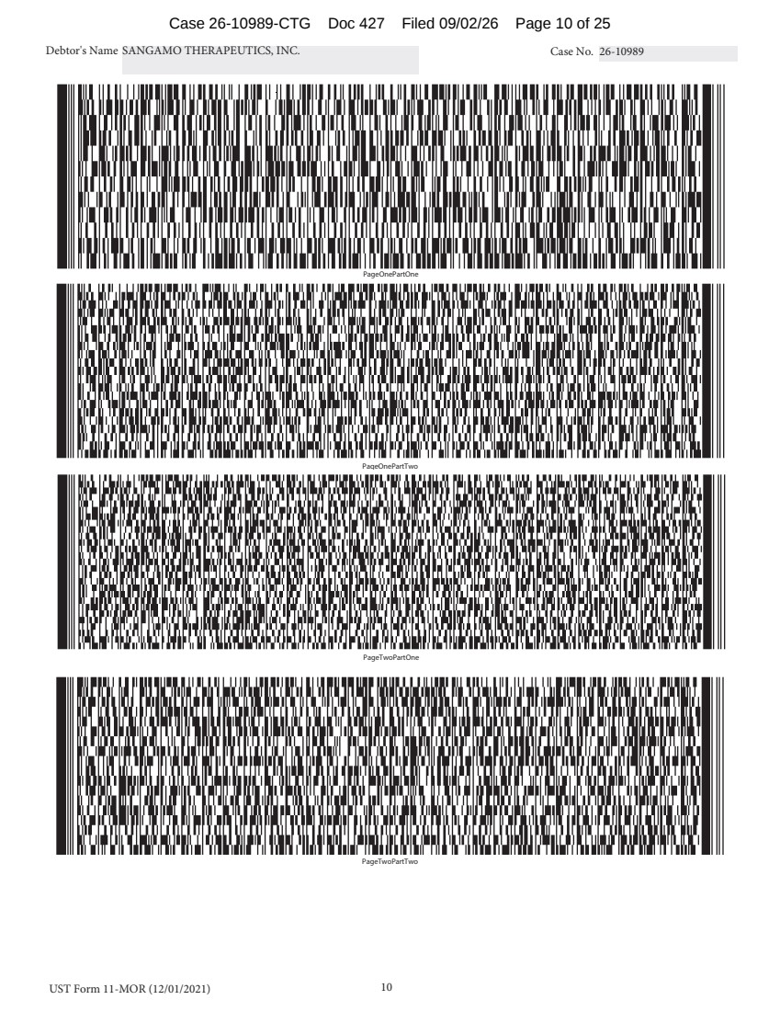 | UST Form 11-MOR (12/01/2021) 10 Debtor's Name SANGAMO THERAPEUTICS, INC. Case No. 26-10989 PageOnePartOne PageOnePartTwo PageTwoPartOne PageTwoPartTwo Case 26-10989-CTG Doc 427 Filed 09/02/26 Page 10 of 25
 | 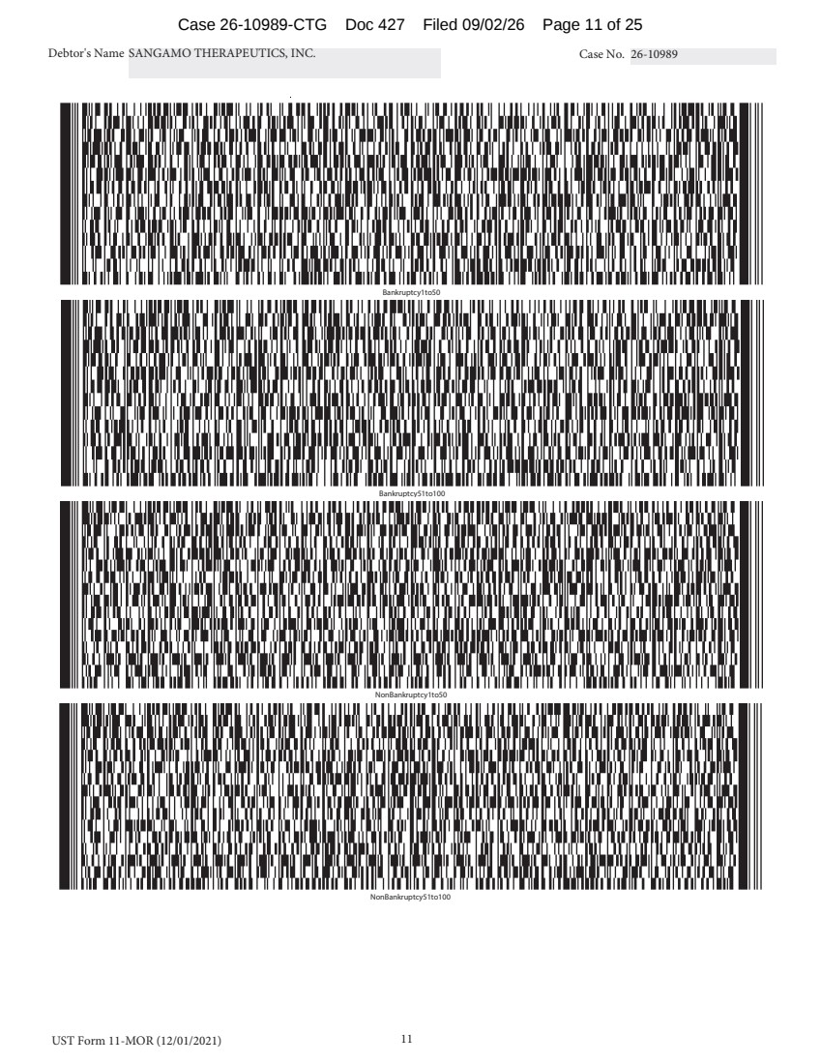 | UST Form 11-MOR (12/01/2021) 11 Debtor's Name SANGAMO THERAPEUTICS, INC. Case No. 26-10989 Bankruptcy51to100 NonBankruptcy1to50 NonBankruptcy51to100 Bankruptcy1to50 Case 26-10989-CTG Doc 427 Filed 09/02/26 Page 11 of 25
 | 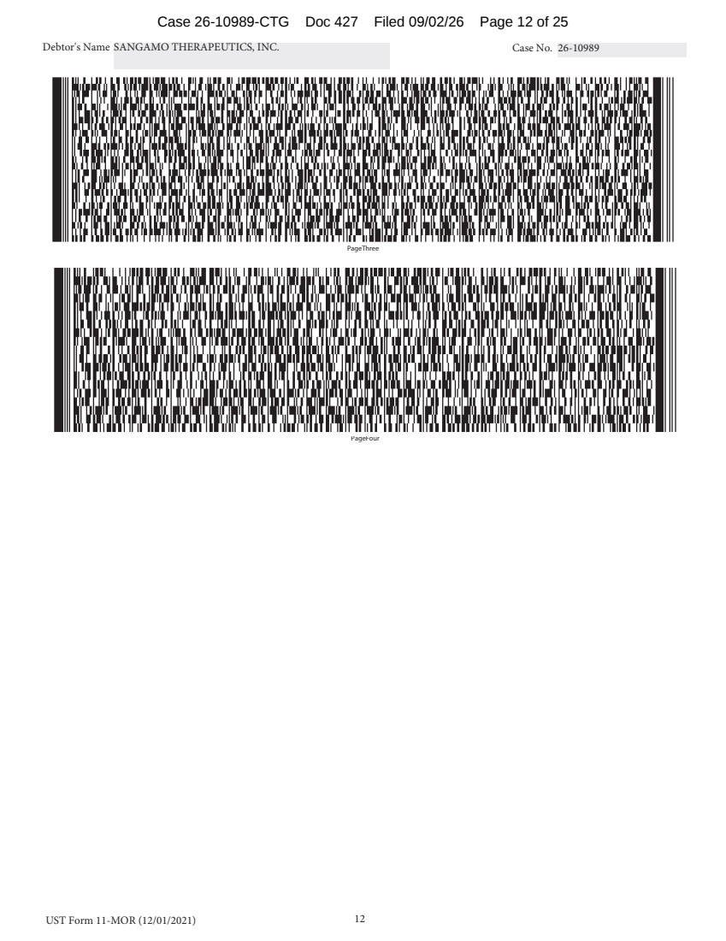 | UST Form 11-MOR (12/01/2021) 12 Debtor's Name SANGAMO THERAPEUTICS, INC. Case No. 26-10989 PageFour PageThree Case 26-10989-CTG Doc 427 Filed 09/02/26 Page 12 of 25
 | 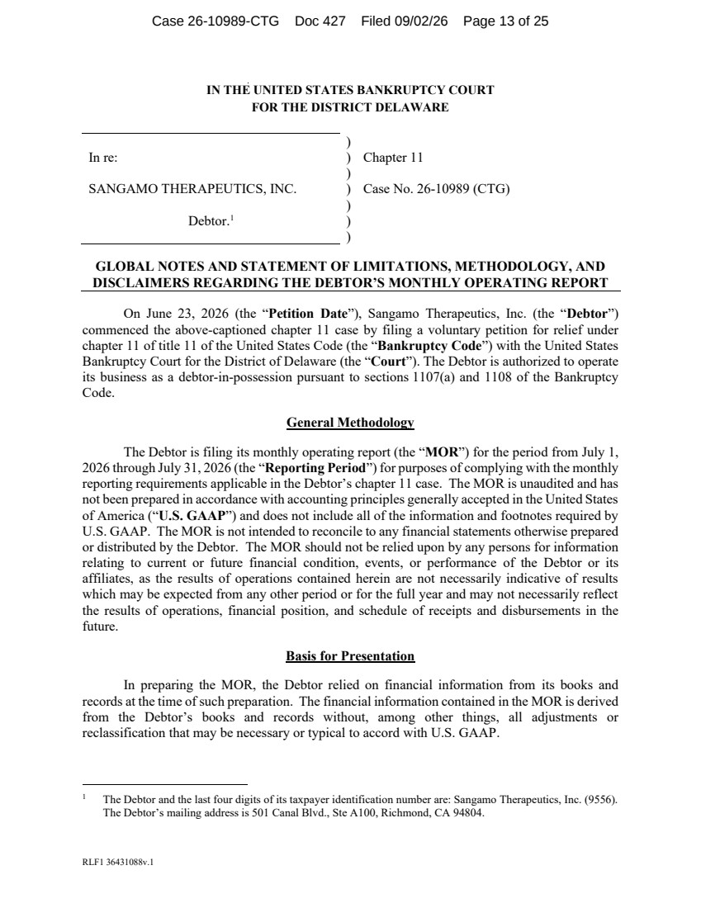 | RLF1 36431088v.1 IN THE UNITED STATES BANKRUPTCY COURT FOR THE DISTRICT DELAWARE ) In re: ) Chapter 11 ) SANGAMO THERAPEUTICS, INC. ) Case No. 26-10989 (CTG) ) Debtor.1 ) ) GLOBAL NOTES AND STATEMENT OF LIMITATIONS, METHODOLOGY, AND DISCLAIMERS REGARDING THE DEBTOR’S MONTHLY OPERATING REPORT On June 23, 2026 (the “Petition Date”), Sangamo Therapeutics, Inc. (the “Debtor”) commenced the above-captioned chapter 11 case by filing a voluntary petition for relief under chapter 11 of title 11 of the United States Code (the “Bankruptcy Code”) with the United States Bankruptcy Court for the District of Delaware (the “Court”). The Debtor is authorized to operate its business as a debtor-in-possession pursuant to sections 1107(a) and 1108 of the Bankruptcy Code. General Methodology The Debtor is filing its monthly operating report (the “MOR”) for the period from July 1, 2026 through July 31, 2026 (the “Reporting Period”) for purposes of complying with the monthly reporting requirements applicable in the Debtor’s chapter 11 case. The MOR is unaudited and has not been prepared in accordance with accounting principles generally accepted in the United States of America (“U.S. GAAP”) and does not include all of the information and footnotes required by U.S. GAAP. The MOR is not intended to reconcile to any financial statements otherwise prepared or distributed by the Debtor. The MOR should not be relied upon by any persons for information relating to current or future financial condition, events, or performance of the Debtor or its affiliates, as the results of operations contained herein are not necessarily indicative of results which may be expected from any other period or for the full year and may not necessarily reflect the results of operations, financial position, and schedule of receipts and disbursements in the future. Basis for Presentation In preparing the MOR, the Debtor relied on financial information from its books and records at the time of such preparation. The financial information contained in the MOR is derived from the Debtor’s books and records without, among other things, all adjustments or reclassification that may be necessary or typical to accord with U.S. GAAP. 1 The Debtor and the last four digits of its taxpayer identification number are: Sangamo Therapeutics, Inc. (9556). The Debtor’s mailing address is 501 Canal Blvd., Ste A100, Richmond, CA 94804. Case 26-10989-CTG Doc 427 Filed 09/02/26 Page 13 of 25
 | 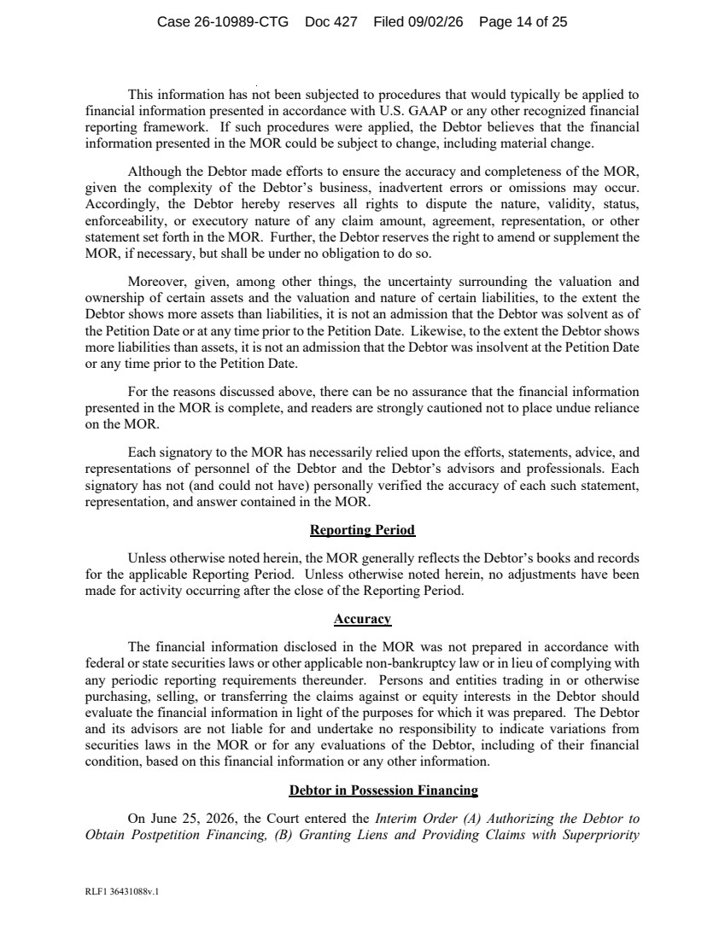 | RLF1 36431088v.1 This information has not been subjected to procedures that would typically be applied to financial information presented in accordance with U.S. GAAP or any other recognized financial reporting framework. If such procedures were applied, the Debtor believes that the financial information presented in the MOR could be subject to change, including material change. Although the Debtor made efforts to ensure the accuracy and completeness of the MOR, given the complexity of the Debtor’s business, inadvertent errors or omissions may occur. Accordingly, the Debtor hereby reserves all rights to dispute the nature, validity, status, enforceability, or executory nature of any claim amount, agreement, representation, or other statement set forth in the MOR. Further, the Debtor reserves the right to amend or supplement the MOR, if necessary, but shall be under no obligation to do so. Moreover, given, among other things, the uncertainty surrounding the valuation and ownership of certain assets and the valuation and nature of certain liabilities, to the extent the Debtor shows more assets than liabilities, it is not an admission that the Debtor was solvent as of the Petition Date or at any time prior to the Petition Date. Likewise, to the extent the Debtor shows more liabilities than assets, it is not an admission that the Debtor was insolvent at the Petition Date or any time prior to the Petition Date. For the reasons discussed above, there can be no assurance that the financial information presented in the MOR is complete, and readers are strongly cautioned not to place undue reliance on the MOR. Each signatory to the MOR has necessarily relied upon the efforts, statements, advice, and representations of personnel of the Debtor and the Debtor’s advisors and professionals. Each signatory has not (and could not have) personally verified the accuracy of each such statement, representation, and answer contained in the MOR. Reporting Period Unless otherwise noted herein, the MOR generally reflects the Debtor’s books and records for the applicable Reporting Period. Unless otherwise noted herein, no adjustments have been made for activity occurring after the close of the Reporting Period. Accuracy The financial information disclosed in the MOR was not prepared in accordance with federal or state securities laws or other applicable non-bankruptcy law or in lieu of complying with any periodic reporting requirements thereunder. Persons and entities trading in or otherwise purchasing, selling, or transferring the claims against or equity interests in the Debtor should evaluate the financial information in light of the purposes for which it was prepared. The Debtor and its advisors are not liable for and undertake no responsibility to indicate variations from securities laws in the MOR or for any evaluations of the Debtor, including of their financial condition, based on this financial information or any other information. Debtor in Possession Financing On June 25, 2026, the Court entered the Interim Order (A) Authorizing the Debtor to Obtain Postpetition Financing, (B) Granting Liens and Providing Claims with Superpriority Case 26-10989-CTG Doc 427 Filed 09/02/26 Page 14 of 25
 | 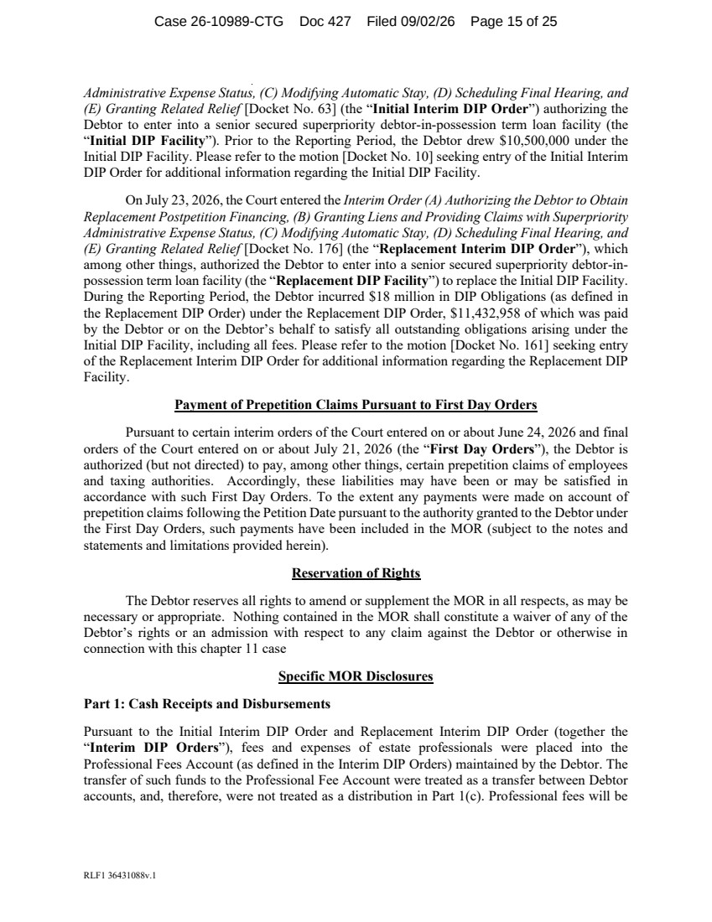 | RLF1 36431088v.1 Administrative Expense Status, (C) Modifying Automatic Stay, (D) Scheduling Final Hearing, and (E) Granting Related Relief [Docket No. 63] (the “Initial Interim DIP Order”) authorizing the Debtor to enter into a senior secured superpriority debtor-in-possession term loan facility (the “Initial DIP Facility”). Prior to the Reporting Period, the Debtor drew $10,500,000 under the Initial DIP Facility. Please refer to the motion [Docket No. 10] seeking entry of the Initial Interim DIP Order for additional information regarding the Initial DIP Facility. On July 23, 2026, the Court entered the Interim Order (A) Authorizing the Debtor to Obtain Replacement Postpetition Financing, (B) Granting Liens and Providing Claims with Superpriority Administrative Expense Status, (C) Modifying Automatic Stay, (D) Scheduling Final Hearing, and (E) Granting Related Relief [Docket No. 176] (the “Replacement Interim DIP Order”), which among other things, authorized the Debtor to enter into a senior secured superpriority debtor-in-possession term loan facility (the “Replacement DIP Facility”) to replace the Initial DIP Facility. During the Reporting Period, the Debtor incurred $18 million in DIP Obligations (as defined in the Replacement DIP Order) under the Replacement DIP Order, $11,432,958 of which was paid by the Debtor or on the Debtor’s behalf to satisfy all outstanding obligations arising under the Initial DIP Facility, including all fees. Please refer to the motion [Docket No. 161] seeking entry of the Replacement Interim DIP Order for additional information regarding the Replacement DIP Facility. Payment of Prepetition Claims Pursuant to First Day Orders Pursuant to certain interim orders of the Court entered on or about June 24, 2026 and final orders of the Court entered on or about July 21, 2026 (the “First Day Orders”), the Debtor is authorized (but not directed) to pay, among other things, certain prepetition claims of employees and taxing authorities. Accordingly, these liabilities may have been or may be satisfied in accordance with such First Day Orders. To the extent any payments were made on account of prepetition claims following the Petition Date pursuant to the authority granted to the Debtor under the First Day Orders, such payments have been included in the MOR (subject to the notes and statements and limitations provided herein). Reservation of Rights The Debtor reserves all rights to amend or supplement the MOR in all respects, as may be necessary or appropriate. Nothing contained in the MOR shall constitute a waiver of any of the Debtor’s rights or an admission with respect to any claim against the Debtor or otherwise in connection with this chapter 11 case Specific MOR Disclosures Part 1: Cash Receipts and Disbursements Pursuant to the Initial Interim DIP Order and Replacement Interim DIP Order (together the “Interim DIP Orders”), fees and expenses of estate professionals were placed into the Professional Fees Account (as defined in the Interim DIP Orders) maintained by the Debtor. The transfer of such funds to the Professional Fee Account were treated as a transfer between Debtor accounts, and, therefore, were not treated as a distribution in Part 1(c). Professional fees will be Case 26-10989-CTG Doc 427 Filed 09/02/26 Page 15 of 25
 | 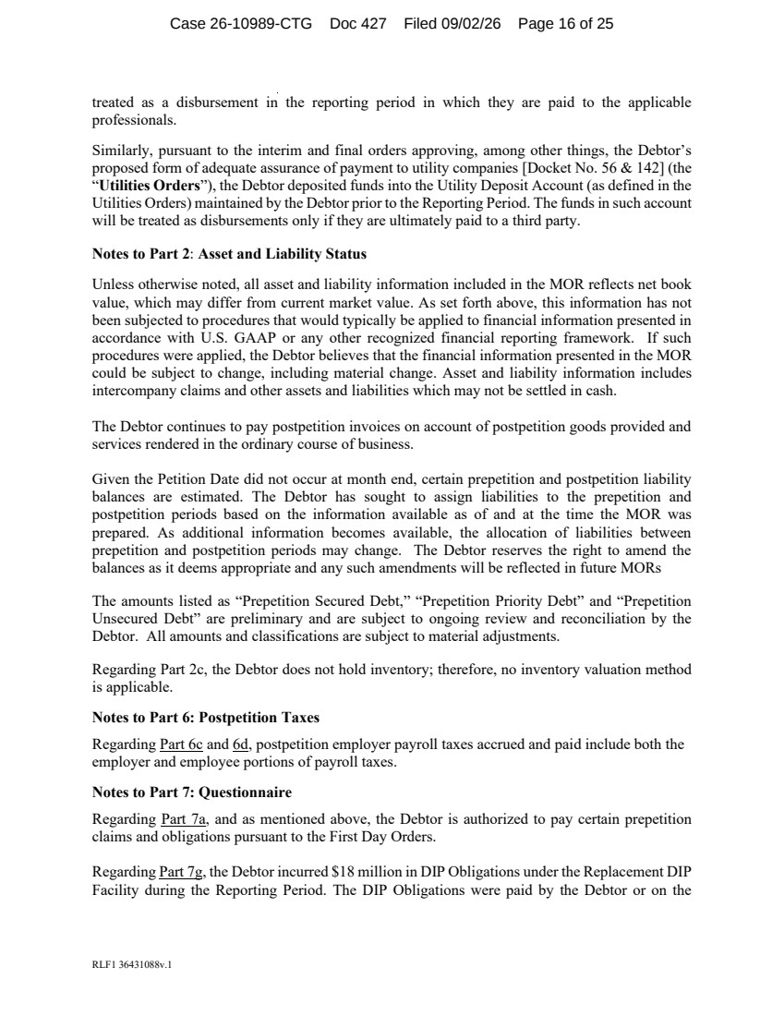 | RLF1 36431088v.1 treated as a disbursement in the reporting period in which they are paid to the applicable professionals. Similarly, pursuant to the interim and final orders approving, among other things, the Debtor’s proposed form of adequate assurance of payment to utility companies [Docket No. 56 & 142] (the “Utilities Orders”), the Debtor deposited funds into the Utility Deposit Account (as defined in the Utilities Orders) maintained by the Debtor prior to the Reporting Period. The funds in such account will be treated as disbursements only if they are ultimately paid to a third party. Notes to Part 2: Asset and Liability Status Unless otherwise noted, all asset and liability information included in the MOR reflects net book value, which may differ from current market value. As set forth above, this information has not been subjected to procedures that would typically be applied to financial information presented in accordance with U.S. GAAP or any other recognized financial reporting framework. If such procedures were applied, the Debtor believes that the financial information presented in the MOR could be subject to change, including material change. Asset and liability information includes intercompany claims and other assets and liabilities which may not be settled in cash. The Debtor continues to pay postpetition invoices on account of postpetition goods provided and services rendered in the ordinary course of business. Given the Petition Date did not occur at month end, certain prepetition and postpetition liability balances are estimated. The Debtor has sought to assign liabilities to the prepetition and postpetition periods based on the information available as of and at the time the MOR was prepared. As additional information becomes available, the allocation of liabilities between prepetition and postpetition periods may change. The Debtor reserves the right to amend the balances as it deems appropriate and any such amendments will be reflected in future MORs The amounts listed as “Prepetition Secured Debt,” “Prepetition Priority Debt” and “Prepetition Unsecured Debt” are preliminary and are subject to ongoing review and reconciliation by the Debtor. All amounts and classifications are subject to material adjustments. Regarding Part 2c, the Debtor does not hold inventory; therefore, no inventory valuation method is applicable. Notes to Part 6: Postpetition Taxes Regarding Part 6c and 6d, postpetition employer payroll taxes accrued and paid include both the employer and employee portions of payroll taxes. Notes to Part 7: Questionnaire Regarding Part 7a, and as mentioned above, the Debtor is authorized to pay certain prepetition claims and obligations pursuant to the First Day Orders. Regarding Part 7g, the Debtor incurred $18 million in DIP Obligations under the Replacement DIP Facility during the Reporting Period. The DIP Obligations were paid by the Debtor or on the Case 26-10989-CTG Doc 427 Filed 09/02/26 Page 16 of 25
 | 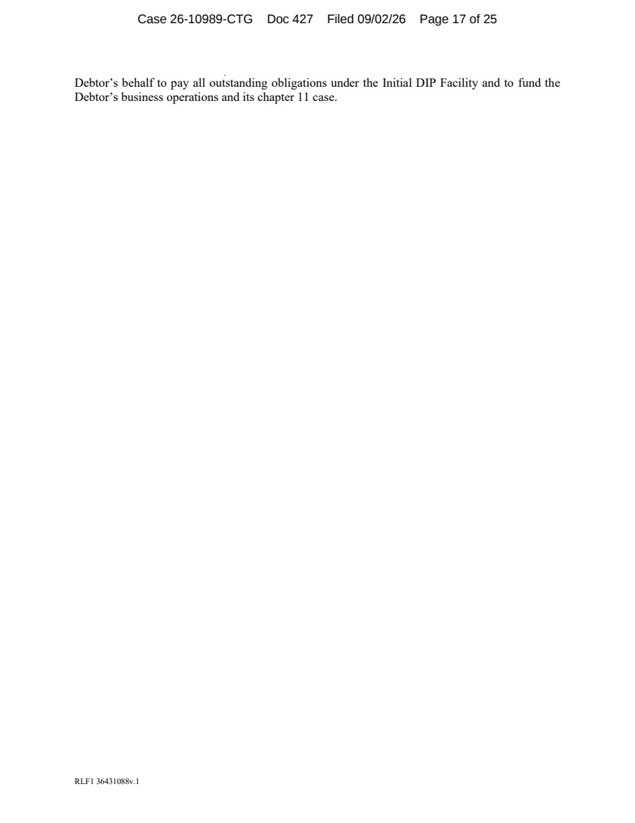 | RLF1 36431088v.1 Debtor’s behalf to pay all outstanding obligations under the Initial DIP Facility and to fund the Debtor’s business operations and its chapter 11 case. Case 26-10989-CTG Doc 427 Filed 09/02/26 Page 17 of 25
 | 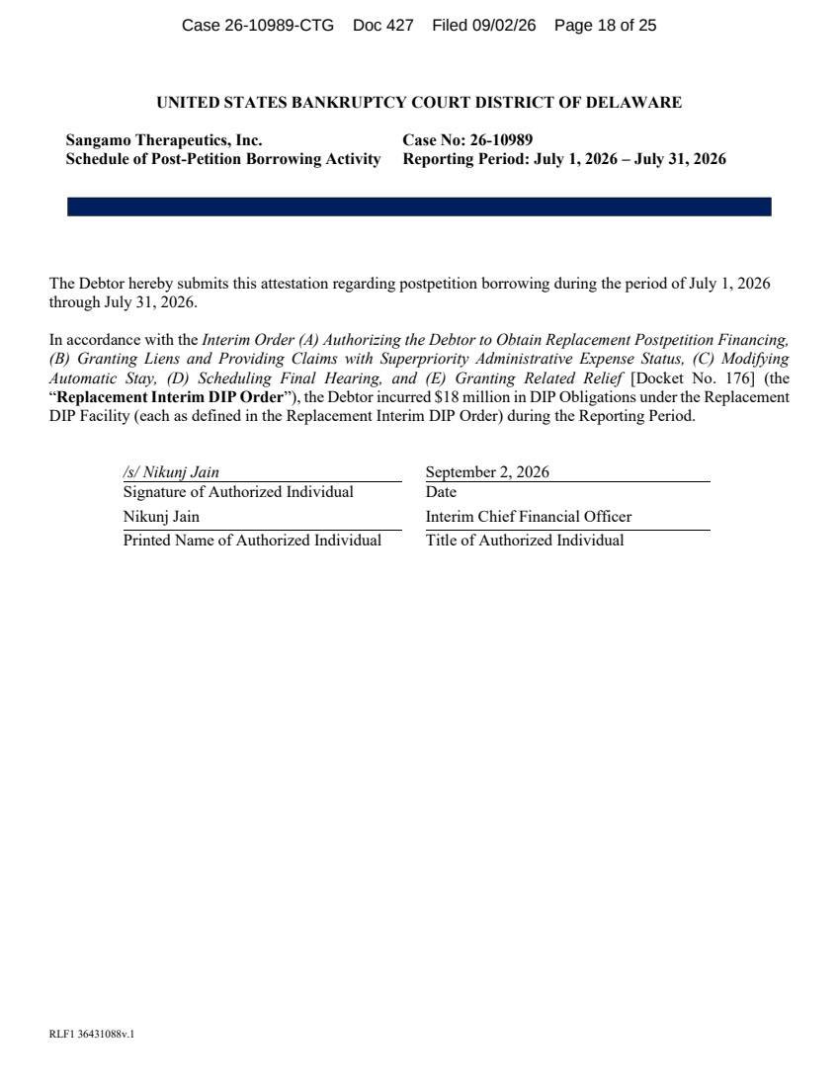 | RLF1 36431088v.1 UNITED STATES BANKRUPTCY COURT DISTRICT OF DELAWARE Sangamo Therapeutics, Inc. Schedule of Post-Petition Borrowing Activity Case No: 26-10989 Reporting Period: July 1, 2026 – July 31, 2026 The Debtor hereby submits this attestation regarding postpetition borrowing during the period of July 1, 2026 through July 31, 2026. In accordance with the Interim Order (A) Authorizing the Debtor to Obtain Replacement Postpetition Financing, (B) Granting Liens and Providing Claims with Superpriority Administrative Expense Status, (C) Modifying Automatic Stay, (D) Scheduling Final Hearing, and (E) Granting Related Relief [Docket No. 176] (the “Replacement Interim DIP Order”), the Debtor incurred $18 million in DIP Obligations under the Replacement DIP Facility (each as defined in the Replacement Interim DIP Order) during the Reporting Period. /s/ Nikunj Jain September 2, 2026 Signature of Authorized Individual Date Nikunj Jain Interim Chief Financial Officer Printed Name of Authorized Individual Title of Authorized Individual Case 26-10989-CTG Doc 427 Filed 09/02/26 Page 18 of 25
 | 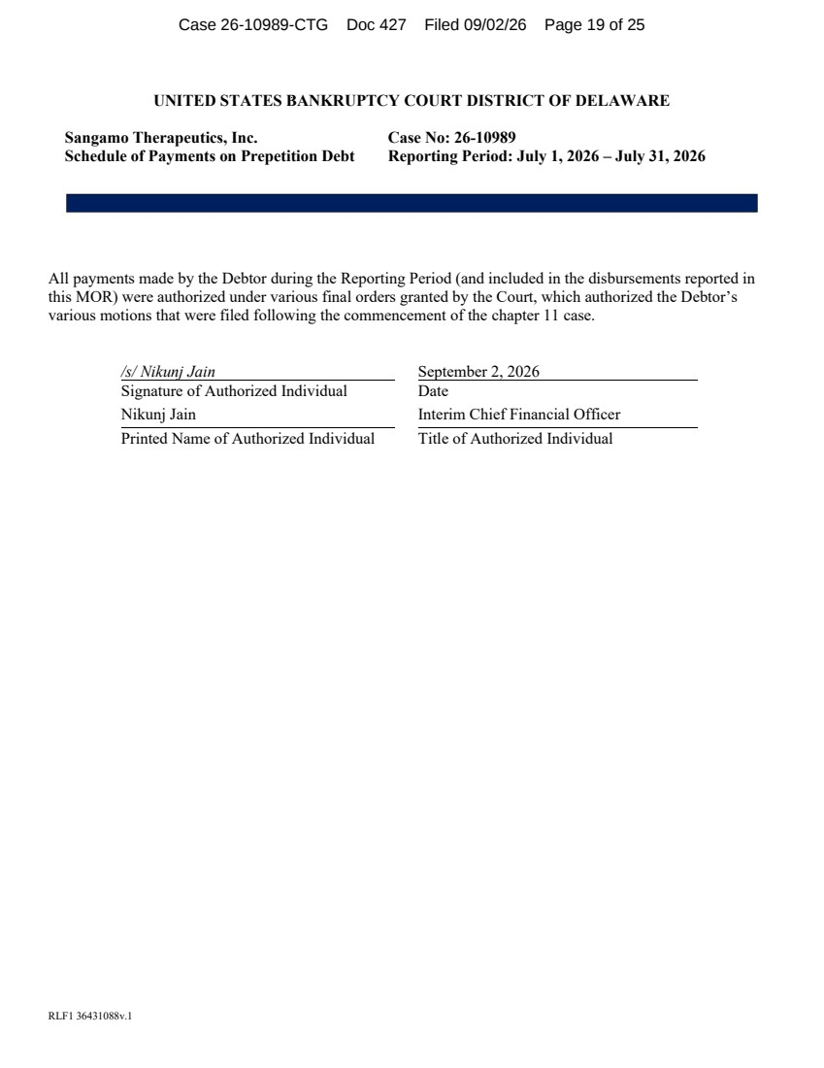 | RLF1 36431088v.1 UNITED STATES BANKRUPTCY COURT DISTRICT OF DELAWARE Sangamo Therapeutics, Inc. Schedule of Payments on Prepetition Debt Case No: 26-10989 Reporting Period: July 1, 2026 – July 31, 2026 All payments made by the Debtor during the Reporting Period (and included in the disbursements reported in this MOR) were authorized under various final orders granted by the Court, which authorized the Debtor’s various motions that were filed following the commencement of the chapter 11 case. /s/ Nikunj Jain September 2, 2026 Signature of Authorized Individual Date Nikunj Jain Interim Chief Financial Officer Printed Name of Authorized Individual Title of Authorized Individual Case 26-10989-CTG Doc 427 Filed 09/02/26 Page 19 of 25
 | 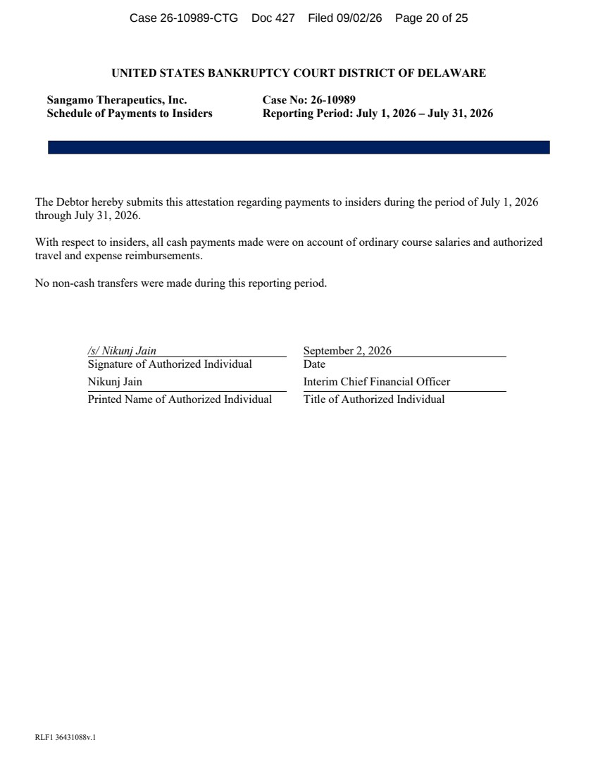 | RLF1 36431088v.1 UNITED STATES BANKRUPTCY COURT DISTRICT OF DELAWARE Sangamo Therapeutics, Inc. Schedule of Payments to Insiders Case No: 26-10989 Reporting Period: July 1, 2026 – July 31, 2026 The Debtor hereby submits this attestation regarding payments to insiders during the period of July 1, 2026 through July 31, 2026. With respect to insiders, all cash payments made were on account of ordinary course salaries and authorized travel and expense reimbursements. No non-cash transfers were made during this reporting period. /s/ Nikunj Jain September 2, 2026 Signature of Authorized Individual Date Nikunj Jain Interim Chief Financial Officer Printed Name of Authorized Individual Title of Authorized Individual Case 26-10989-CTG Doc 427 Filed 09/02/26 Page 20 of 25
 | 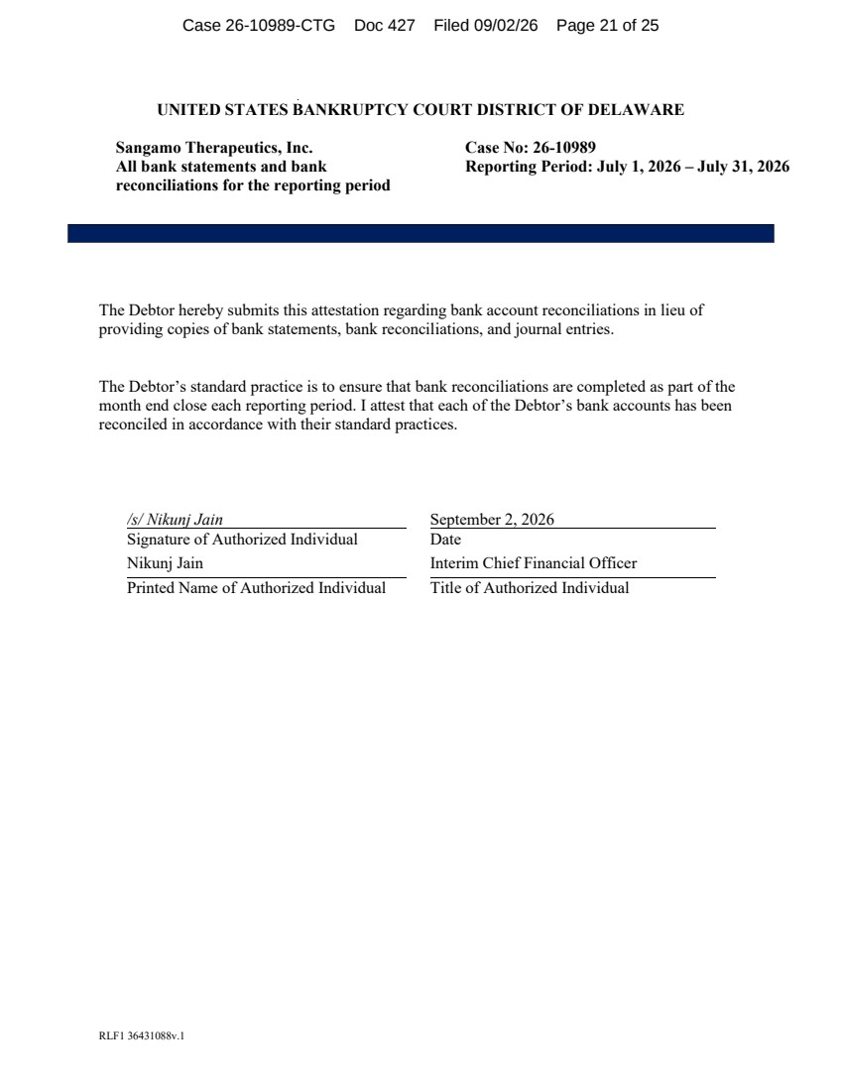 | RLF1 36431088v.1 UNITED STATES BANKRUPTCY COURT DISTRICT OF DELAWARE Sangamo Therapeutics, Inc. All bank statements and bank reconciliations for the reporting period Case No: 26-10989 Reporting Period: July 1, 2026 – July 31, 2026 The Debtor hereby submits this attestation regarding bank account reconciliations in lieu of providing copies of bank statements, bank reconciliations, and journal entries. The Debtor’s standard practice is to ensure that bank reconciliations are completed as part of the month end close each reporting period. I attest that each of the Debtor’s bank accounts has been reconciled in accordance with their standard practices. /s/ Nikunj Jain September 2, 2026 Signature of Authorized Individual Date Nikunj Jain Interim Chief Financial Officer Printed Name of Authorized Individual Title of Authorized Individual Case 26-10989-CTG Doc 427 Filed 09/02/26 Page 21 of 25
 | 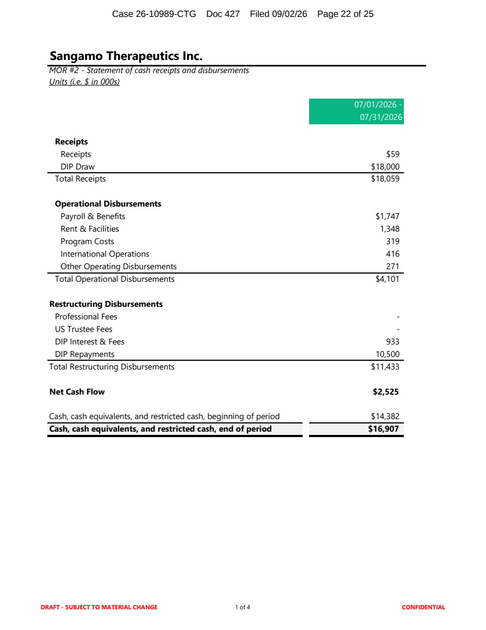 | Sangamo Therapeutics Inc. MOR #2 - Statement of cash receipts and disbursements Units (i.e. $ in 000s) 07/01/2026 - 07/31/2026 Receipts Receipts $59 DIP Draw $18,000 Total Receipts $18,059 Operational Disbursements Payroll & Benefits $1,747 Rent & Facilities 1,348 Program Costs 319 International Operations 416 Other Operating Disbursements 271 Total Operational Disbursements $4,101 Restructuring Disbursements Professional Fees - US Trustee Fees - DIP Interest & Fees 933 DIP Repayments 10,500 Total Restructuring Disbursements $11,433 Net Cash Flow $2,525 Cash, cash equivalents, and restricted cash, beginning of period $14,382 Cash, cash equivalents, and restricted cash, end of period $16,907 DRAFT - SUBJECT TO MATERIAL CHANGE 1 of 4 CONFIDENTIAL Case 26-10989-CTG Doc 427 Filed 09/02/26 Page 22 of 25
 | 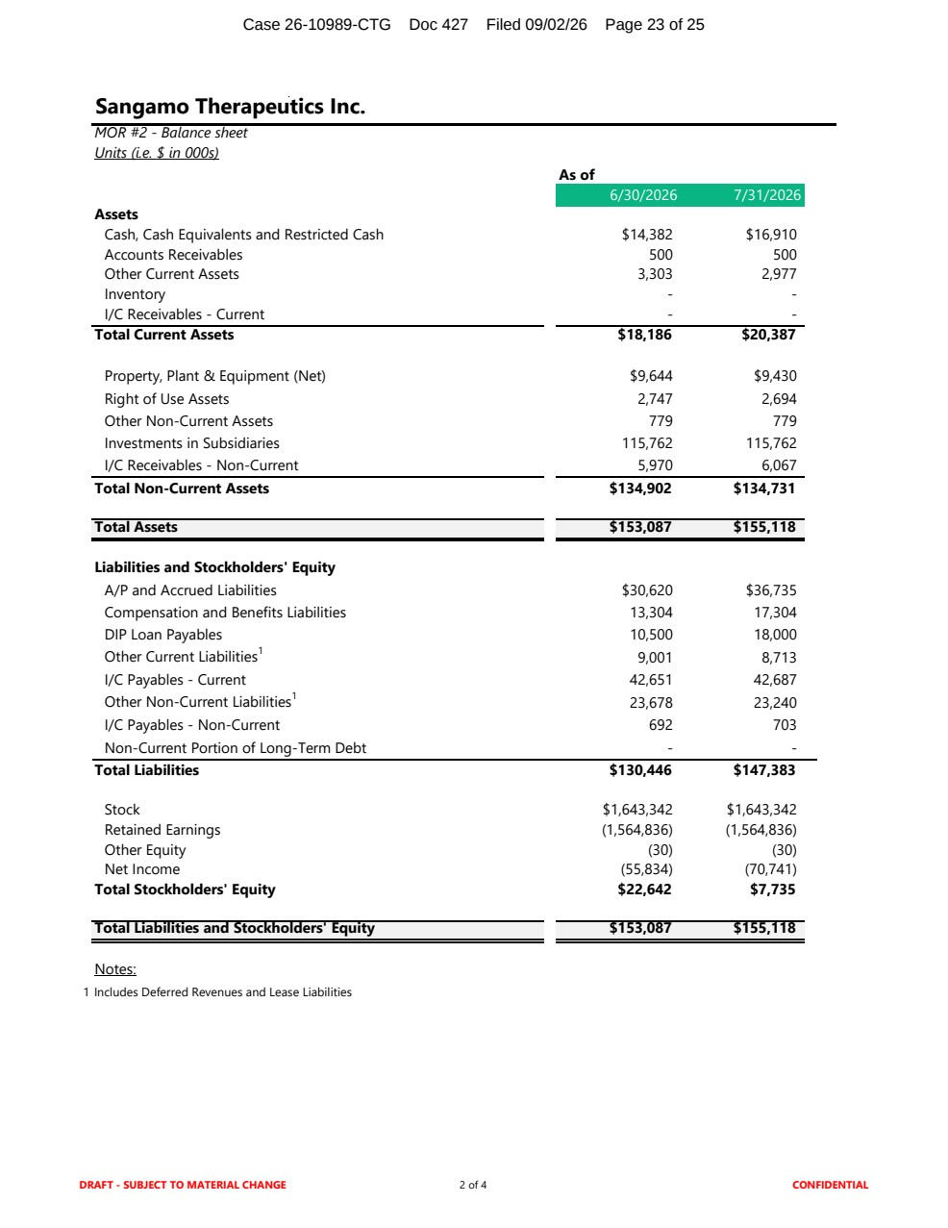 | Sangamo Therapeutics Inc. MOR #2 - Balance sheet Units (i.e. $ in 000s) As of 6/30/2026 7/31/2026 Assets Cash, Cash Equivalents and Restricted Cash $14,382 $16,910 Accounts Receivables 500 500 Other Current Assets 3,303 2,977 Inventory - - I/C Receivables - Current - - Total Current Assets $18,186 $20,387 Property, Plant & Equipment (Net) $9,644 $9,430 Right of Use Assets 2,747 2,694 Other Non-Current Assets 779 779 Investments in Subsidiaries 115,762 115,762 I/C Receivables - Non-Current 5,970 6,067 Total Non-Current Assets $134,902 $134,731 Total Assets $153,087 $155,118 Liabilities and Stockholders' Equity A/P and Accrued Liabilities $30,620 $36,735 Compensation and Benefits Liabilities 13,304 17,304 DIP Loan Payables 10,500 18,000 Other Current Liabilities1 9,001 8,713 I/C Payables - Current 42,651 42,687 Other Non-Current Liabilities1 23,678 23,240 I/C Payables - Non-Current 692 703 Non-Current Portion of Long-Term Debt - - Total Liabilities $130,446 $147,383 Stock $1,643,342 $1,643,342 Retained Earnings (1,564,836) (1,564,836) Other Equity (30) (30) Net Income (55,834) (70,741) Total Stockholders' Equity $22,642 $7,735 Total Liabilities and Stockholders' Equity $153,087 $155,118 Notes: 1 Includes Deferred Revenues and Lease Liabilities DRAFT - SUBJECT TO MATERIAL CHANGE 2 of 4 CONFIDENTIAL Case 26-10989-CTG Doc 427 Filed 09/02/26 Page 23 of 25
 | 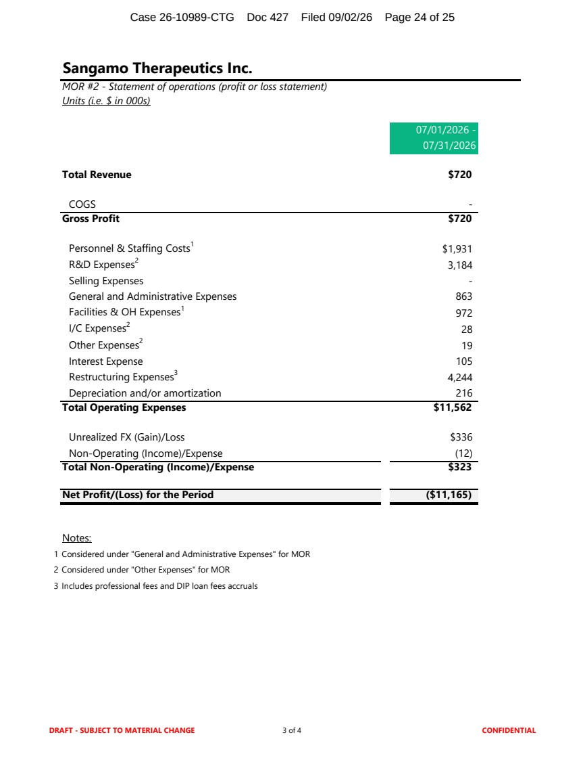 | Sangamo Therapeutics Inc. MOR #2 - Statement of operations (profit or loss statement) Units (i.e. $ in 000s) 07/01/2026 - 07/31/2026 Total Revenue $720 COGS - Gross Profit $720 Personnel & Staffing Costs1 $1,931 R&D Expenses2 3,184 Selling Expenses - General and Administrative Expenses 863 Facilities & OH Expenses1 972 I/C Expenses2 28 Other Expenses2 19 Interest Expense 105 Restructuring Expenses3 4,244 Depreciation and/or amortization 216 Total Operating Expenses $11,562 Unrealized FX (Gain)/Loss $336 Non-Operating (Income)/Expense (12) Total Non-Operating (Income)/Expense $323 Net Profit/(Loss) for the Period ($11,165) Notes: 1 Considered under "General and Administrative Expenses" for MOR 2 Considered under "Other Expenses" for MOR 3 Includes professional fees and DIP loan fees accruals DRAFT - SUBJECT TO MATERIAL CHANGE 3 of 4 CONFIDENTIAL Case 26-10989-CTG Doc 427 Filed 09/02/26 Page 24 of 25
 | 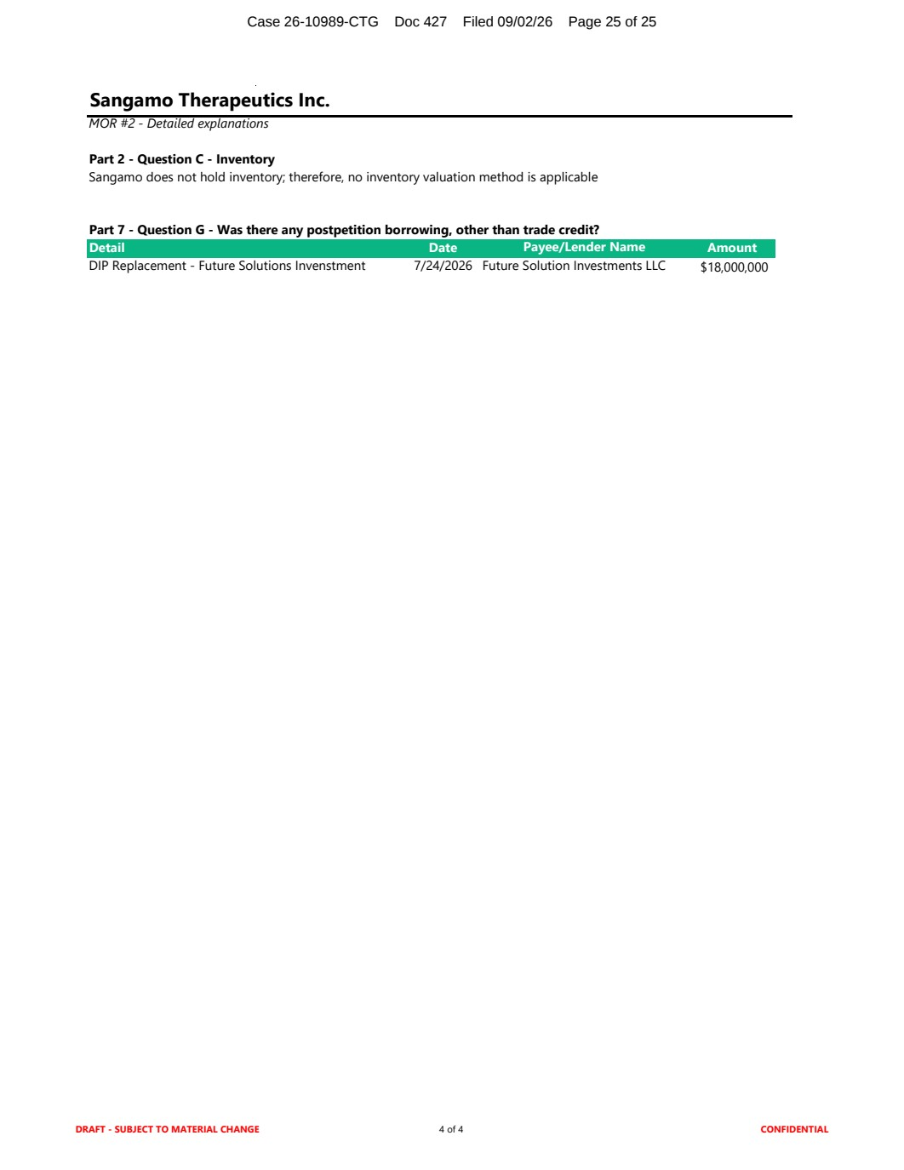 | Sangamo Therapeutics Inc. MOR #2 - Detailed explanations Part 2 - Question C - Inventory Sangamo does not hold inventory; therefore, no inventory valuation method is applicable Part 7 - Question G - Was there any postpetition borrowing, other than trade credit? Detail Date Payee/Lender Name Amount DIP Replacement - Future Solutions Invenstment 7/24/2026 Future Solution Investments LLC $18,000,000 DRAFT - SUBJECT TO MATERIAL CHANGE 4 of 4 CONFIDENTIAL Case 26-10989-CTG Doc 427 Filed 09/02/26 Page 25 of 25

